
STATEMENT OF ACCOUNTS

FOR THE YEAR ENDED 31ST MARCH 2013

STATEMENT OF ACCOUNTS

2012/2013
CONTENTS

 |  | PAGE
Section 1 | Explanatory Foreword | 5
Section 2 | Statement of Responsibilities for the Statement of Accounts | 15
Section 3 | Independent Auditor's Report | 17
Section 4 | Core Financial Statements
 | - Movement in Reserves Statement | 21
 | - Comprehensive Income & Expenditure Statement | 23
 | - Balance Sheet | 25
 | - Cash Flow Statement | 26
Section 5 | Notes to the Accounts | 27
Section 6 | Supplementary Single Entity Financial Statements
 | - Housing Revenue Account | 121
 | - Collection Fund | 129
Section 7 | Group Accounts | 135
Section 8 | Annual Governance Statement | 149
Section 9 | Glossary of Terms | 163

EXPLANATORY FOREWORD
INTRODUCTION

The Statement of Accounts summarises the financial performance of the Council for the year ended 31st March 2013. The foreword gives a brief summary of the Council’s overall financial results for 2012/2013, the type of expenditure incurred and the funds used to pay for it. It also highlights the main influences affecting the accounts and assists in the interpretation of the main accounting statements.

These accounts have been prepared in accordance with the Accounts and Audit (England) Regulations 2011 and the current Code of Practice on Local Authority Accounting In the United Kingdom, based on International Financial Reporting Standards.

EXPLANATION OF THE STATEMENTS

The statements presented in the following pages comprise:-

Statement of Responsibilities for the Statement of Accounts

This sets out the respective responsibilities of the Council and the Treasurer for the accounts.

The accounts are supported by notes to the financial statements. These notes include a summary of significant accounting policies, further detail relating to items in the main financial statements and assumptions made about the future.

Movement in Reserves Statement

This statement shows the movement in year on the different reserves held by the Council, analysed into “usable” reserves (i.e those that can be applied to fund expenditure or reduce local taxation) and other reserves.

Comprehensive Income and Expenditure Account

This statement shows the accounting cost in the year of providing services in accordance with generally accepted accounting practices, rather than the amount to be funded from taxation. Authorities raise taxation to cover expenditure in accordance with regulations; this may be different from the accounting cost. The taxation position is shown in the Movement in Reserves Statement.

Balance Sheet

This sets out the overall financial position of the Council as at 31st March 2013. It shows the reserves and balance of the Council, its long–term indebtedness and the value of fixed and net current assets.

Cash Flow Statement

This summarises the inflows and outflows of cash arising from transactions with third parties for revenue and capital purposes.

Housing Revenue Account

This reflects a statutory obligation to account separately for local authority housing provision. It shows the major elements of housing revenue expenditure and income.

Collection Fund

This account reflects the statutory requirement for billing authorities to maintain a separate Collection Fund which shows the transactions on non-domestic rates and council tax and illustrates the way in which these are distributed to Lancashire Police Authority, Lancashire Fire Authority and the Council’s General Fund.

Group Accounts

This summarises group financial statements prepared in order to show the overall financial position and results of the local authority group.

SUMMARY OF THE FINANCIAL YEAR

REVENUE SUMMARY

The budget for 2012/2013 was set by the Council on 24th February 2012 in the sum of £144.237m. There was no increase in Council Tax which remained at Band D of £1,306.09 for services which are the responsibility of the Council to deliver or £1,519.67 when precepts for Lancashire Police Authority and Lancashire Fire Authority are included. The budget was financed as follows:

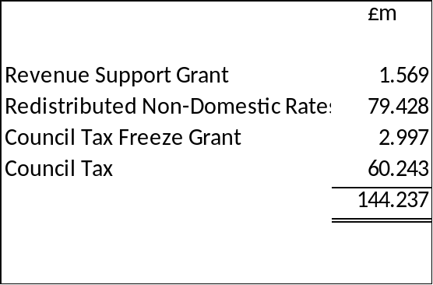

The provisional revenue outturn for 2012/2013 (before allowing for changes to working balances) is £145,037,000 compared with the approved budget of £144,785,000 – a net overspend of £252,000.

The year-end variance position for each department is summarised as follows:-

Department | 2012/2013  Variance  £000
Chief Executive | (116)
Human Resources, Communication & Engagement | (64)
Democratic Services | (46)
Treasurer Services | (168)
Built Environment | 34
Organisation, Property & Information Technology | (8)
Regeneration, Tourism & Culture | 17
Strategic Leisure Assets | 1,866
Leisure & Operational Services | (26)
Adult Services | (1,377)
Children’s Services | 1,330
Sub-total | 1,442
Area Panel and Ward Budgets | (800)
Total | 642

The main reasons for this net service overspend are:-

Service | Reasons | £000
Regeneration, Tourism & Culture – Strategic Leisure Assets | The overspend consists of a £936k overspend brought forward from 2011/2012, less buoyant trading conditions than budgeted in-year and vacant units within the Golden Mile. This has been cushioned by the temporary application of the Council’s Composite Rate of Interest on Leisure Assets debt for the purpose of accelerating the payback period. | 1,866
Children’s Services | The main reason for the overspend relates to the increase in Looked After Children (LAC) numbers. LACs continued to rise during 2012/2013 from 434 as at 1st April 2012 to 488 as at 31st March 2013, resulting in an overspend on Children’s Social Care of £2.3m. This has been offset in-year by savings in the Community Early Help for Children division (495k), additional Early Intervention Grant income (£400k) and savings from the Youth Offending division (£114k). A recovery plan that targets a reduction in LAC numbers to 390 by 31st March 2016, whilst also using less costly placements through an investment in 15 additional social workers, was approved by the Executive on 12th December 2012 in order to address this issue over the medium term. | 1,330
Built Environment | Overspending on beach patrol staffing of £75k has been partly offset by £41k savings in staff vacancies and on contracts. | 34
Regeneration, Tourism & Culture | Increased costs of £26k on insuring the Illuminations have been partly offset by £9k of efficiency savings. | 17
Chief Executive / Human Resources, Communication & Engagement / Democratic Services / Treasurer Services / Organisation, Property & IT / Leisure & Operational Services | The majority of these underspends relate to staff savings totalling £246k. The remainder is due to increased efficiency savings and good housekeeping. | (428)
Area Forum and Ward Budgets | Scheme commitments of £272k are being carried forward to 2013/2014 which reduces the real surplus on budgets to £528k. | (800)
Adult Services | There are 2 main reasons for the underspend in Adults services. Firstly, stricter adherence to the eligibility criteria through the work of the Review Team Plus and identifying & implementing a more efficient use of resources in meeting client needs has resulted in savings in the Adult Commissioning Placements division (£289k). Secondly, vacant posts across the Department have been held throughout the year pending a significant number of service redesigns, resulting in savings in the Adult Social Care (£433k) and Care & Support (£578k) divisions. | (1,377)
Total |  | 642

The 2012/2013 figures include underspendings of £1,238,000 brought forward from the previous financial year. After allowing for these sums, the provisional outturn shows that departmental budgets overspent in-year by £1,880,000.

The financial outturn for budgets ‘outside the cash limit’ is detailed below and shows an aggregate underspending of £188,000. The main reasons for this are:-

Service | Reasons | £000
Concessionary Fares | The reason for this overspend is a significant increase in ridership costs of 21% year-on-year, reflecting a 11% increase in passenger numbers coupled with increased fares. | 1,068
Parking Services | Overspending due to a shortfall in car parking income and the purchase of a new parking system. This has been partly offset by reduced staffing levels. | 966
Council Tax and NNDR Cost of Collection | Increase in council tax benefit payments and a reduction in costs recovered. | 149
Land Charges | - | (1)
Housing Benefits | This relates to a DWP subsidy adjustment on a prior year claim following a challenge by the Council. | (164)
Subsidiary Companies | Primarily the good performance of the Blackpool Operating Company, which manages and operates the Sandcastle Waterpark, has led to a reduced subsidy requirement. | (306)
Treasury Management | The use of temporary borrowing and internal financing in lieu of long-term borrowing and the passporting of reduced interest by LCC on the Local Government Reorganisation debt achieved significant savings in interest payable. Higher cash balances during the year resulted in increased temporary investment income, albeit at continuing low interest rates. | (1,900)
Total |  | (188)

Treatment of Revenue Budget Variances

Having considered the Provisional Revenue Outturn 2012/2013 in detail and the financial outlook, it was agreed by the Executive on 17th June 2013 that:-

- the planned overspending of £1,866,000 on the Strategic Leisure Assets, in accordance with the original decision for this scheme of the Executive on 7th February 2011, is carried forward to 2013/2014 in full;

- the underspending of £800,000 on Area Forum and Ward Budgets is carried forward to 2013/2014 in full;

- the following service underspendings are carried forward at 50% and covered by earmarked reserve in order not to adversely impact upon working balances if and when spent; the remaining 50% will transfer to a Budget 2014/2015 Reserve to mitigate against the anticipated high risks in setting that year’s Budget:

Department | £000
Chief Executive | 58.0
Human Resources, Communication & Engagement | 32.0
Democratic Services | 23.0
Treasurer Services | 84.0
Organisation, Property & IT | 4.0
Leisure & Operational Services | 13.0
Adult Services | 688.5
Total | 902.5

- the following service overspendings are to be carried forward to 2013/2014 in full:

Department | £000
Built Environment | 34.0
Regeneration, Tourism & Culture | 17.0
Total | 51.0

- the following service overspending is carried forward to be funded from the Budget 2013/14 Reserve:

Department | £000
Children’s Services | 1,330.0

This will allow Children’s Services to enter the new financial year in a balanced position and give the Department a realistic chance in meeting its budget savings targets for that year.

GENERAL FUND WORKING BALANCES

In setting the Council’s original budget for 2012/2013 the target General Fund working balances as at 31st March 2013 were approximately £6m. However the outturn position means that the actual General Fund working balances as at 31st March 2013 were £5.7m.

The graph below shoes the change in the General Fund Working Balances over the last 6 years.

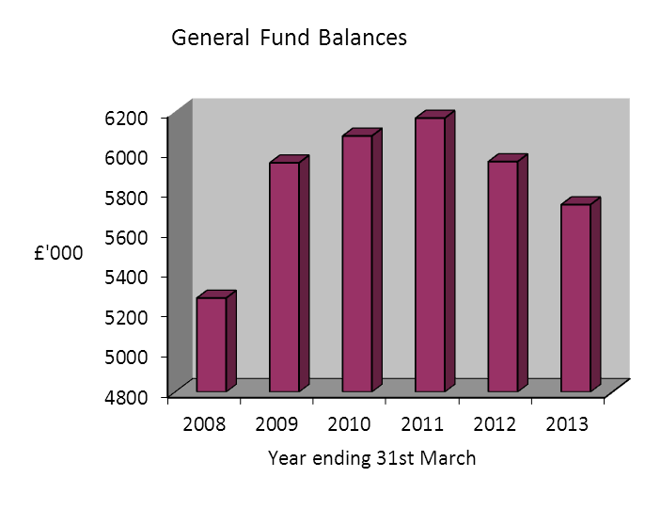
CAPITAL SUMMARY

The total of the Council’s capital spending in 2012/2013 was £70.6m, which although a 25% decrease from the previous year is still a significant sum for a local authority of this size. The main reason for the decrease in capital spending is that many of the larger schemes are nearing completion e.g. seafront and tramway. The net book value of the Council’s fixed assets as at 31st March 2013 was £862.5m.

The main areas of capital spending during the year were:

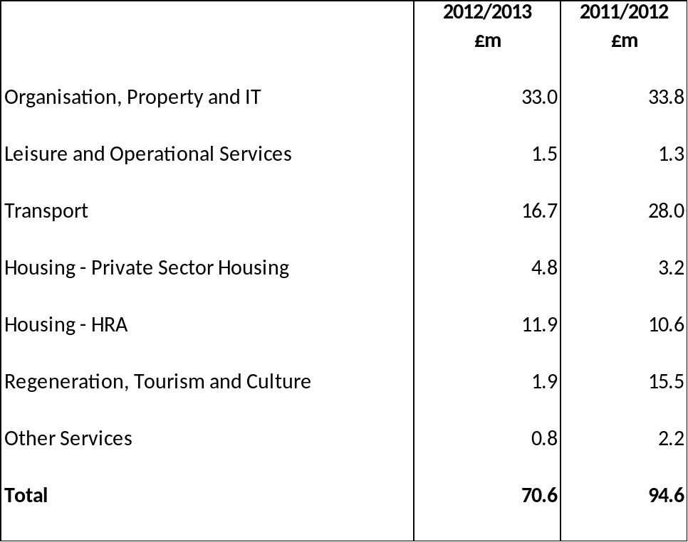

Organisation, Property and IT includes capital expenditure on all Council properties including schools and adult and family centres.

The funding of capital expenditure came from a number of sources as summarised below:

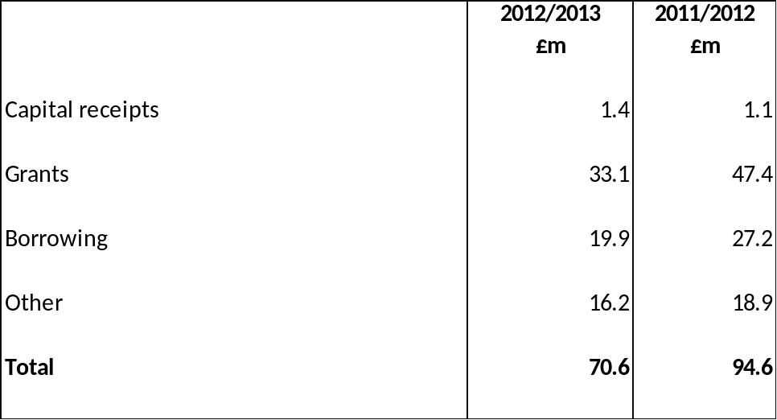

As at 31st March 2013 the Council held a balance of usable capital receipts amounting to £2m. Most of these capital receipts are committed towards future schemes such as the Central Business District and Tramway projects.

The Council plans future capital developments within the financial constraints placed upon it. Key policy objectives for the future include regeneration and renewal of the town on a significant scale.

- A Tramway programme totalling £100m and funded by the Department for Transport commenced in 2008/2009 and was phased over 4 years. The scheme is almost complete and the tramway is now functioning at full capacity.
- £34m of investment was made in Blackpool Tower and Winter Gardens with funding made available by ERDF, NWDA and Homes & Communities Agency. The Council is also making a significant contribution to improve and develop the facilities in order to meet the requirements of the current market. The attractions were fully opened during 2011/2012, although further investment was made in 2012/2013 to complete the attractions to the desired standard.
- Project 30 commenced in 2011/2012 and continued into 2012/2013. This is an investment of £30m over 4 years to update the road network and infrastructure to a level considered adequate for a town of Blackpool’s stature. The investment made will provide significant long-term benefits for the town whose current roads require upgrading.

HOUSING REVENUE ACCOUNT (HRA)

Under the Local Government and Housing Act 1989 expenditure on council housing is “ring-fenced” meaning no contribution can be made to or from the General Fund. Furthermore, the Housing Revenue Account (Accounting Practices) Directions 2000 applies whereby “Resource Accounting” is implemented, making more transparent the costs of capital tied up in the assets and providing resources to maintain them

HRA Reserves
The balance on the HRA reserve stands at £3.4m at 31 March 2013.

PENSION LIABILITY

In accordance with best accounting practice the Council must show the surplus or deficit position on its share of the Pension Fund. For Blackpool the net position showed a liability of £211.666m for 2012/2013 compared to a liability of £174.564m for 2011/2012. The increase in liability is £37.102m.

The liabilities have been assessed on an actuarial basis using the projected unit method, an estimate of the pensions that will be payable in future years dependent on the assumptions about mortality rates, salary levels, etc. The assets and liabilities have been assessed by Mercer Human Resource Consulting Ltd, an independent firm of actuaries. The liabilities will not become due immediately or all at once, as they relate to pensions payable to current scheme members on their normal retirement dates. The position at the end of the financial year is based on prevailing market and other economic conditions. As such it may fluctuate significantly from one year to the next.

ACCOUNTING PRACTICE COMPLIANCE

These accounts have been prepared in accordance with the Accounts and Audit Regulations 2011 and the current Code of Practice on Local Authority Accounting in the United Kingdom, based on International Financial Reporting Standards.
In accordance with the latest CIPFA Code of Practice on Local Authority Accounting in the United Kingdom, which is applicable to financial reporting from 1st April 2012, the Comprehensive Income and Expenditure Account is presented using a Service Expenditure Analysis (SEA) reflecting the Service Reporting Accounting Code of Practice approach to consistent financial reporting. The accounting policies adopted by the Council are explained fully in Section 5.

COMPLIANCE WITH STATUTORY CONTROLS & TARGETS

In 2012/2013 the Council did not apply any supported capital expenditure (SCE) approvals in order to borrow for capital purposes. It is government policy to gradually replace SCEs with Capital Grant. In addition the Council also has authority to prudentially borrow to fund schemes. The costs of this borrowing must be met from the service revenue budget over the useful life of the asset and it is the Council’s policy that the cost of the capital scheme using prudential borrowing must have a nil effect on the council tax. Therefore, increased income/savings must be achievable before the scheme can go ahead.

The Council set aside a minimum revenue provision (MRP) of £6.3m representing 4% of the capital financing requirement, as adjusted in respect of the commutation of certain Government housing grants. In addition to the statutory minimum of 4%, £2.5m has been set aside to repay debt relating to shorter life assets that have been funded by prudential borrowing.

FURTHER INFORMATION

The Statement of Accounts forms one element of the Council’s financial reporting to local taxpayers, employees and other interested parties. Further information can be found in the following publications, which are produced each year:

Revenue Budget available for inspection in local libraries or on the
Council’s website
Schedule of Fees & Charges obtainable from the Treasurer
Council Tax Leaflet distributed to all households with 2012/2013 council tax bills

Information can also be found on the Council’s website www.blackpool.gov.uk

Transparency

The Government’s Transparency Agenda encourages local authorities to make public data openly available. Details of the Council’s spend over £250 and senior managers’ salaries can be found on the above website.

Further information about this Statement of Accounts is available from:

Treasurer
Blackpool Council
P O Box 4
Town Hall
Blackpool
FY1 1NA

Public Inspection of Accounts

Interested members of the public have a statutory right to inspect the accounts before the audit is completed. This inspection will take place from 8th July 2013 until 2nd August 2013 for the 2012/2013 Statement of Accounts. The availability of the accounts for inspection was advertised in the local press in June 2013.

STATEMENT OF RESPONSIBILITIES FOR THE STATEMENT OF ACCOUNTS

- THE COUNCIL’S RESPONSIBILITIES

The Council is required to:

- make arrangements for the proper administration of its financial affairs and to secure that one of its officers has the proper responsibility for the administration of those affairs. In this authority that officer is the Treasurer;
- manage its affairs to secure economic, efficient and effective use of resources and safeguard its assets; and
- approve the Statement of Accounts.

Chair – Finance and Audit Committee
Date

- THE TREASURER’S RESPONSIBILITIES

The Treasurer is responsible for the preparation of the authority’s Statement of Accounts in accordance with proper practices as set out in the CIPFA/LASAAC Code of Practice on Local Authority Accounting in United Kingdom (“the Code of Practice”).

In preparing this Statement of Accounts, the Treasurer has:

- selected suitable accounting policies and then applied them consistently;
- made judgements and estimates that were reasonable and prudent; and
- complied with the Code of Practice.

The Treasurer has also:

- kept proper accounting records which were up to date; and
- taken reasonable steps for the prevention and detection of fraud and other irregularities.

- THE TREASURER’S CERTIFICATE

The Statement of Accounts represents fairly the financial position of the Council at the accounting date and its income and expenditure for the year ended 31st March 2013.

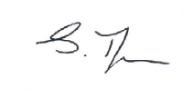
S Thompson
Treasurer
27th June 2013

INDEPENDENT AUDITOR’S REPORT

REPORT WILL BE INSERTED FOLLOWING THE AUDIT

SECTION 4

CORE FINANCIAL STATEMENTS

MOVEMENT IN RESERVES STATEMENT

This statement shows the movement in the year on the different reserves held by the authority, analysed into `usable reserves’ (i.e those that can be applied to fund expenditure or reduce local taxation) and other reserves. The (Surplus) or deficit on the Provision of Services line shows the true economic cost of providing the authority’s services, more details of which are shown in the Comprehensive Income and Expenditure Statement. This is different from the statutory amounts required to be charged to the General Fund Balance and the Housing Revenue Account for council tax setting and dwellings rent setting purposes. The Net Increase/Decrease before Transfers to Earmarked Reserves line shows the statutory General Fund Balance and Housing Revenue Account Balance before any discretionary transfers to or from earmarked reserves undertaken by the Council.

2012/2013

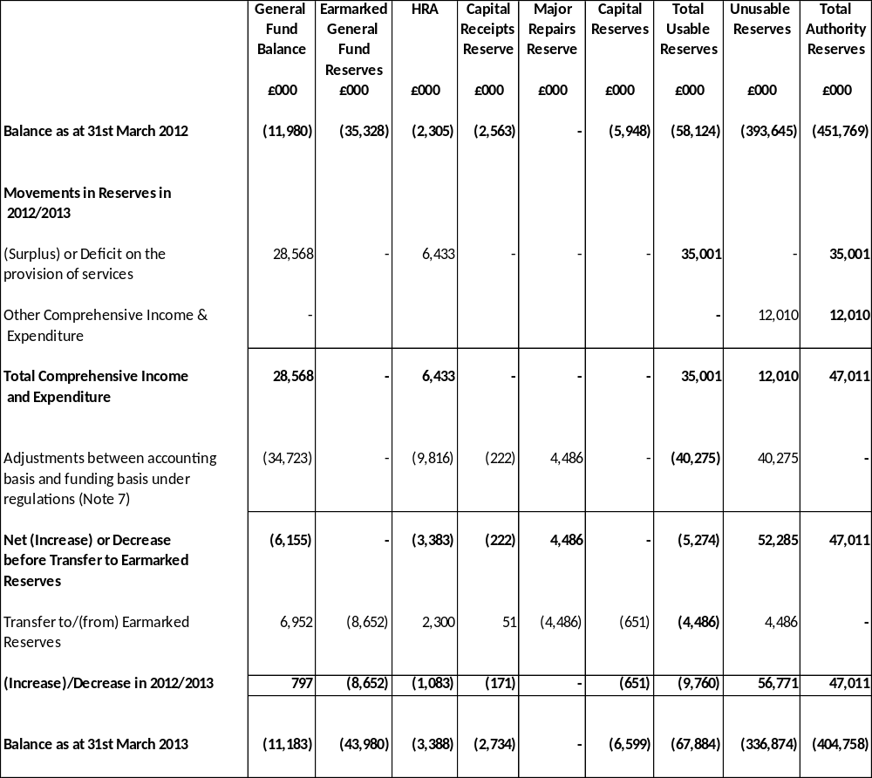

2011/2012

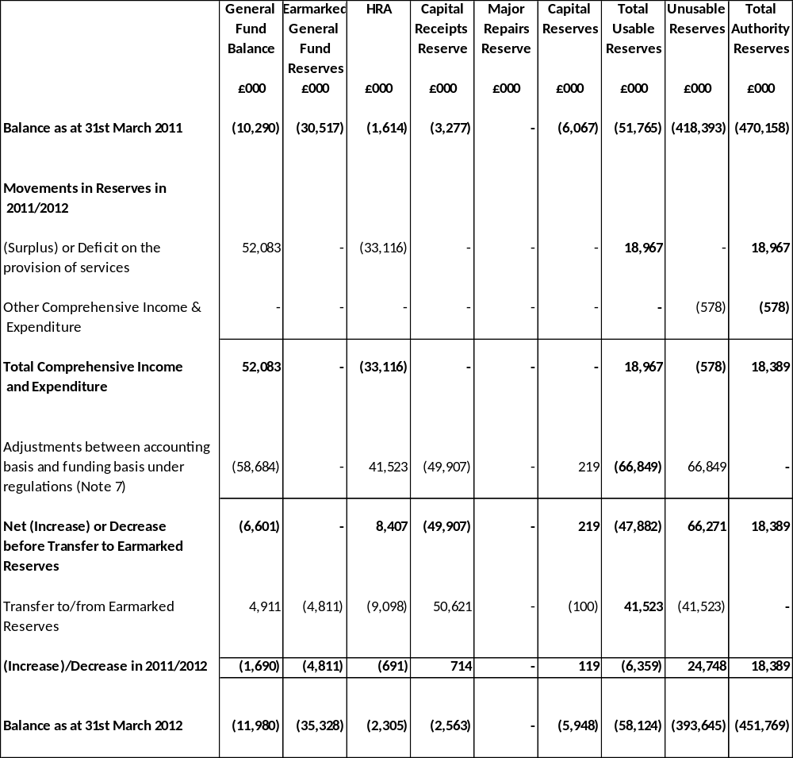

COMPREHENSIVE INCOME AND EXPENDITURE STATEMENT FOR THE YEAR ENDED 31ST MARCH 2013
This statement shows the accounting cost in the year of providing services in accordance with generally accepted accounting practices, rather than the amount to be funded from taxation. Authorities raise taxation to cover expenditure in accordance with regulations; this may be different from the accounting cost. The taxation position is shown in the Movement in Reserves Statement.
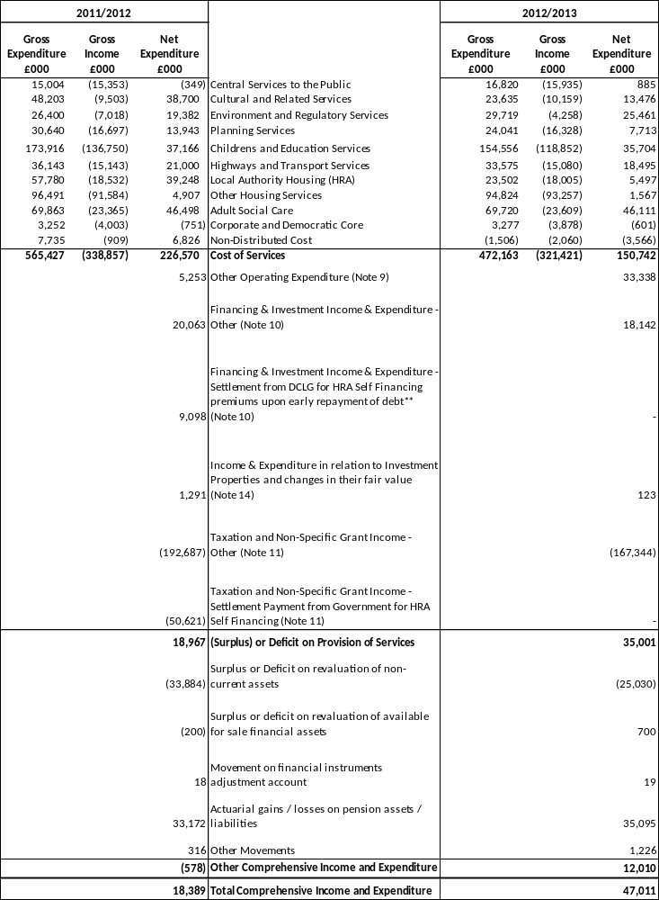

** HRA Self Financing Settlement

The Housing Revenue Account subsidy is central government’s contribution towards the cost of council housing in Blackpool. It is calculated as the amount required to balance a notional Housing Revenue Account, based on government estimates of the income and expenditure which should be earned and spent by the Authority on council housing.

The Housing Subsidy system ceased on 1 April 2012 when the HRA self-financing system was introduced, as a result of the Localism Act 2011. The purpose of this Act is to put all local authorities in a position where they can manage their council houses from their own income in future.

As a receiver of subsidy, Blackpool received a capital sum of £41,523,000 on 28th March 2012, in order to exit the subsidy system on 1st April 2012. The Secretary of State made a payment of £41,523,000 to the Public Works Loan Board (PWLB) to redeem PWLB debt on behalf of Blackpool. This early debt repayment lead to a premium payment of £9,098,000 which, in accordance with the Settlement Payment Determination, was also met by the Secretary of State. The total receipt of £50,621,000 is shown within 2011/2012 HRA under Capital grants and contributions and the immediate redemption of the debt and premium is also reflected in the Accounts.

BALANCE SHEET FOR THE YEAR ENDED 31ST MARCH 2013
The Balance Sheet shows the value as at the Balance Sheet date of the assets and liabilities recognised by the authority. The net assets of the authority (assets less liabilities) are matched by the reserves held by the authority. Reserves are reported in two categories. The first category of reserves are usable reserves, i.e those reserves that the authority may use to provide services, subject to the need to maintain a prudent level of reserves and any statutory limitations on their use (for example Capital Receipts Reserve may only be used to fund capital expenditure or repay debt). The second category of reserves is those that the authority is not able to use to provide services. This category of reserves includes reserves that hold unrealised gains and losses (for example revaluation reserve), where amounts would only become available to provide services if the assets are sold; and reserves that hold timing differences shown in the Movement in reserves Statement line ‘Adjustments between accounting basis and funding basis under regulations’.

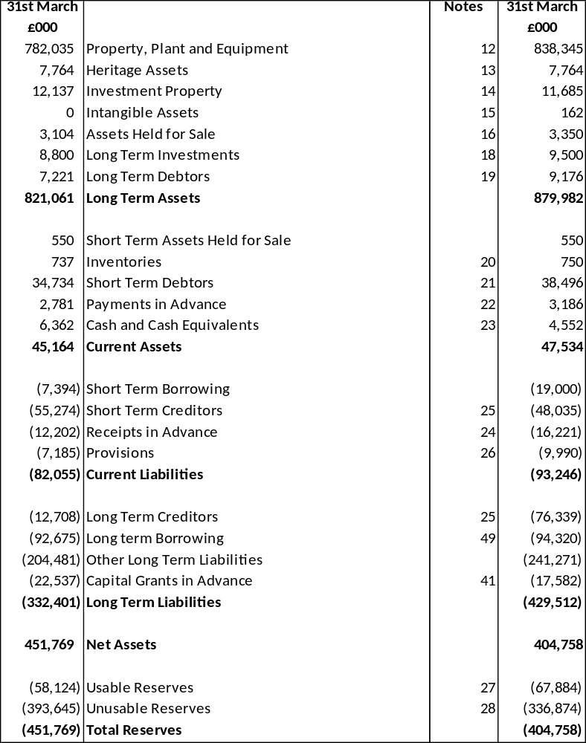

CASH FLOW STATEMENT FOR THE YEAR ENDED 31ST MARCH 2013
The Cash Flow Statement shows the changes in cash and cash equivalents of the authority during the reporting period. The statement shows how the authority generates and uses cash and cash equivalents by classifying cash flows as operating, investing and financing activities. The amount of net cash flows arising from operating activities is a key indicator of the extent to which the operations of the authority are funded by way of taxation and grant income or from the recipients of services provided by the authority. Investing activities represent the extent to which cash outflows have been made for resources which are intended to contribute to the authority’s future service delivery. Cash flows arising from financing activities are useful in predicting claims on future cash flow by providers of capital (i.e borrowing) to the authority.

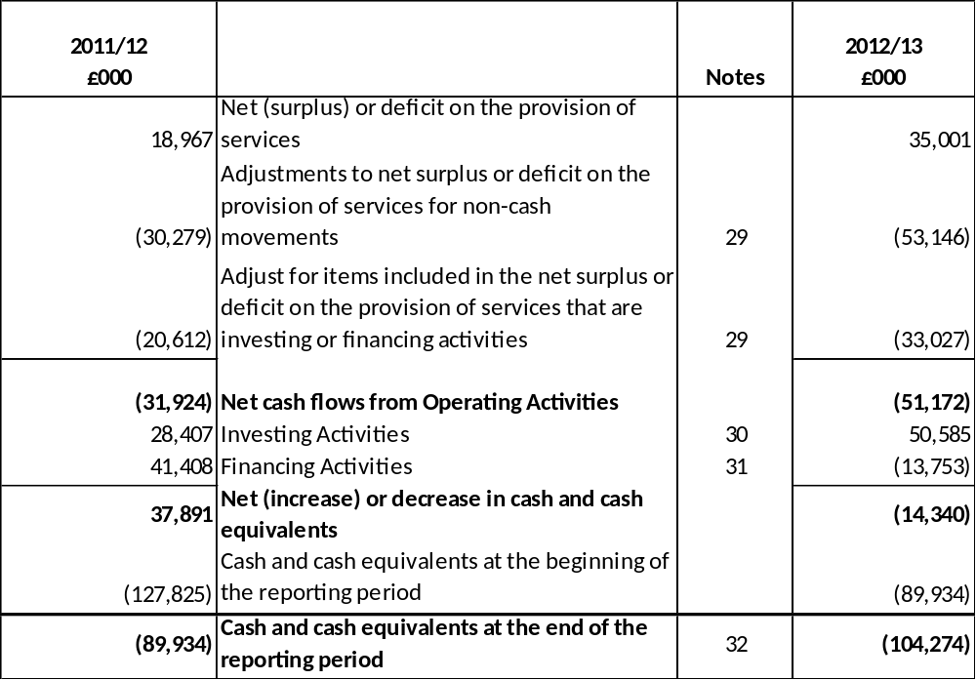

SECTION 5

NOTES TO THE ACCOUNTS

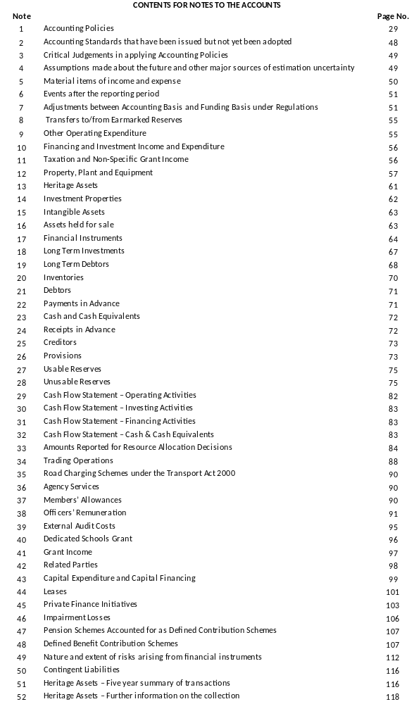
- ACCOUNTING POLICIES

GENERAL PRINCIPLES

The Statement of Accounts summarises the transactions for the 2012/2013 financial year and its position at the year-end 31st March 2013. The Council is required to prepare an annual statement of accounts by the Accounts and Audit (England) Regulations 2011, which those regulations require to be prepared in accordance with proper accounting practices. These practices primarily comprise the Code of Practice on Local Authority Accounting in the United Kingdom 2012/2013 (the ‘Code’)and the Service Reporting Code of Practice 2012/2013 (SERCOP) supported by International Financial Reporting Standards (IFRS) and statutory guidance issued under section 12 of the 2003 Act.

The accounting convention adopted in the Statement of Accounts is principally historical cost, modified by the revaluation of certain categories of non-current assets and financial instruments.

ACCRUALS OF INCOME AND EXPENDITURE

Activity is accounted for in the year that it takes place, not simply when cash payments are made or received. In particular:

- Revenue from the sale of goods is recognised when the Council transfers the significant risks and rewards of ownership to the purchaser and it is probable that economic benefits or service potential associated with the transaction will flow to the Authority.
- Revenue from the provision of services is recognised when the Council can measure reliably the percentage of completion of the transaction and it is probable that economic benefits or service potential associated with the transaction will flow to the Council.
- Supplies are recorded as expenditure when they are consumed – where there is a gap between the date supplies are received and their consumption, they are carried as inventories on the Balance Sheet. Works are charged as expenditure when they are completed, before which they are carried as works in progress on the balance sheet.
- Expenses in relation to services received (including services provided by employees) are recorded as expenditure when the services are received rather than when payments are made.
- Interest payable on borrowing and receivable on investments is accounted for respectively as income and expenditure on the basis of the effective interest rate for the relevant financial instrument rather than the cash flows fixed or determined by the contract.
- Where revenue and expenditure have been recognised but cash has not been received or paid, a debtor or creditor for the relevant amount is recorded in the balance sheet. Where debts may not be settled, the balance of debtors is written down and a charge made to revenue for the income that might not be collected (bad debt provision).
- Dividend income is recognised in the accounts in the year that it is declared rather than the year to which it relates.

CASH AND CASH EQUIVALENTS

Cash is represented by cash in hand and deposits with financial institutions repayable without penalty on notice of not more than 24 hours. Cash equivalents are highly liquid investments that mature within three months or less from the date of acquisition and that are readily convertible to known amounts of cash with insignificant risk of change in value. Bank overdrafts are presented within current liabilities.
In the Cash Flow Statement, cash and cash equivalents are shown net of bank overdrafts that are repayable on demand and form an integral part of the Council’s cash management.

EXCEPTIONAL ITEMS
When items of income and expense are material, their nature and amount is disclosed separately either on the face of the Comprehensive Income and Expenditure Statement or in the notes to the accounts, depending on how significant the items are to an understanding of the Council’s financial performance.
PRIOR PERIOD ADJUSTMENTS, CHANGES IN ACCOUNTING POLICIES AND ESTIMATES AND ERRORS
Prior period adjustments may arise as a result of a change in accounting policies or to correct a material error. Changes in accounting estimates are accounted for prospectively, i.e. in the current and future years affected by the change and do not give rise to a prior period adjustment.
Changes in accounting policies are only made when required by proper accounting practices or the change provides more reliable and relevant information about the effect of transactions, other events and conditions on the Council’s financial position or financial performance. Where a change is made, it is applied retrospectively by adjusting opening balances and comparative amounts for the prior period as if the new policy had always been applied.
Material errors discovered in prior period figures are corrected retrospectively by amending opening balances and comparative amounts for the prior period.
CHARGES TO REVENUE FOR NON-CURRENT ASSETS
Services, support services and trading accounts are debited with the following amounts to record the cost of holding fixed assets during the year:
- depreciation attributable to the assets used by the relevant service
- revaluation and impairment losses on assets used by the service where there are no accumulated gains in the Revaluation Reserve against which the losses can be written off
- amortisation of intangible fixed assets attributable to the service.

The Authority is not required to raise council tax to fund depreciation, revaluation and impairment losses or amortisations. However, it is required to make an annual contribution from revenue towards the reduction in its overall borrowing requirement equal to an amount calculated on a prudent basis determined by the authority in accordance with statutory guidance. Depreciation, revaluation and impairment losses and amortisations are therefore replaced by the contribution in the General Fund Balance (MRP or loans fund principal), by way of an adjusting transaction with the Capital Adjustment Account in the Movement in Reserves Statement for the difference between the two.
EMPLOYEE BENEFITS
Benefits Payable During Employment
Short-term employee benefits are those due to be settled within 12 months of the year-end. They include such benefits as wages and salaries, paid annual leave and paid sick leave, bonuses and non monetary benefits for current employees and are recognised as an expense for services in the year in which employees render service to the Council. An accrual is made for the cost of holiday entitlements and flexi time earned by employees but not taken before the year-end which employees can carry forward into the next financial year. The accrual is made at the wage and salary rates applicable in the following accounting year, being the period in which the employee takes the benefit. The accrual is charged to Surplus or Deficit on the Provision of Services, but then reversed out through the Movement on Reserves Statement so that holiday benefits are charged to revenue in the financial year in which the holiday absence occurs.

Termination Benefits
Termination benefits are amounts payable as a result of a decision by the Council to terminate an officer’s employment before the normal retirement date or an officer’s decision to accept voluntary redundancy and are charged on an accruals basis to the Non Distributed Costs line in the Comprehensive Income and Expenditure Statement when the Authority is demonstrably committed to the termination of the employment of an officer or group of officers or making an offer to encourage voluntary redundancy.
Where termination benefits involve the enhancement of pensions, statutory provisions require the General Fund balance to be charged with the amount payable by the Authority to the pension fund or pensioner in the year, not the amount calculated according to the relevant accounting standards. In the Movement in Reserves Statement, appropriations are required to and from the Pensions Reserve to remove the notional debits and credits for pension enhancement termination benefits and replace them with debits for the cash paid to the pension fund and pensioners and any such amounts payable but unpaid at the year end.
Post - Employment Benefits
Employees of the Authority are members of two separate pension schemes:
- The Teachers’ Pension Scheme, administered by Capita Teachers’ Pensions on behalf of the Department for Education (DfE).
- The Local Government Pensions Scheme, administered by Lancashire County Council.

Both schemes provide defined benefits to members (retirement lump sums and pensions), earned as employees work for the Authority.
However, the arrangements for the teachers’ scheme mean that liabilities for these benefits cannot ordinarily be identified specifically to the Authority. The scheme is therefore accounted for as if it were a defined benefit contribution scheme and no liability for future payments of benefits is recognised in the Balance Sheet. The Education and Children’s Services line in the Comprehensive Income and Expenditure Statement is charged with the employer’s contributions payable to the Teachers pensions in the year.
The Local Government Pension Scheme
The Local Government Scheme is accounted for as a defined benefits scheme:
- The liabilities of the Lancashire County Council pension scheme attributable to the Council are included in the Balance Sheet on an actuarial basis using the projected unit method – ie an assessment of the future payments that will be made in relation to retirement benefits earned to date by the employees, based on assumptions about mortality rates, employee turnover rates, etc, and projections of projected earnings for current employees.

- Liabilities are discounted to their value at current prices, using a discount rate of 4.2% (4.9% in 2011/2012) (based on the weighted average of “spot yields” on AA rated corporate bonds).

- The assets of the Lancashire County Council pension fund attributable to the Council are included in the Balance Sheet at their fair value:

  - Quoted securities – current bid price
  - Unquoted securities – professional estimate
  - Unitised securities – current bid price
  - Property – market value

    - The change in the net pensions liability is analysed into seven components:

- current service cost – the increase in liabilities as result of years of service earned this year – allocated in the Comprehensive Income and Expenditure Statement to the revenue accounts for services for which the employees worked
- past service cost – the increase in liabilities arising from current year decisions whose effect relates to years of service earned in earlier years – debited to the Net Cost of Services in the Comprehensive Income and Expenditure Statement as part of Non Distributed Costs
- interest cost- the expected increase in the present value of liabilities during the year as they move one year closer to being paid – debited to the Financing and Investment Income and Expenditure line in the Comprehensive Income and Expenditure Statement
- expected return on assets – the annual investment return on the fund assets attributable to the Council, based on average of the expected long-term return – credited to the Financing and Investment Income and Expenditure line in the Comprehensive Income and Expenditure Statement
- gains/losses on settlements and curtailments – the result of actions to relieve the Council of liabilities or events that reduce the expected future service or accrual of benefits of employees – debited or credited to the Surplus or Deficit on the Provision of Services in the Comprehensive Income and Expenditure Statement as part of Non Distributed Costs
  - actuarial gains and losses – changes in the net pension liability that arise because events have not coincided with assumptions made at the last actuarial valuation or because the actuaries have updated their assumptions – debited to the Pensions Reserve
- contributions paid to the Lancashire County Council pension fund – cash paid as employer’s contributions to the pension fund in settlement of liabilities; not accounted for as an expense.

In relation to retirement benefits, statutory provisions require the General Fund balance to be charged with the amount payable by the Council to the pension fund or directly to pensioners in the year, not the amount calculated according to the relevant accounting standards. In the Movement in Reserves Statement, this means that there are appropriations to and from the Pensions Reserve to remove the notional debits and credits for retirement benefits and replace them with debits for the cash paid to the pension fund and pensioners and any such amounts payable to the fund but unpaid at the year-end. The negative balance that arises on the Pensions Reserve thereby measures the beneficial impact to the General Fund of being required to account for retirement benefits on the basis of cash flows rather than as benefits are earned by employees.

discretionary benefits

The Council also has restricted powers to make discretionary awards of retirement benefits in the event of early retirements. Any liabilities estimated to arise as a result of an award to any member of staff (including teachers) are accrued in the year of the decision to make the award and accounted for using the same policies as are applied to the Local Government Pension Scheme.

EVENTS AFTER THE BALANCE SHEET DATE
Events after the balance sheet date are those events, both favourable and unfavourable, that occur between the end of the reporting period and the date when the Statement of Accounts is authorised for issue. Two types of events can be identified:
- those that provide evidence of conditions that existed at the end of the reporting period – the Statement of Accounts is adjusted to reflect such events
- those that are indicative of conditions that arose after the reporting period – the Statement of Accounts is not adjusted to reflect such events, but where a category of events would have a material effect, disclosure is made in the notes of the nature of the events and their estimated financial effect.

Events taking place after the date of authorisation for issue are not reflected in the Statement of Accounts.
FINANCIAL INSTRUMENTS
Financial Liabilities
Financial Liabilities are recognised on the Balance Sheet when the Authority becomes a party to the contractual provisions of a financial instrument and are initially measured at fair value and are carried at their amortised cost. Annual charges to the Financing and Investment Income and Expenditure line in the Comprehensive Income and Expenditure Statement for interest payable are based on the carrying amount of the liability, multiplied by the effective rate of interest for the instrument. The effective interest rate is the rate that exactly discounts estimated future cash payments over the life of the instrument to the amount at which it was originally recognised.
For most of the borrowings that the Authority has, this means that the amount presented in the Balance Sheet is the outstanding principal repayable (plus accrued interest); and interest charged to the Comprehensive Income and Expenditure Statement is the amount payable for the year according to the loan agreement.
Gains and losses on the repurchase or early settlement of borrowing are credited and debited to the Financing and Investment Income and Expenditure line in the Comprehensive Income and Expenditure Statement in the year of repurchase/settlement. However, where repurchase has taken place as part of a restructuring of the loan portfolio that involves the modification or exchange of existing instruments, the premium or discount is respectively deducted from or added to the amortised cost of the new or modified loan and the write down to the Comprehensive Income and Expenditure Statement is spread over the life of the loan by an adjustment to the effective interest rate.
Where premiums and discounts have been charged to the Comprehensive Income and Expenditure Statement, regulations allow the impact on the General Fund Balance to be spread over future years. The Council has a policy of spreading the gain/loss over the term that was remaining on the loan against which the premium was payable or discount receivable when it was repaid. However if funds allow, the premium or discount will be charged to the Comprehensive Income and Expenditure Statement in full in the year it is incurred. The reconciliation of amounts charged to the Comprehensive Income and Expenditure Statement to the net charge required against the General Fund Balance is managed by a transfer to or from the Financial Instruments Adjustment Account in the Movement of Reserves Statement.
Financial Assets
Financial assets are classified into two types:
- Loans and receivables – assets that have fixed or determinable payments but are not quoted in an active market

- Available-for-sale assets – assets that have a quoted market price and/or do not have fixed or determinable payments.

Loans and Receivables
Loans and receivables are recognised on the Balance Sheet when the Council becomes a party to the contractual provisions of a financial instrument and are initially measured at fair value. They are subsequently measured at their amortised cost. Annual credits to the Financing and Investment Income and Expenditure line in the Comprehensive Income and Expenditure Statement for interest receivable are based on the carrying amount of the asset multiplied by the effective rate of interest for the instrument. For most of the loans that the Council has made, this means that the amount presented in the Balance Sheet is the outstanding principal receivable (plus accrued interest) and interest credited to the Comprehensive Income and Expenditure Statement is the amount receivable for the year in the loan agreement.
However, the Council has made loans to Lancashire and Blackpool Tourist Board and Lancashire County Developments at less than market rates (soft loans) – see Note 19. When soft loans are made, a loss is recorded in the Comprehensive Income and Expenditure Statement (debited to the appropriate service) for the present value of the interest that will be foregone over the life of the instrument, resulting in a lower amortised cost than the outstanding principal. Interest is credited to the Financing and Investment Income and Expenditure line in the Comprehensive Income and Expenditure Statement at a marginally higher effective rate than the rate receivable from the organisations, with the difference serving to increase the amortised cost of the loan in the Balance Sheet. Statutory provisions require that the impact of soft loans on the General Fund Balance is the interest receivable for the financial year – the reconciliation of amounts debited and credited to the Comprehensive Income and Expenditure Statement to the net gain required against the General Fund Balance is managed by a transfer to or from the Financial Instruments Adjustment Account in the Movement in Reserves Statement.
Where assets are identified as impaired because of a likelihood arising from a past event that payments due under the contract will not be made, the asset is written down and a charge made to the relevant service (for receivables specific to the service) or the Financing and Investment Income and Expenditure line in the Comprehensive Income and Expenditure Statement. The impairment loss is measured as the difference between the carrying amount and the present value of the revised future cash flows discounted at the asset’s original effective interest rate.
Any gains and losses that arise on the de-recognition of the asset are credited/debited to the Financing and Investment Income and Expenditure line in the Comprehensive Income and Expenditure Statement.
Available-for–Sale Assets
Available-for-sale assets are recognised on the Balance Sheet when the Council becomes a party to the contractual provisions of a financial instrument and are initially measured and carried at fair value. Where the asset has fixed or determinable payments, annual credits to the Financing and Investment Income and Expenditure line in the Comprehensive Income and Expenditure Statement for interest receivable are based on the amortised cost of the asset multiplied by the effective rate of interest for the instrument. Where there are no fixed or determinable payments, income (e.g. dividends) is credited to the Comprehensive Income and Expenditure Statement when it becomes receivable by the Council.
Assets are maintained in the Balance Sheet at fair value. Values are based on the following principles:
- Instruments with quoted market prices – the market price
- Other instruments with fixed and determinable payments – discounted cash flow analysis
- Equity shares with no quoted market prices – independent appraisal of company valuations
Changes in fair value are balanced by an entry in the Available-for-Sale Reserve and the gain/loss is recognised in the Surplus or Deficit on Revaluation of Available for Sale Financial Assets. The exception is where impairment losses have been incurred – these are debited to the Financing and Investment Income and Expenditure line in the Comprehensive Income and Expenditure Statement, along with net gain/loss for the asset accumulated in the Available for Sale Reserve.
Where assets are identified as impaired because of a likelihood arising from a past event that payments due under the contract will not be made (fixed or determinable payments) or fair value falls below cost, the asset is written down and a charge made to the Financing and Investment Income and Expenditure line in the Comprehensive Income and Expenditure Statement. If the assets Financing and Investment Income and Expenditure line in the Comprehensive Income and Expenditure Statement has fixed or determinable payments, the impairment loss is measured a the difference between the carrying amount and the present value of the revised future cash flows discounted at the asset’s original effective interest rate. Otherwise, the impairment loss is measured as any shortfall of fair value against acquisition cost of the instrument (net of any principal repayment and amortisation).
Any gains and losses that arise on the de-recognition of the asset are credited/debited to the Financing and Investment Income and Expenditure line in the Comprehensive Income and Expenditure Statement along with any accumulated gains/losses previously recognised in the Available for Sale Reserve.
Where fair value cannot be measured reliably, the instrument is carried at cost (less any impairment losses).
FOREIGN CURRENCY TRANSACTIONS
Where the Council has entered into a transaction denominated in a foreign currency, the transaction is converted into sterling at the exchange rate applicable on the date the transaction was effective. Where amounts in foreign currency are outstanding at the year end they are reconverted at the spot exchange rate at 31st March. Resulting gains or losses are recognised in the Financing and Investment Income and Expenditure line in the Comprehensive Income and Expenditure Statement.

GOVERNMENT GRANTS AND CONTRIBUTIONS

Whether paid on account, by instalment or in arrears, government grants and third party contributions and donations are recognised as due to the Authority when there is reasonable assurance that:
- the Council will comply with the conditions attached to the payments, and
- the grants and contributions will be received.

Amounts recognised as due to the Council are not credited to the Comprehensive Income and Expenditure Statement until conditions attached to the grant or contribution have been satisfied. Conditions are stipulations that specify that the future economic benefits or service potential embodied in the asset acquired using the grant or contribution are required to be consumed by the recipient as specified, or future economic benefits or service potential must be returned to the transferor.

Monies advanced as grants and contributions for which conditions have not been satisfied are carried on the Balance Sheet as creditors. When conditions have been satisfied, the grant or contribution is credited to the relevant service line (attributable revenue grants and contributions) or Taxation and Non Specific Grant Income (non ring-fenced revenue grants and all capital grants) in the Comprehensive Income and Expenditure Statement.

Where capital grants are credited to the Comprehensive Income and Expenditure Statement they are reversed out of the General Fund Balance in the Movement in Reserves Statement. Where the grant has yet been used to finance capital expenditure, it is posted to the Capital Grants Unapplied Reserve. Where it has been applied it is posted to the Capital Adjustment Account. Amounts in the Capital Grants Unapplied Reserve are transferred to the Capital Adjustment Account once they have been applied to fund capital expenditure.

Business Improvement District
A Business Improvement District (BID) scheme applies across the whole of the Council. The scheme is funded by a BID levy paid by non-domestic ratepayers. The Council acts as principal under the scheme, and accounts for income received and expenditure incurred (including contributions to the BID project) within the relevant services within the Comprehensive Income and Expenditure Statement.
INTANGIBLE ASSETS
Expenditure on non-monetary assets that do not have physical substance but are controlled by the Council as a result of past events (e.g. software licences) is capitalised when it is expected that future economic benefits or service potential will flow from the intangible asset to the Council.
Internally generated assets are capitalised where it is demonstrable that the project is technically feasible and is intended to be completed (with adequate resources being available) and the Council will be able to generate future economic benefits or deliver service potential by being able to sell or use the asset. Expenditure is capitalised where it can be measured reliably as attributable to the asset and is restricted to that incurred during the development phase (research expenditure cannot be capitalised).
Expenditure on the development of websites is not capitalised if the website is solely or primarily intended to promote or advertise the Council’s goods and services.
Intangible assets are measured initially at cost. Amounts are only revalued where the fair value of the assets held by the Authority can be determined by reference to an active market. In practice, no intangible asset held by the Authority meets this criterion, and they are therefore carried at amortised cost. The depreciable amount of an intangible asset is amortised over its useful life to the relevant service line in the Comprehensive Income and Expenditure Statement. An asset is tested for impairment whenever there is an indication that the asset might be impaired – any losses recognised are posted to the relevant service line in the Comprehensive Income and Expenditure Statement. Any gain or loss arising on the disposal or abandonment of an intangible asset is posted to the Other Operating Expenditure line in the Comprehensive Income and Expenditure Statement.
Where expenditure on intangible assets qualifies as capital expenditure for statutory purposes, amortisation, impairment losses and disposal gains and losses are not permitted to have an impact on the General Fund Balance. The gains and losses are therefore reversed out of the General Fund Balance in the Movement in Reserves Statement and posted to the Capital Adjustment Account and (for any sale proceeds over £10,000) the Capital Receipts Reserve.

HERITAGE ASSETS

Tangible and Intangible Heritage Assets

Heritage assets are recognised and measured (including the treatment of revaluation gains and losses) in accordance with the Authority’s accounting policies on property, plant and equipment. However some of the measurement rules have been relaxed in relation to heritage assets as detailed below. The Authority’s collections of heritage assets are accounted for as below:

Illuminations Historic Collection

This is a collection of illuminations that have been on display in the past but no longer form part of the annual display (i.e. non-operational). They are kept for their historical significance. These items are reported in the balance sheet at insurance valuations that are based on market values. These insurance valuations are reviewed on a 4 yearly basis.

Due to the unique nature of the collection it is deemed to have an indeterminate life and a high residual value hence, the Authority does not consider it appropriate to charge depreciation.

The collection is fairly static. Any transfers of operational illuminations to this collection would be recognised at a value ascertained by the Illuminations Manager in accordance with the Authority’s policy.

Art Collection

The art collection consists of paintings (both oil and watercolour), oriental works of art, European works of art and furniture, and is reported in the balance sheet at market value. Due to funds being unavailable for professional valuations the collection has not been revalued for many years. However, the valuation is adequate for insurance purposes and has been reported in the balance sheet.

The collection is deemed to have an indeterminate life and a high residual value hence the Authority does not consider it appropriate to charge depreciation.

The collection is fairly static; any acquisitions and donations are rare. Where they do occur acquisitions are initially recognised at cost and donations are recognised at a valuation ascertained by the Head of Arts in accordance with the Authority’s policy on art collection.

Tower Company Collection and Local and Family History Collections

These collections are not as large as the art collection but contain some rare items. They include paintings, tourism memorabilia (e.g. model of Blackpool Tower) and other items of significant local interest. The collections have been valued by the Head of Heritage using estimated market valuations (although some items are rare and unique to the area so it is difficult to assess their true value) and have been reported in the balance sheet on this basis.

The collections are deemed to have indeterminate lives and a high residual value hence the Authority does not consider it appropriate to charge depreciation.

The collections are fairly static any acquisitions and donations are rare. Where they do occur acquisitions are initially recognised at cost and donations are recognised at a valuation ascertained by the Head of Heritage in accordance with the Authority’s policy on the collections.

Civic Regalia

This collection includes the Mayoral chain, Deputy Mayor’s chain, Mace and many other civic items. They are reported in the balance sheet at market value. The collection is revalued every four years by external valuers.

The collection is deemed to have an indeterminate life and a high residual value hence the Authority does not consider it appropriate to charge depreciation.

The collection is static and any acquisitions and donations are highly unlikely. Where they do occur acquisitions are initially recognised at cost and donations are recognised at a valuation ascertained by the Head of Democratic Services in accordance with the Authority’s policy on the collections.

Cenotaph

This had previously been included within community assets in the balance sheet. It is included in balance sheet at historic cost less depreciation and is valued by external valuers every four years.

The cenotaph has an estimated useful life of 50 years and therefore the Authority considers it appropriate to charge depreciation.

Stanley Park Statues

These are being held for purposes of knowledge and culture and are therefore considered to be heritage assets. Due to the cost of obtaining external valuations, they have been reported in the balance sheet based on insurance valuations. They are to be revalued every four years by external valuers.

They are deemed to have indeterminate lives and a high residual value hence the Authority does not consider it appropriate to charge depreciation.

The collection is fairly static; any acquisitions and donations are rare. Where they do occur acquisitions are initially recognised at cost and donations are recognised at a valuation ascertained by valuers in accordance with the Authority’s policy on the collections.

INTERESTS IN COMPANIES AND OTHER ENTITIES

The Council has material interests in companies and other entities that have the nature of subsidiaries, associates and joint ventures and require it to prepare group accounts. In the Council’s own single entity accounts, the interests in companies and other entities are recorded as investments i.e. at cost less any provision for losses.

INVENTORIES AND LONG TERM CONTRACTS

Items of stock held by the Central Print Unit are valued at current price. All other operational stores of the Council, including spares for plant and vehicle fleets, are included in the accounts at the lower of average cost or net realisable value.
Long term contracts are accounted for on the basis of charging the Surplus or Deficit on the Provision of Services with the value of works and services received under the contract during the financial year.
Work in progress arises in the Leisure and Operational Service Directorate, the Illuminations Division (production of new features) and the Central Print Unit. It is valued at cost including an allocation of overheads.

INVESTMENT PROPERTY

Investment properties are those that are solely used to earn rentals and/or for capital appreciation. The definition is not met if the property is used in any way to facilitate the delivery of the service or production of goods or is held for sale.

Investment properties are measured initially at cost and subsequently at fair value, based on the amount at which the asset could be exchanged between knowledgeable parties at arm’s length. Properties are not depreciated but are revalued annually according to market conditions at the year end. Gains and losses on revaluation are posted to the Financing and Investment Income and Expenditure line in the

Comprehensive Income and Expenditure Statement. The same treatment is applied to gains and losses on disposal.

Rentals received in relation to investment properties are credited to the Financing and Investment Income line and result in a gain for the General Fund Balance. However, revaluation and disposal gains and losses are not permitted by statutory arrangements to have an impact on the General Fund Balance. The gains and losses are therefore reversed out of the General Fund Balance in the Movement in Reserves Statement and posted to the Capital Adjustment Account and (for any sale proceeds greater than £10,000) the Capital Receipts Reserve.

JOINTLY CONTROLLED OPERATIONS AND JOINTLY CONTROLLED ASSETS

Jointly controlled operations are activities undertaken by the Council in conjunction with other venturers that involve the use of assets and resources of the venturers rather than the establishment of a separate entity. The Council recognises on its Balance Sheet the assets that it controls and the liabilities that it incurs and debits and credits the Comprehensive Income and Expenditure Statement with the expenditure it incurs and the share of income it earns from the activity of the operation.

Jointly controlled assets are items of Property, Plant or Equipment that are jointly controlled by the Authority and other venturers, with the assets being used to obtain benefits for the venturers. The joint venture does not involve the establishment of a separate entity. The Council accounts for only its share of the jointly controlled assets, the liabilities and expenses that it incurs on its own behalf or jointly with others in respect of its interest in the joint venture and income that it earns from the venture.

LEASES

Leases are classified as finance leases where the terms of the lease transfer substantially all the risks and rewards incidental to ownership of the Property, Plant or Equipment from the lessor to the lessee. All other leases are classified as operating leases.
Where a lease covers both land and buildings, the land and buildings elements are considered separately for classification.
Arrangements that do not have the legal status of a lease but convey the right to use an asset in return for payment are accounted for under this policy where fulfilment of the arrangement is dependent on the use of specific assets.
The Authority as Lessee
Finance Leases
Property, Plant and Equipment held under finance leases is recognised in the Balance Sheet at the commencement of the lease at its fair value measured at the lease’s inception (or the present value of the minimum lease payments, if lower). The asset recognised is matched by a liability for the obligation to pay the lessor. Initial direct costs of the Authority are added to the carrying amount of the asset. Premiums paid on entry into a lease are applied to writing down the lease liability. Contingent rents are charged as expenses in the periods in which they are incurred.
Lease payments are apportioned between:
- a charge for the acquisition of the interest in the Property, Plant or Equipment – applied to write down the lease liability, and
- a finance charge (debited to the Financing and Investment Income and Expenditure line in the Comprehensive Income and Expenditure Statement).

Property, plant and equipment recognised under finance leases is accounted for using the policies applied generally to such assets, subject to depreciation being charged over the lease term if this is shorter than the assets estimated useful life (where ownership of the asset does not transfer to the authority at the end of the lease period).
The Council is not required to raise council tax to cover depreciation or revaluation and impairment losses arising on leased assets. Instead, a prudent annual contribution is made from revenue funds towards the deemed capital investment in accordance with statutory requirements. Depreciation and revaluation and impairment losses are therefore substituted by a revenue contribution in the General Fund Balance, by way of an adjusting transaction with the Capital Adjustment Account in the Movement in Reserves Statement for the difference between the two.
Operating Leases
Rentals paid under operating leases are charged to the Comprehensive Income and Expenditure Statement as an expense of the services benefiting from use of the leased property, plant and equipment. Charges are made on a straight line basis over the life of the lease, even if this does not match the pattern of payments (e.g. there is a rent free period at the commencement of the lease).
Leases that do not meet the definition of finance leases are accounted for as operating leases. Rentals payable are charged to the relevant service revenue account on a straight-line basis over the term of the lease generally meaning that rentals are charged when they become payable. Rental of a building will always contain an element of land (on which the building stands), the land will generally be treated as an operating lease.
The Authority as Lessor
Finance Leases
Where the Council grants a finance lease over a property or an item of plant and equipment, the relevant asset is written out of the Balance Sheet as a disposal. At the commencement of the lease, the carrying amount of the asset in the Balance Sheet (whether property, plant and equipment or assets held for sale) is written off to the Other Operating Expenditure line in the Comprehensive Income and Expenditure Statement as part of the gain or loss on disposal. A gain, representing the Council’s net investment in the lease, is credited to the same line in the Comprehensive Income and Expenditure Statement also as part of the gain or loss on disposal (i.e. netted off against the carrying value of the asset at the time of disposal), matched by a lease (long term debtor) asset in the Balance Sheet.
Lease rentals receivable are apportioned between:
- a charge for the acquisition of the interest in the property – applied to write down the lease debtor (together with any premiums received), and
- finance income (credited to the Financing and Investment Income and Expenditure line in the Comprehensive Income and Expenditure Statement).

The gain credited to the Comprehensive Income and Expenditure Statement on disposal is not permitted by statute to increase the General Fund Balance and is required to be treated as a capital receipt. Where a premium has been received, this is posted out of the General Fund Balance to the Capital Receipts Reserve in the Movement in Reserves Statement. Where the amount due in relation to the lease asset is to be settled by the payment of rentals in future financial years, this is posted out of the General Fund Balance to the Deferred Capital Receipts Reserve in the Movement in Reserves Statement.

The written off value of disposals is not a charge against council tax, as the cost of fixed assets is fully provided for under separate arrangements for capital financing. Amounts are therefore appropriated to the Capital Adjustment Account from the General Fund Balance in the Movement in Reserves Statement.
Operating Leases
Where the Council grants an operating lease over a property or an item of plant or equipment, the asset is retained in the Balance Sheet. Rental income is credited to the Other Operating Expenditure line in the Comprehensive Income and Expenditure Statement. Credits are made on a straight-line basis over the life of the lease, even if this does not match the pattern of payments (e.g. there is a premium paid at the commencement of the lease). Initial direct costs incurred in negotiating and arranging the lease are added to the carrying amount of the relevant asset and charged as an expense over the lease term on the same basis as rental income.
OVERHEADS AND SUPPORT SERVICES
The costs of overheads and support services are charged to those that benefit from the supply or service in accordance with the costing principles of the CIPFA Service Reporting Code of Practice 2012/2013. The total absorption costing principle is used – full cost of overheads and support services are shared between users in proportion to the benefits received, with the exception of:
- Corporate and Democratic Core – costs relating to the Council’s status as a multi-functional, democratic organisation.
- Non Distributed Costs – the cost of discretionary benefits awarded to employees retiring early and impairment losses chargeable on Assets Held for Sale.

These two cost categories are defined in Service Reporting Code of Practice and accounted for as separate headings in the Comprehensive Income and Expenditure Statement, as part of Net Expenditure on Continuing Services.
The main basis for charging of overhead costs is: -
Percentage Time – Management
Financial Services
Payroll (also number of employees/payslips)
Debtors & Creditors (also number of transactions)
Human Resources
Information Technology (also Direct Allocation/No of PCs)
Corporate Leadership Team
Desk Numbers - Administrative Buildings
Actual Time Allocation – Property Services, Legal Services, Highways, Transportation, Streetscene and Capital Projects Division

PROPERTY, PLANT AND EQUIPMENT

Assets that have physical substance and are held for use in the production or supply of goods and services, for rental to others, or for administrative purposes and that are expected to be used during more than one financial year are classified as Property, Plant and Equipment.

Recognition

Expenditure on the acquisition, creation or enhancement of Property, Plant and Equipment is capitalised on an accruals basis, provided that it is probable that the future economic benefits or service potential associated with the item will flow to the Authority and the cost of the item can be measured reliably. Expenditure that maintains but does not add to an asset’s potential to deliver future economic benefits or service potential (i.e. repairs and maintenance) is charged as an expense when it is incurred.

Measurement

Assets are initially measured at cost, comprising

- the purchase price
- any costs attributable to bringing the asset to the location and condition necessary for it to be capable of operating in the manner intended by management
- the initial estimate of the costs of dismantling and removing the item and restoring the site on which it is located.

The Authority does not capitalise borrowing costs incurred whilst assets are under construction.

The cost of assets acquired other than by purchase is deemed to be its fair value, unless the acquisition does not have commercial substance (i.e. it will not lead to a variation in the cash flows of the Authority). In the latter case, where an asset is acquired via an exchange the cost of the acquisition is the carrying amount of the asset given up by the Authority.

Assets are then carried in the Balance Sheet using the following measurement bases:

- infrastructure, community assets and assets under construction – depreciated historical cost

- dwellings – fair value, determined using the basis of existing use value for social housing (EUV-SH)

- all other assets – fair value, determined as the amount that would be paid for the asset in its existing use.

Where there is no market-based evidence of fair value because of the specialist nature of an asset, depreciated replacement cost (DRC) is used as an estimate of fair value.

Where non property assets have short useful lives or low values (or both), depreciated historical cost basis is used as a proxy for fair value.

Assets included in the balance sheet at fair value are revalued as part of a rolling programme every four years to ensure that their carrying amount is not materially different from their fair value at the year end. Increases in valuations are matched by credits to the Revaluation Reserve to recognise unrealised gains.

Where decreases in value are identified, they are accounted for by:

- where there is a balance of revaluation gains for the asset in the Revaluation Reserve, the carrying amount of the asset is written down against that balance (up to the amount of the accumulated gains)
- where there is no balance in the Revaluation Reserve or an insufficient balance, the carrying amount of the asset is written down against the relevant service line in the Comprehensive Income and Expenditure Statement.

The Revaluation Reserve contains revaluation gains recognised since 1 April 2007 only, the date of its formal implementation. Gains arising before that date have been consolidated into the Capital Adjustment Account.

Impairment

Assets are assessed at each year end as to whether there is any indication that an asset may be impaired. Where indications exist and any possible differences are estimated to be material, the recoverable amount of the asset is estimated and, where this is less than the carrying amount of the asset, an impairment loss is recognised for the shortfall.

Where impairment losses are identified, they are accounted for by:

- where there is a balance of revaluation gains for the asset in the Revaluation Reserve, the carrying amount of the asset is written down against that balance (up to the amount of the accumulated gains)
- where there is no balance in the Revaluation Reserve or an insufficient balance, the carrying amount of the asset is written down against the relevant service line in the Comprehensive Income and Expenditure Statement.

Where an impairment loss is reversed subsequently, the reversal is credited to the relevant service line in the Comprehensive Income and Expenditure Statement, up to the amount of the original loss, adjusted for depreciation that would have been charged if the loss had not been recognised.

Depreciation

Depreciation is provided for on all Property, Plant and Equipment assets by the systematic allocation of their depreciable amounts over their useful lives. An exception is made for assets without a determinable useful life (ie freehold land and certain Community Assets) and assets that are not yet available for use (ie assets under construction), with a determinable finite life, by allocating the value of the asset in the balance sheet over the periods expected to benefit from their use. The economic life of the asset is reviewed at least every four years as is the likely residual value.

Depreciation is calculated on the following bases:

dwellings and other buildings – straight-line allocation over the useful life of the property as estimated by the valuer.

vehicles, plant, furniture and equipment – a percentage of the value of each class of assets in the Balance Sheet, as advised by a suitably qualified officer.

infrastructure – straight line allocation over 25 years

Where an item of Property, Plant and Equipment asset has major components whose cost is at least 20% of the total cost of the item, the components are depreciated separately. Only items with a value in excess of £1m were determined material for component accounting.

Disposals and Non-current Assets Held for Sale

When it becomes probable that the carrying amount of an asset will be recovered principally through the sale transaction rather than through its continuing use, it is classified as an Asset Held for Sale. The asset is revalued immediately before reclassification and then carried at the lower of this amount and fair value less costs to sell. Where there is a subsequent decrease to fair value less costs to sell, the loss is posted to the Other Operating Expenditure line in the Comprehensive Income and Expenditure Statement. Gains in fair value are recognised only up to the amount of any previous losses recognised in the Surplus or Deficit on Provision of Services. Depreciation is not charged on Assets Held for Sale.

If assets no longer meet the criteria to be classified as Assets Held for Sale, they are reclassified back to non-current assets and valued at the lower of their carrying amount before they were classified as held for sale; adjusted depreciation, amortisation or revaluations that would have been recognised had they not been classified as Held for Sale, and their recoverable amount at the date of the decision not to sell.

When an asset is disposed of or decommissioned, the carrying amount of the asset in the balance sheet is written off to the Other Operating Expenditure line in the Comprehensive Income and Expenditure Statement as part of the gain or loss on disposal. Receipts from disposals are credited to the same line in the Comprehensive Income and Expenditure Statement also as part of the gain or loss on disposal (i.e. netted off against the carrying value of the asset at the time of disposal). Any revaluation gains that have accumulated for the asset in the Revaluation Reserve are transferred to the Capital Adjustment Account.

Amounts received for a disposal in excess of £10,000 are categorised as capital receipts. A proportion of the receipts relating to housing disposals (75% for dwellings, 50% for land and other assets, net of statutory deductions and allowances) is payable to the Government. The balance of receipts is required to be credited to the Capital Receipts Reserve and can then only be used for new capital investment or set aside to reduce the Council’s underlying need to borrow (the capital financing requirement). Receipts are appropriated to the Reserve from the General Fund Balance in the Movement in Reserves Statement.

The written off value of disposals is not a charge against council tax, as the cost of fixed assets is fully provided for under separate arrangements for capital financing. Amounts are appropriated to the Capital Adjustment Account from the General Fund Balance in the Movement in Reserves Statement.

PRIVATE FINANCE INITIATIVE (PFI) AND SIMILAR CONTRACTS
PFI and similar contracts are agreements to receive services where the responsibility for making available the Property, Plant and Equipment needed to provide the services passes to the PFI contractor. As the Council is deemed to control the services that are provided under its PFI schemes and as ownership of the Property, Plant and Equipment will pass to the Council at the end of the contracts for no additional charge, the council carries the assets used under the contracts on the Balance Sheet as part of Property, Plant and Equipment.
The original recognition of these assets at fair value (based on the cost to purchase the Property, Plant and Equipment) was balanced by the recognition of a liability for amounts due to the scheme operator to pay for the capital investment.
Non current assets recognised on the Balance Sheet are revalued and depreciated in the same way as Property, Plant and Equipment owned by the Council.

The amounts payable to the PFI operators each year are analysed into four elements:
- fair value of services received during the year debited to the relevant service in the Comprehensive Income and Expenditure Statement
- finance cost – an interest charge of a percentage of the outstanding Balance Sheet liability, debited to the Financing and Investment Income and Expenditure line in the Comprehensive Income and Expenditure Statement
- payment towards liability – applied to write down the Balance Sheet liability towards the PFI operator
- lifecycle replacement costs- proportion of the amounts payable is posted to the Balance Sheet as a prepayment and then recognised as additions to Property, Plant and Equipment when the relevant works are eventually carried out.

Waste Disposal PFI
Blackpool Council has entered into a Joint Working Agreement with Lancashire County Council to co-operate in the provision of certain waste disposal functions. The Council has authorised Lancashire County Council to enter into a PFI contract with Global Renewables Lancashire Limited and administer all matters under that contract on behalf of Blackpool Council. This arrangement is a continuing commitment until March 2037.

Street Lighting PFI
This project will be for 25 years and includes the replacement of approximately 2,500 streetlights in the first 12 months. The service provider will be responsible for all management and maintenance of street lights. The project commenced on 4th January 2010. The total value of the project is £129m.

PROVISIONS, CONTINGENT LIABILITIES AND CONTINGENT ASSETS

Provisions are made where an event has taken place that gives the Council a legal or constructive obligation that probably requires settlement by a transfer of economic benefits or service potential, and a reliable estimate can be made of the amount of the obligation.
Provisions are charged as an expense to the appropriate service line in the Comprehensive Income and Expenditure Statement in the year that the authority becomes aware of the obligation, and are measured at the best estimate at the balance sheet date of the expenditure required to settle the obligation, taking into account relevant risks and uncertainties.
When payments are eventually made, they are charged to the provision carried in the Balance Sheet. Estimated settlements are reviewed at the end of each financial year – where it becomes less than probable that a transfer of economic benefits will now be required (or a lower settlement than anticipated is made), the provision is reversed and credited back to the relevant service.
Where some or all of the payment required to settle a provision is expected to be recovered from another party, this is only recognised as income in the relevant revenue account if it is virtually certain that reimbursement will be received if the obligation is settled.

Landfill Allowance Trading Scheme (LATS)

The Waste and Emissions Trading Act 2003 places a duty on waste disposal authorities (WDAs) to reduce the amount of biodegradable municipal waste (BMW) disposed to landfill. It also provides the legal framework for LATS, which commenced operation on 1st April 2005.

Landfill allowances, whether allocated by DEFRA or purchased from another Waste Disposal Authority (WDA) are recognised as current assets and are initially measured at fair value. Landfill allowances allocated by DEFRA are accounted for as a government grant.

After initial recognition, allowances are measured at the lower of cost and net realisable value.

As landfill is used, a liability and an expense are recognised. The liability is discharged either by surrendering allowances or by payment of a cash penalty to DEFRA. The liability is measured at the best estimate of the expenditure required to meet the obligation, normally the market price of the number of allowances required to meet the liability at the reporting date. However, where some of the obligation will be met by paying a cash penalty to DEFRA, that part of its liability is measured at the cost of the penalty.

In 2012/2013 Blackpool did not buy or sell any allowances. The value of the landfill allowances is nil for 2012/2013.

Contingent Liabilities

A contingent liability arises where an event has taken place that gives the authority a possible obligation whose existence will only be confirmed by the occurrence or otherwise of uncertain future events not wholly within the control of the Authority. Contingent liabilities also arise in circumstances where a provision would otherwise be made but either it is not probable that an outflow of resources will be required or the amount of the obligation cannot be measured reliably.

Contingent liabilities are not recognised in the Balance Sheet but disclosed in a note to the accounts.

Contingent Assets

A contingent asset arises where an event has taken place that gives the authority a possible asset whose existence will only be confirmed by the occurrence or otherwise of uncertain future events not wholly within the control of the Authority.

Contingent assets are not recognised in the Balance Sheet but disclosed in a note to the accounts where it is probable that there will be an inflow of economic benefits or service potential.

Reserves

The Council sets aside specific amounts as reserves for future policy purposes or to cover contingencies. Reserves are created by appropriating amounts out of the General Fund Balance in the Movement in Reserves Statement. When expenditure to be financed from a reserve is incurred, it is charged to the appropriate service in that year to score against the Surplus or Deficit on the Provision of Services in the Comprehensive Income and Expenditure Statement. The reserve is then appropriated back into the General Fund Balance in the Movement in Reserves Statement so that there is no net charge against council tax for the expenditure.

Certain reserves are kept to manage the accounting processes for non-current assets, financial instruments, retirement and employee benefits and do not represent usable resources for the Council.

REVENUE EXPENDITURE FUNDED FROM CAPITAL UNDER STATUTE

Expenditure incurred during the year that may be capitalised under statutory provisions but does not result in the creation of a non current asset has been charged as expenditure to the relevant service in the Comprehensive Income and Expenditure Statement in the year. Where the Council has determined to meet the cost of this expenditure from existing capital resources or by borrowing, a transfer in the Movement in Reserves Statement from the General Fund Balance to the Capital Adjustment Account then reverses out the amounts charged so that there is no impact on the level of Council Tax.

VAT

VAT payable is included as an expense only to the extent that it is not recoverable from Her Majesty’s Revenue and Customs. VAT receivable is excluded from income.
ACCOUNTING FOR THE COSTS OF THE CARBON REDUCTION COMMITMENT SCHEME

The authority is required to participate in the Carbon Reduction (CRC) Energy Efficiency Scheme. This scheme is currently in its introductory phase which will last until 31st March 2014. The authority is required to purchase and surrender allowances, currently retrospectively, on the basis of emissions i.e. carbon dioxide produced as energy is used. As carbon dioxide is emitted (i.e. as energy is used), a liability and an expense are recognised. The liability will be discharged by surrendering allowances. The liability is measured at the best estimate of the expenditure required to meet the obligation, normally at the current market price of the number of allowances required to meet the liability at the reporting date. The cost to the authority is recognised and reported in the costs of the authority’s services and is apportioned to services on the basis of the energy consumption.
- ACCOUNTING STANDARDS THAT HAVE BEEN ISSUED BUT NOT YET ADOPTED

The Code of Practice on Local Authority Accounting in the United Kingdom 2012/13 (the Code) has introduced several changes to accounting policies which will be required from 1 April 2013, the following changes are not considered to have a significant impact on the Statement of Accounts as demonstrated below:

- IAS 1 Presentation of Financial Statements – The changes requires authorities to disclose separately the gains and losses reclassifiable into the Surplus or Deficit on the Provision of Services. The gains and losses are separately identified on the Comprehensive Income and Expenditure Statement and therefore no further disclosure is required.
- Service Concession Arrangements, clarification for the recognition criteria for assets under construction or intangible assets – There is one scheme this could potentially affect, the street lighting PFI which are asset under construction. This has been recognised as an asset on the balance sheet, in line with recognition criteria, the change will therefore not impact on the Statement of Accounts.
- IAS 12 Income taxes – This change in accounting policies affects investment properties but is not expected to affect the Statement of Accounts.
- IFRS 7 Financial Instruments Disclosures – The change in accounting policy is in relation to the offsetting of financial assets and liabilities. Within the cash and cash equivalents line on the balance sheet there is a bank overdraft, note provides a breakdown of this item.
- There have been several significant changes in relation IAS 19 Employee Benefits. IAS19 is changing for accounting years starting on or after 1 January 2013 and this will affect the budgeted pension expense for the next financial year. The key change affecting LGPS employers relates to the expected return on assets. Advance credit for anticipated outperformance of return seeking assets (such as equities) will no longer be permitted. The expected return on assets is currently credited to profit and loss, however from 2013 this is effectively replaced with an equivalent figure calculated using the discount rate (as opposed to that calculated using the Expected Return on Assets assumption).

- CRITICAL JUDGEMENTS IN APPLYING ACCOUNTING POLICIES

In applying the accounting policies set out in Note 1 the Council has had to make certain judgements about complex transactions or those involving uncertainty about future events. The critical judgments made in the Statement of Accounts are:

- There is a high degree of uncertainty about future levels of funding for local government. However, the Council has determined that this uncertainty is not sufficient to provide an indication that the assets of the Council might be impaired as a result of the need to close facilities and reduce levels of service provision.
- The Council is deemed to control the services provided under the agreement for the replacement and upgrade of street lighting and also to control the residual value of the lighting at the end of the agreement. The accounting policies for PFI schemes and similar contracts have been applied to the arrangements and the assets are recognised as Property, Plant and Equipment on the Council’s Balance Sheet.
- The following claims have potentially significant settlement values:

  - There are a number of claims against the Authority regarding accidents and injuries sustained on Council land.
  - There are a number of claims against the Authority regarding injuries sustained on roads and footpaths.
- Schools which have converted to Academies are not included in the Council’s balance sheet. When a school which is held on the Council’s balance sheet transfers to Academy status the Council accounts for this as a disposal for nil consideration, on the date the schools converts to Academy status.

- ASSUMPTIONS MADE ABOUT THE FUTURE AND MAJOR SOURCES OF ESTIMATION UNCERTAINTY

The Statement of Accounts contains estimated figures that are based on assumptions made by the Council about the future or that are otherwise uncertain. Estimates are made taking into account historical experience, current trends and other relevant factors. However, because balances cannot be determined with certainty, actual results could be materially different from the assumptions and estimates.
The items in the Authority’s Balance Sheet at 31st March 2013 for which there is a significant risk of material adjustment in the forthcoming financial year are shown below:

Item | Uncertainties | Effect if Actual Results Differ from Assumptions
Property Plant and Equipment  Pensions Liability  Arrears | Assets are depreciated over useful lives that are dependent on assumptions about the level of repairs and maintenance that will be incurred in relation to individual assets. The current economic climate makes it uncertain that the Authority will be able to sustain its current spending on repairs and maintenance, bringing into doubt the useful lives assigned to assets.  Estimation of the net liability to pay pensions depends on a number of complex judgements relating to the discount rate used, the rate at which salaries are projected to increase, changes in retirement ages, mortality rates and expected returns on pension fund assets. A firm of consulting actuaries is engaged to provide the Council with expert advice about the assumptions to be applied.  At 31/3/13 the Authority had a balance of sundry debtors of £10.5m. £6.4m of this balance was expected to be paid in full. A review of the remaining £4.1m suggested that an impairment of doubtful debts of 37% was appropriate. However, in the current economic climate it is not certain that such an allowance would be sufficient. | If the useful life of assets is reduced, depreciation increases and the carrying amount of the asset falls.  It is estimated that the annual depreciation charge for buildings would increase by £430,000 for every year that useful lives had to be reduced.  The effects on the net pensions liability of changes in individual assumptions can be measured. For instance, a 1% increase in the discount rate assumption would result in an increase in the pension liability of £5,692,910.  However, the assumptions interact in complex ways. During 2012/2013, the Authority’s actuaries advised the budgeted surplus/(deficit) would be (£178,779,000). However as a result of estimates being corrected the actual net finance costs was £208,773,000.  If collection rates were to deteriorate a doubling of the impairment of doubtful debts would require an additional £1.4m to be set aside as an allowance.

- MATERIAL ITEMS OF INCOME AND EXPENSE

The Council has transferred land and buildings for the following 6 schools moving to Academy status during the year. The value of the land and buildings which are no longer on the Council’s balance sheet are:

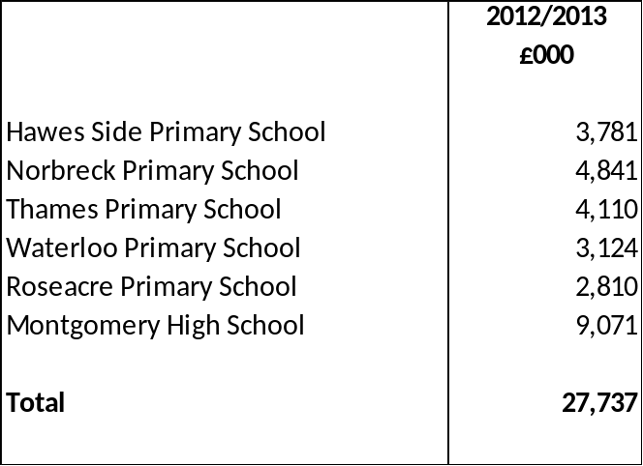
- EVENTS AFTER THE REPORTING PERIOD

The Statement of Accounts was authorised for issue by the Treasurer on 27th June 2013. Events taking place after this date are not reflected in the financial statements and notes. Where events taking place before this date provide information about conditions existing at 31st March 2013, the figures in the financial statements and notes have been adjusted in all material respects to reflect the impact of this information.

- ADJUSTMENT BETWEEN ACCOUNTING BASIS AND FUNDING BASIS UNDER REGULATIONS

This note details the adjustments that are made to the Comprehensive Income and Expenditure recognised by the Authority in the year in accordance with proper accounting practice to the resources that are specified by statutory provisions as being available to the Authority to meet future capital and revenue expenditure.

The following sets out a description of the reserves that the adjustments are made against:-

General Fund Balance

The General Fund is the statutory fund into which all the receipts of an authority are paid and out of which all liabilities of the authority are met, except to the extent that statutory rules might provide otherwise. These rules can also specify the financial year in which liabilities and payments should impact on the General Fund Balance, which is not necessarily in accordance with proper accounting practice. The General Fund Balance therefore summarises the resources that the Council is statutorily empowered to spend on its services or on capital investment (or the deficit of resources that the Council is required to recover) at the end of the financial year. However the balance is not available to be applied in funding HRA services.

Housing Revenue Account

The HRA balance reflects the statutory obligation to maintain a revenue account for local authority council housing provision in accordance with Part VI of the Local Government and Housing Act 1989. It contains the balance of income and expenditure as defined by the 1989 Act, that is available to fund future expenditure in connection with the Council’s landlord function or (where in deficit) that is required to be recovered from tenants in future years.

Major Repairs Reserve

The authority is required to maintain the Major Repairs Reserve which controls the application of the Major Repairs Allowance (MRA). The MRA is restricted to being applied to new capital investment in HRA assets or the financing of historical capital expenditure by the HRA. The balance shows the MRA that has yet to be applied at year end.

Capital Receipts Reserve

The Capital Receipts Reserve holds the proceeds from the disposal of land and other assets, which are restricted by statute from being used other than to fund new capital expenditure or to be set aside to finance historical capital expenditure. The balance on the reserve shows the resources that have yet to be applied for these purposes at the year end.

Capital Grants Unapplied

The Capital Grant Unapplied Account (Reserve) holds the grants and contributions received towards capital projects for which the Council has met the conditions that would otherwise require replacement of monies but which have yet to be applied to meet expenditure. The balance is restricted by grant terms as to capital expenditure against which it can be applied and/or the financial year in which this can take place.

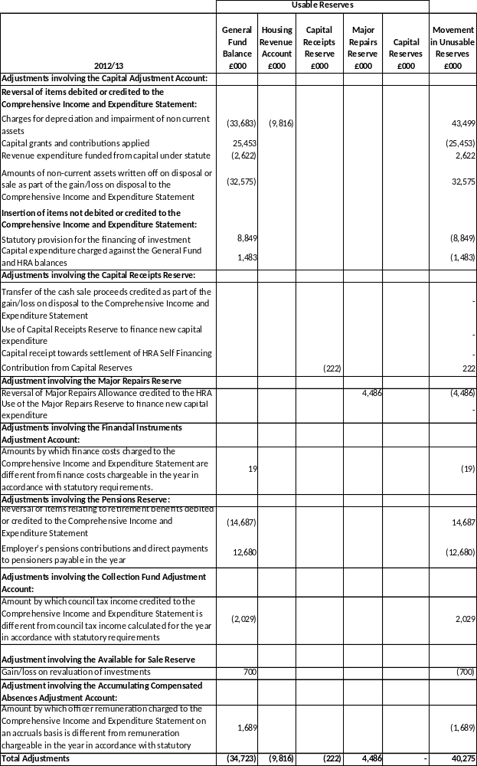
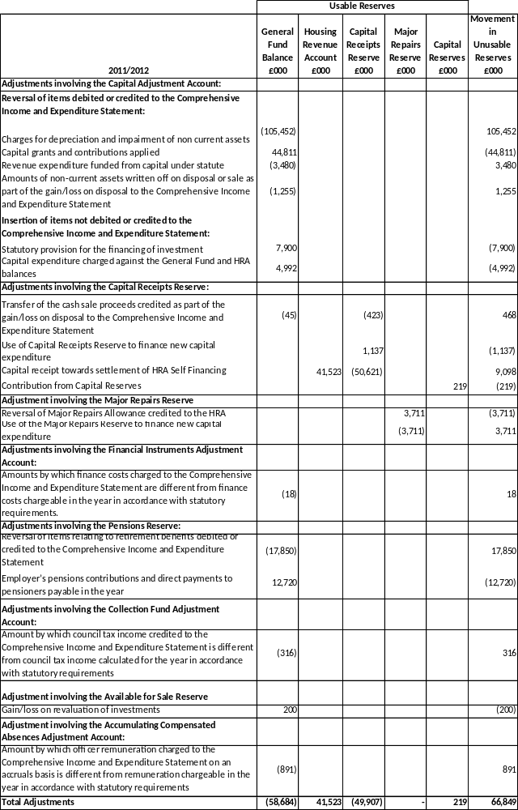

- TRANSFERS TO/FROM EARMARKED RESERVES

This note sets out the amounts set aside from the General Fund and HRA balances in Earmarked Reserves to provide financing for future expenditure plans and the amounts posted back from Earmarked Reserves to meet General Fund and HRA expenditure in 2012/2013.

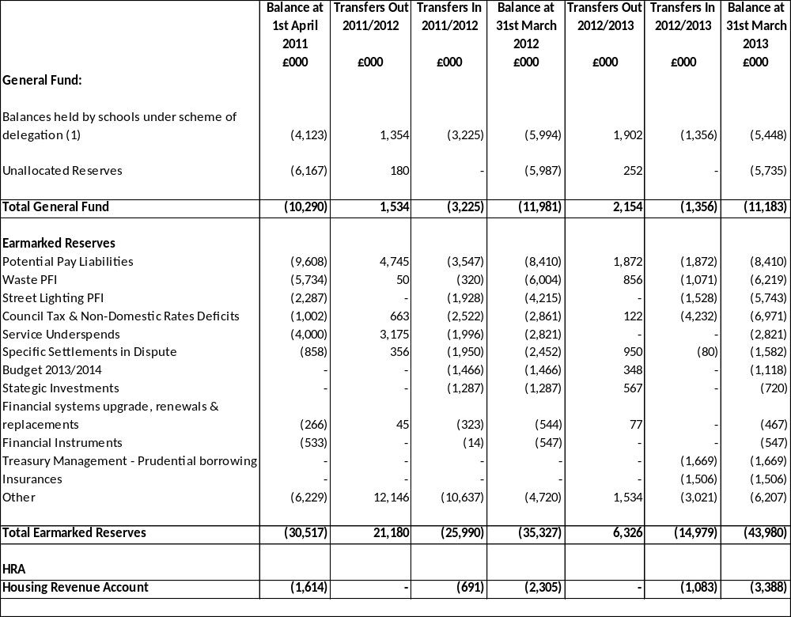
- Such balances are committed to be spent on the Education Service.
- All reserves with balances over £500,000 are shown separately.

- OTHER OPERATING EXPENDITURE

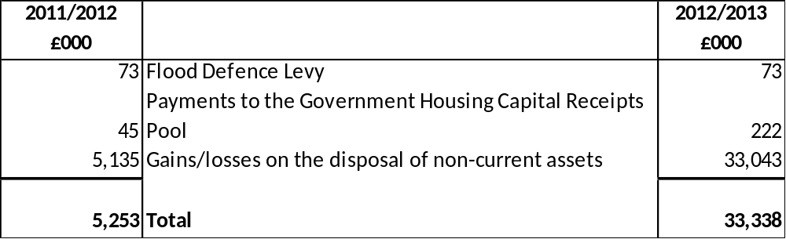

- FINANCING AND INVESTMENT INCOME AND EXPENDITURE

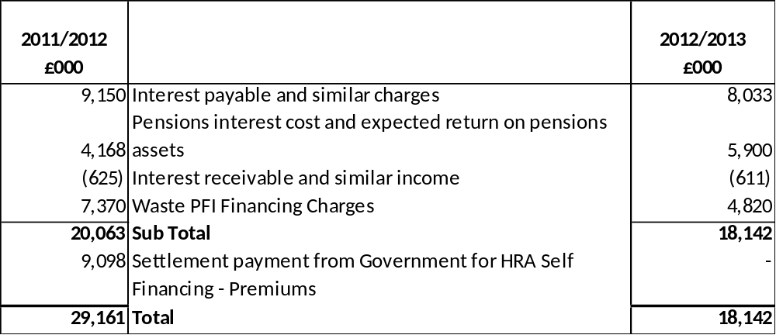

- TAXATION AND NON SPECIFIC GRANT INCOMES

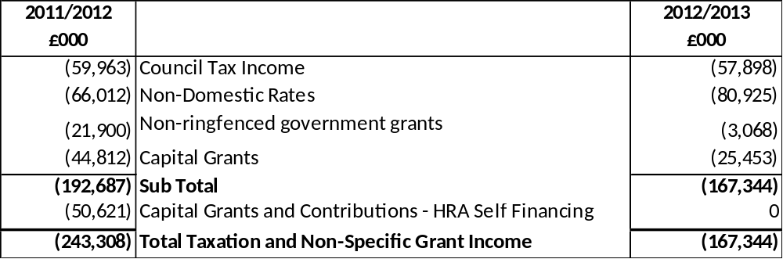

- PROPERTY PLANT AND EQUIPMENT (PPE)

The movements on property, plant and equipment during the year were as follows:-

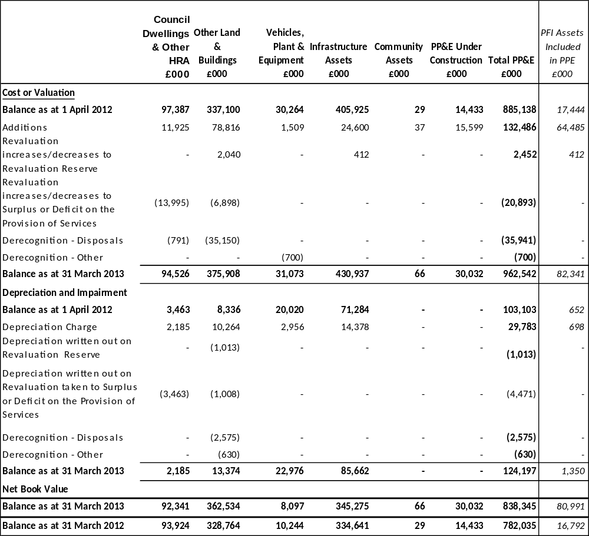

COMPARATIVE MOVEMENTS 2011/2012

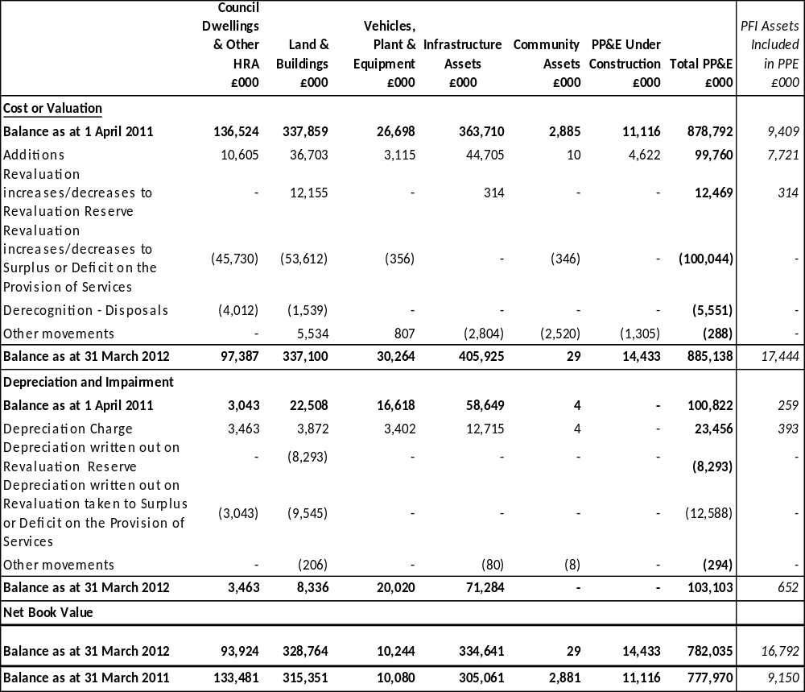

Depreciation

The following assets have been depreciated at varying rates in relation to their useful economic lives:

- Council Dwellings and Other Buildings – straight line allocation over the useful life of the property as estimated by the valuer.
- Plant, Furniture and Equipment – a percentage of the value of each class of asset in the Balance Sheet as advised by a suitably qualified officer
- Infrastructure - straight line allocation over 25 years

The useful economic lives are reviewed at least every four years as is the likely residual value.

Where an item of Property, Plant and Equipment asset has major components whose cost is at least 20% of the total cost of the item, the components are depreciated separately. Only items with a value in excess of £1m were deemed material for component accounting.

Capital Commitments

At 31st March 2013, the Council has entered into a number of contracts for the construction or enhancement of Property, Plant and Equipment in 2013/2014 and future years budgeted to cost £10m. Similar commitments at 31st March 2012 were £18m. The major commitment is relation to the Central Business District Scheme.
Effects of Changes in Estimates

In 2010/2011, the Council made a material change to its accounting estimates for Property, Plant and Equipment in relation to the implementation of IFRS. This manifested itself in the following process being undertaken.

- Identifying properties with a value in excess of de minimis levels (£1m)
- Separating these properties into components
- These components were to account for at least 20% of the value of the property
- A component is identified where it meets the above criteria and has a different useful economic life than the main structure.

The valuation of these properties entailed valuers breaking the property down into components, so that differing depreciation rates could be applied to the elements of a property according to their own particular useful economic life.

Revaluations

The Council carries out a rolling programme that ensures that all Property, Plant and Equipment required to be measured at fair value is revalued at least every four years. Valuations were carried out both internally and externally during 2012/2013. These valuations of land and buildings were carried out in accordance with the methodologies and bases for estimation set out in the professional standards of the Royal Institution of Chartered Surveyors. Valuations of vehicles, plant, furniture and equipment are based on current prices where there is an active second-hand market or latest list prices adjusted for the condition of the asset.

The significant assumptions in estimating fair values are:-

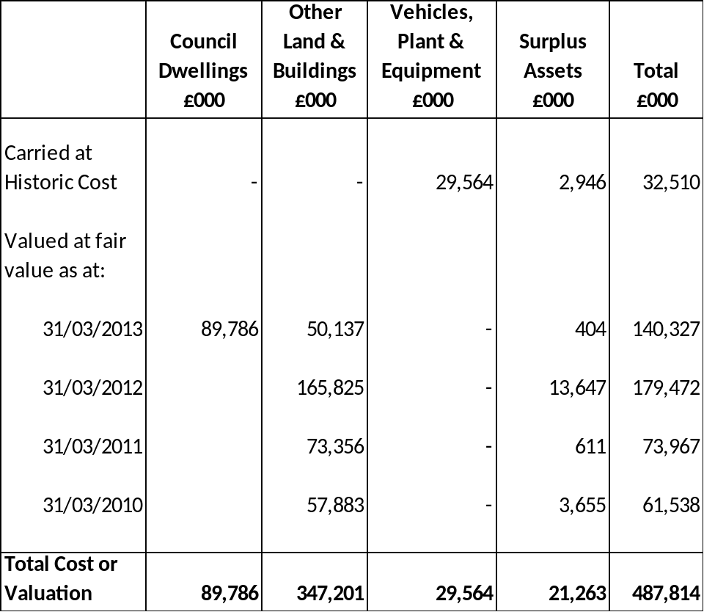

Component Accounting

Council Dwellings

Within the Net Book Value of Assets – Council Dwellings (Note12) are the following assets which have been accounted for on a component basis. This means they are written off according to their own unique economic life.

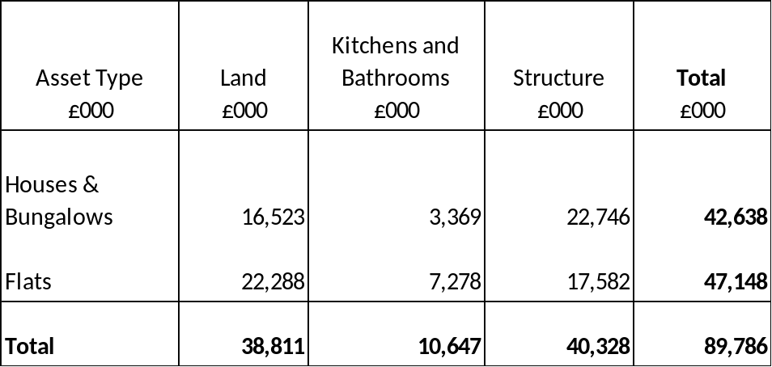

Other Land and Buildings

Items valued at £1m and above have been subject to component accounting. A component must be worth at least 20% of the value of the asset. The valuations are on a 4 year rolling programme, the items valued in 2012/2013 and are now included on a component basis are shown below. The total value of assets within land and buildings that have been valued on a component basis is £51.4m and this represents 14% of the total land and buildings.

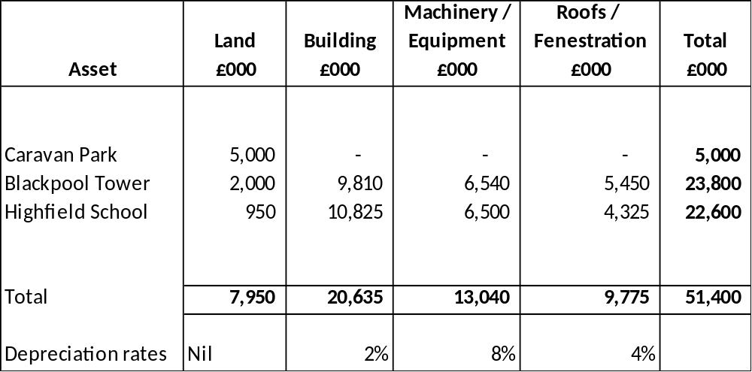

- HERITAGE ASSETS

Reconciliation of the carrying value of heritage assets held by the Authority is as follows;

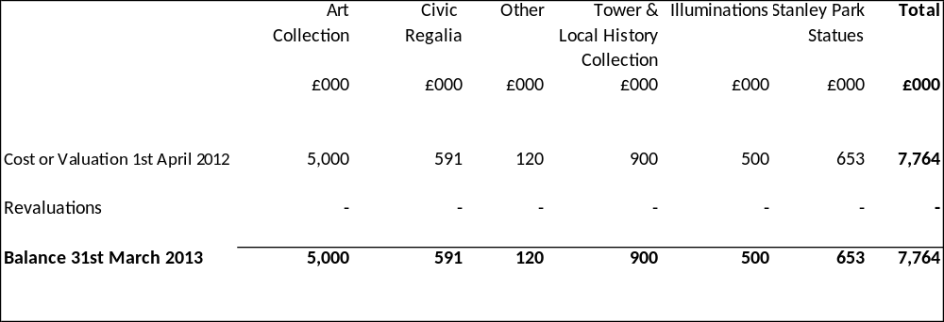

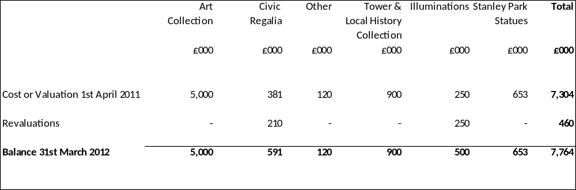

Art Collection

The Authority’s Art Collection has not been formally valued for a number of years but insurance valuations have been used for the balance sheet.

Civic Regalia

The Authority’s civic regalia was valued as at 31st March 2012 by an external valuer. The valuations were based on commercial markets.

Cenotaph

This was previously classed as a community asset and is valued by external valuers every 4 years.

Tower & Local Historical Collection

This has been valued by the Head of Heritage as at 31st March 2012.

Illuminations

These assets have been valued by the Illuminations Manager as at 31st March 2012

Statues

Insurance valuations have been used for the purposes of valuing these assets. The valuations are as at 31st March 2012.

- INVESTMENT PROPERTIES

The following items of income and expense have been accounted for in the Financing and Investment Income and Expenditure line in the Comprehensive Income and Expenditure Statement.

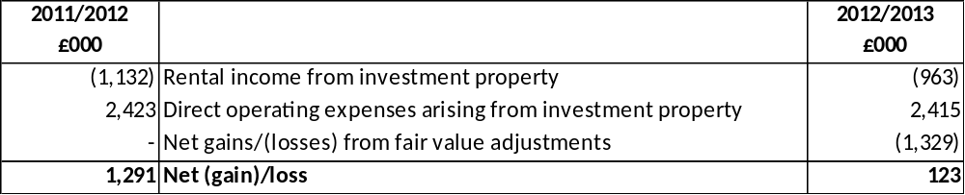

There are no restrictions on the Authority’s ability to realise the value of its investment property or on the Authority’s right to the remittance of income and the proceeds of disposal. The Authority has no contractual obligations to purchase, construct or develop investment property or repairs, maintenance and enhancement.
The following table summarises the movement in the fair value of investment properties over the year.

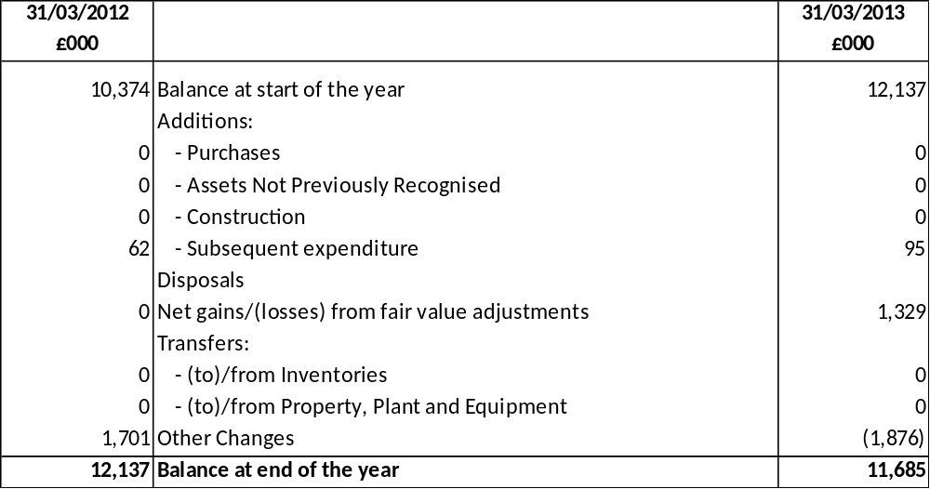

- INTANGIBLE ASSETS

The Authority accounts for its software as intangible assets, to the extent that the software is not an integral part of a particular IT system and accounted for as part of the hardware item of Property, Plant and Equipment. The intangible assets include purchased software licenses.

All software is given a finite useful life based on the assessments of the period that the software is expected to be use of to the Authority. The useful lives assigned to major software suites used by the Authority are 5 years.

The movement in intangible asset balances during the year is as follows:
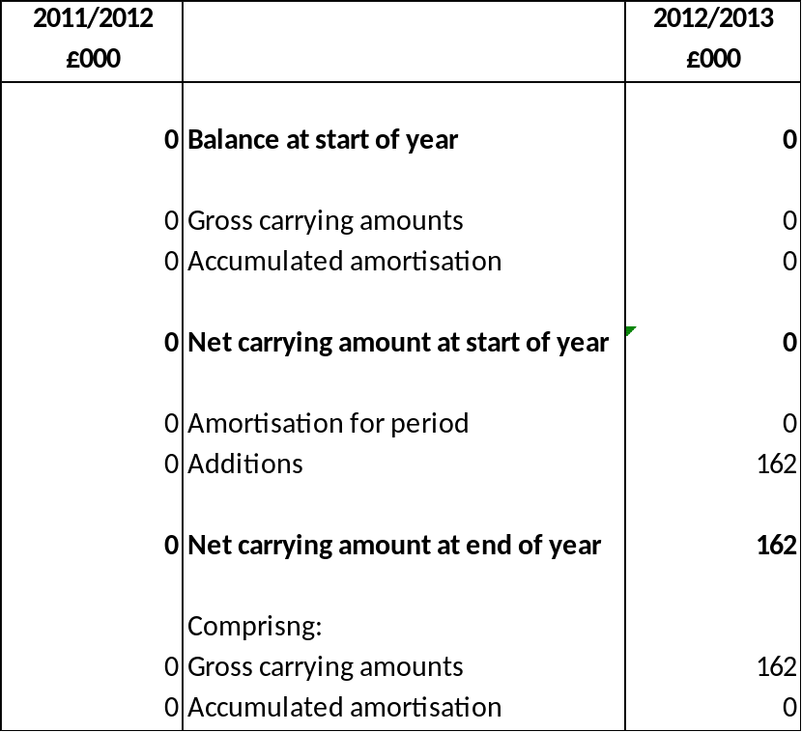
16. ASSETS HELD FOR SALE

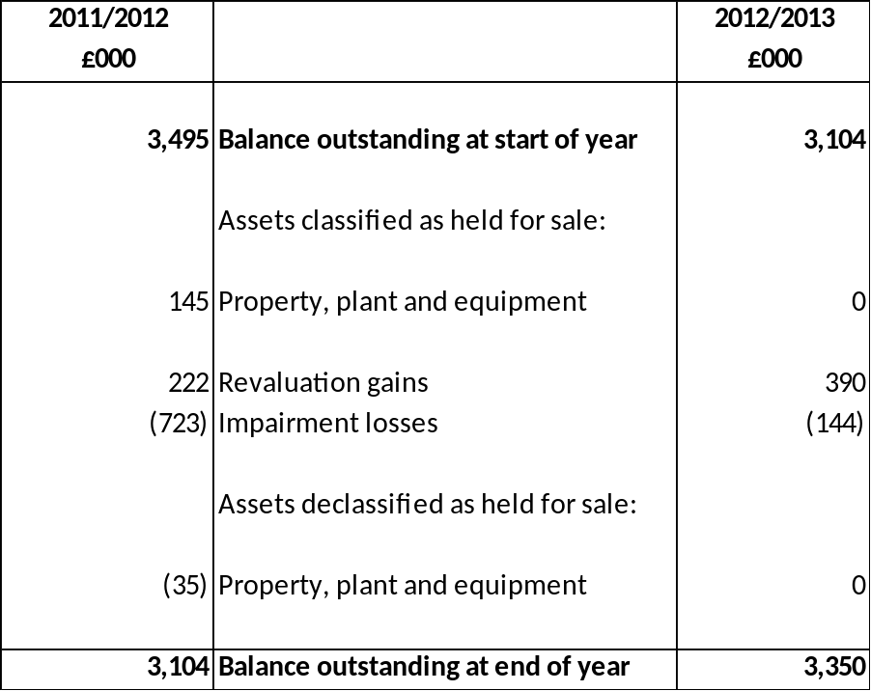
- FINANCIAL INSTRUMENTS

Categories of Financial Instruments

The following categories of financial instruments are carried in the Balance Sheet:
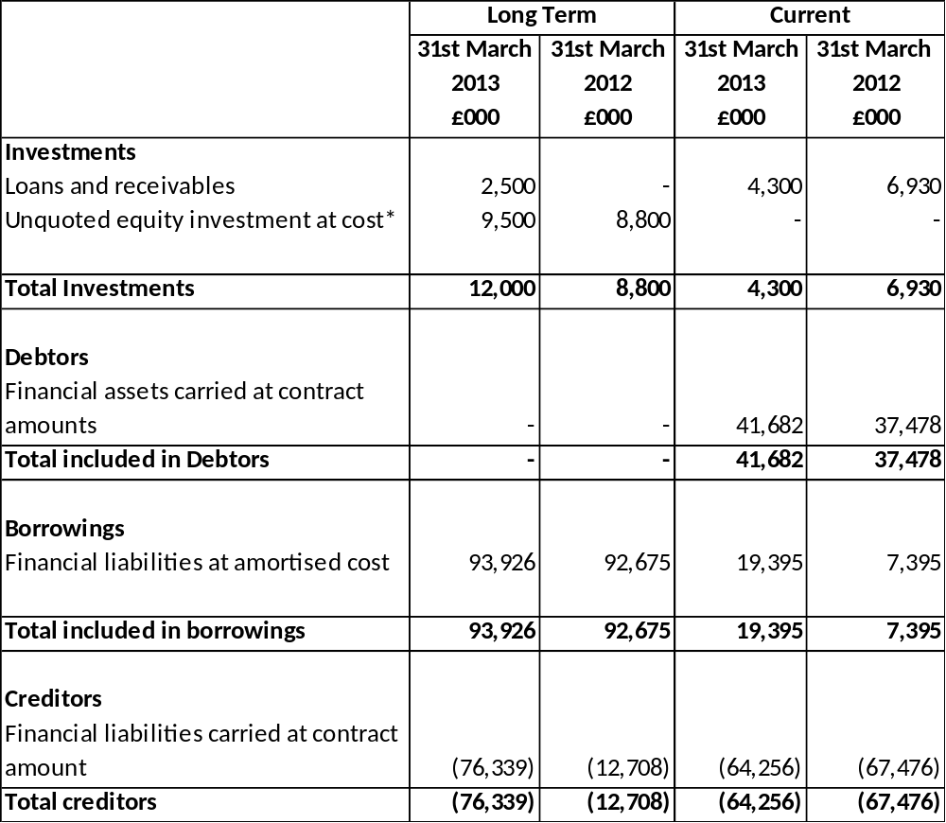

*= shares in Blackpool Transport Services

Material Soft Loan made by the Authority to Lancashire County Developments

Upon Local Government Reorganisation in 1998 the Authority took over a 10% share in a loan made to Lancashire County Developments by Lancashire County Council. The loan was due to be repaid in full in 2010/2011 but Lancashire County Council re-negotiated the loan and it is now due to be repaid in 2031. Under requirements of IAS 32 this loan has been revalued to fair value. The original amount of the loan was £721,000. The fair value of the loan in 2011/2012 was £310,000 (£297,000 in 2010/2011).

The interest rate at which the fair value of this soft loan has been made is arrived at by taking the authority’s prevailing cost of borrowing and adding an allowance for the risk that the loan might not be repaid, in this case a zero rate.

Employee Car Loans
The authority makes loans for car purchase to 24 employees in the authority who are in posts that require them to drive regularly on the authority’s business. Interest is charged on the loans at 5.5%.

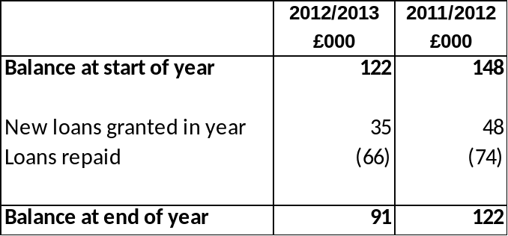

Income, Expense, Gains and Losses

(1) Available for Sale Assets – The Council holds all of the shares in Blackpool Transport Services Ltd which operates buses and trams within the Blackpool area. The shares cost £2,789,000. The fair value of the shares, based on the accounts to 31st March 2013 is £8.8m.

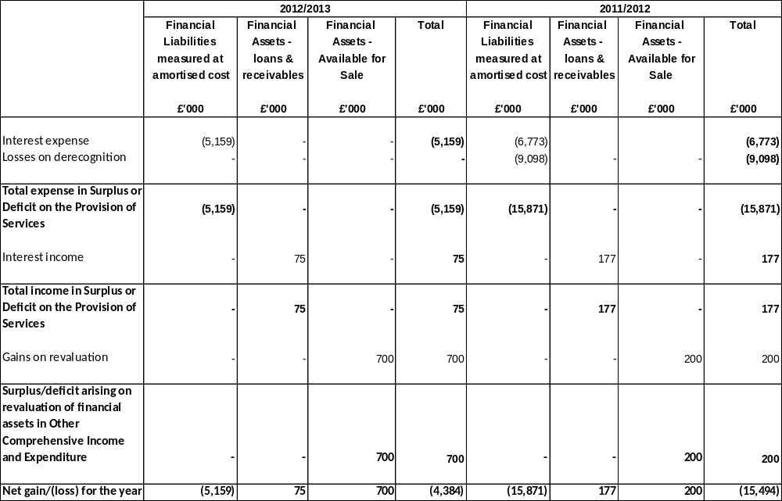

Fair Values of Assets and Liabilities

Financial liabilities, financial assets represented by loans and receivables and long-term debtors and creditors are carried in the Balance Sheet at amortised cost. Their fair value can be assessed by calculating the present value of the cash flows that will take place over the remaining term of the instruments, using the following assumptions:

- Estimated ranges of interest rates at 31st March 2013 of 0.02% to 3.13% for loans from the PWLB and 0.47% to 3.05% for other loans receivable and payable, based on new lending rates for equivalent loans at that date
- no early repayment or impairment is recognised
- where an instrument will mature in the next 12 months, carrying amount is assumed to be approximate to fair value
- the fair value of trade and other receivables is taken to be the invoiced or billed amount.

The fair values calculated as follows:

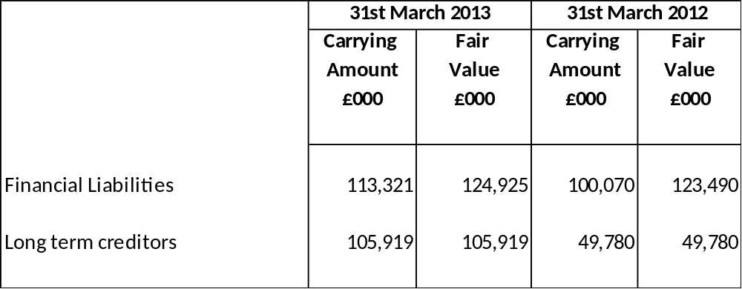

The fair value of the liabilities is higher than the carrying amount because the Authority’s portfolio of loans includes a number of fixed rate loans where the interest rate payable is higher than the prevailing rates at the Balance Sheet date. This shows a notional future loss (based on economic conditions at 31 March 2013) arising from a commitment to pay interest to lenders above current market rates.

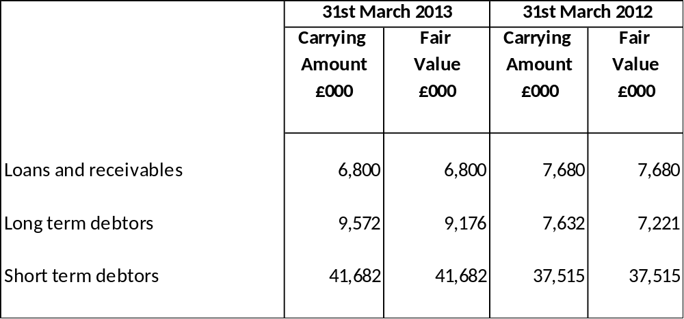

The fair value of the assets is lower than the carrying amount because the Authority’s portfolio of investments includes a number of fixed rate loans where the interest rate receivable is lower than the rates available for similar loans at the Balance Sheet date. This shows a notional future loss (based on economic conditions at 31 March 2013) attributable to the commitment to receive interest below current market rates.

Available for sale assets and assets and liabilities at fair value through profit and loss are carried in the Balance Sheet at their fair value. These fair values are based on public price quotations where there is an active market for the instrument.

Short term debtors and creditors are carried at cost as this is a fair approximation of their value.

- LONG-TERM INVESTMENTS

BLACKPOOL TRANSPORT SERVICES LIMITED

Investments in Blackpool Transport Services Limited consist of share capital (£2,789,000 at historic cost) in the company which was set up in accordance with the provisions of the Transport Act 1985 to operate the Council’s municipal bus operation. The company provides a comprehensive passenger transport service in the Fylde coast area through its bus and tram operations. The Council leases the tramway and associated premises to Blackpool Transport Services Limited and as landlord is obliged to maintain the tramway and attend to exterior repairs to the depot and offices. The company is wholly owned by the Council.
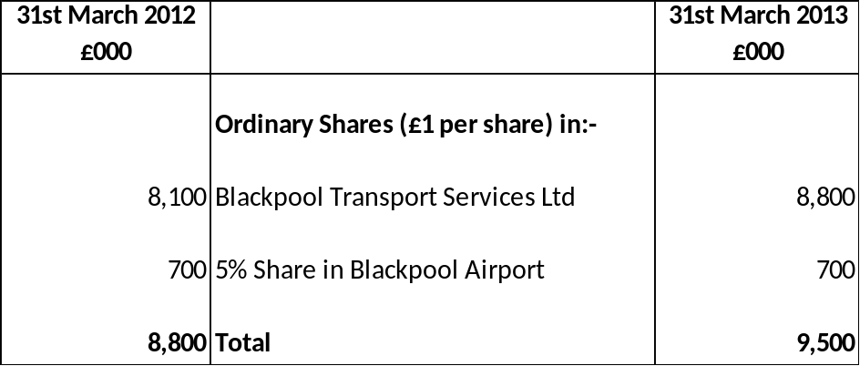

The quoted market share prices, similar comparative companies and the audited accounts of Blackpool Transport Services have been used as the basis upon which to arrive at a formal valuation for the Council’s shareholding of the company. The investment value included within the Council’s balance sheet represents the value of Total Equity Shareholder Funds. In 2012/2013 there was an increase in value of £700,000. All profit and losses on revaluation are credited or charged to the Available for Sale Reserve via the Movement in Reserves Statement.
BLACKPOOL AIRPORT
Upon the sale of Blackpool Airport to City Hopper Airports the Council retained a 5% share in the Airport.
BLACKPOOL OPERATING COMPANY LTD (SANDCASTLE WATERPARK)
The Council purchased the operation of the centre from a private company on 20th June 2003 and now wholly owns both the building and the commercial operator - Blackpool Operating Company Limited (BOC). The Council’s shares in Blackpool Operating Company are valued at £2.

As 100% shareholders Blackpool Council agrees to meet all accumulated deficits or losses of Blackpool Transport Services Limited and Blackpool Operating Company.

19. LONG-TERM DEBTORS

Long-term debtors relate to amounts that are due to be repaid in over twelve months time. These include a share in land held for use under the Lancashire Waste Private Finance Initiative, care and repair loans and staff car loans.

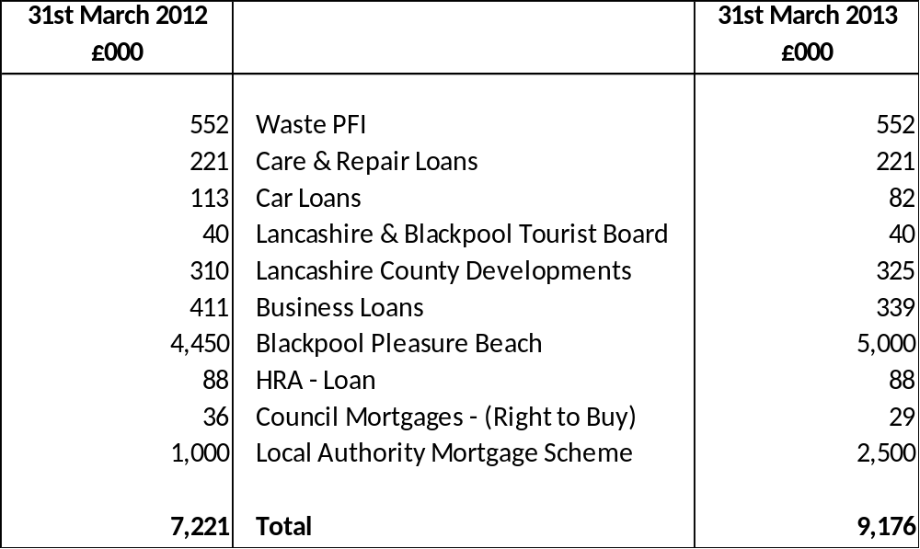

Waste PFI

The total value of land held under the PFI contract at current market value is estimated at £4.415m. Under the terms of the Joint Working Agreement, Blackpool Council will be due a 12.5% share of this at the end of the PFI contract.

Care and Repair Loans

These are loans to council tenants for home improvements and repairs to be paid back over a number of years

Car Loans

The number of outstanding long-term car loans at 31st March 2013 was 24 (27 as at 31 March 2012).See note 17 for breakdown.

Lancashire and Blackpool Tourist Board

The loan to Lancashire and Blackpool Tourist Board was issued in January 2008. The loan is interest free and due to be repaid in January 2018.

Lancashire County Developments

The loan to Lancashire County Developments was due to be repaid in full in 2010/2011, Lancashire County Council re-negotiated the loan which is now due to be repaid in 2031. Under requirements of IAS 32 this loan has been revalued to fair value. The original amount of the loan was £721,000. The fair value of the loan in 2012/2013 was £325,000 (£310,000 in 2011/2012). The movement in fair value of £14,000 has been charged to the Comprehensive Income and Expenditure Account and then transferred to the Financial Instruments Adjustment Account via Movement in Reserves. This does not affect the loan repayment due to the authority in 2031.

The car loans and loan to Lancashire and Blackpool Tourist Board have not been recalculated to fair value due to the immaterial amounts.

Business Loans

In 2009/2010 the Council set up a £3m fund for businesses to safeguard and create jobs and help Blackpool get through the recession. The aim of the fund is to provide a lifeline for local, normally sound businesses that are currently experiencing difficulty in getting finance from the banks because of the global slow down. These loans have been divided into four categories:

  - Retail – loans of £5,000 to assist businesses and premises in a defined Town Centre Area
  - Promenade – loans of £5,000 to help businesses situated between Central and North Pier
  - Investment Fund – up to £150,000 loans for businesses that are growing or planning to invest in Blackpool thereby bringing new jobs to the town.
  - Credit Crunch – this loan fund applies to good and sound businesses experiencing cash flow problems but not within other categories.

There were no new loans issued in 2012/2013.

Blackpool Pleasure Beach

In 2010/2011 the authority granted a loan of £5m to Blackpool Pleasure Beach towards the development of Nickelodeon Land. The loan is due to be repaid by September 2018 and interest is charged at the market rate.

Local Authority Mortgage Scheme

In 2011/2012 the authority advanced £1m with Lloyds Banking Group as part of the Local Authority Mortgage Scheme. This scheme is aimed at first time buyers within Blackpool and the advance reflects the authority’s share of financial assistance through the provision of an indemnity. This indemnity will be in place for a fixed five-year period, at which point the advance will be returned to the authority.

In 2012/2013 the scheme was extended with a further £1m being advanced to Lloyds Banking Group and £500,000 advanced to Leeds Building Society.

20. INVENTORIES

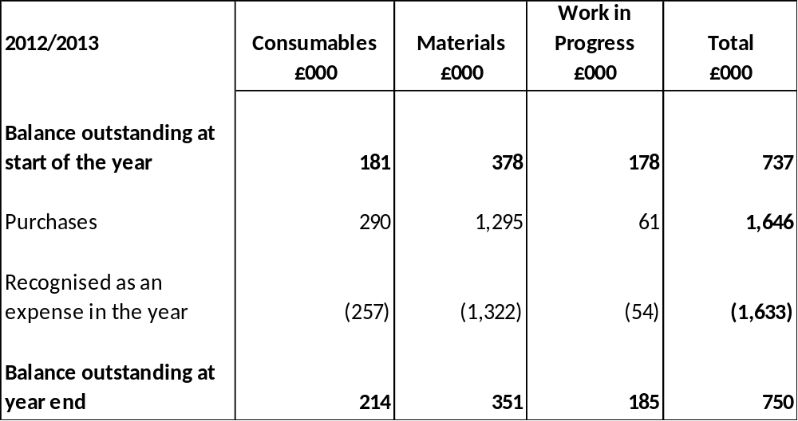

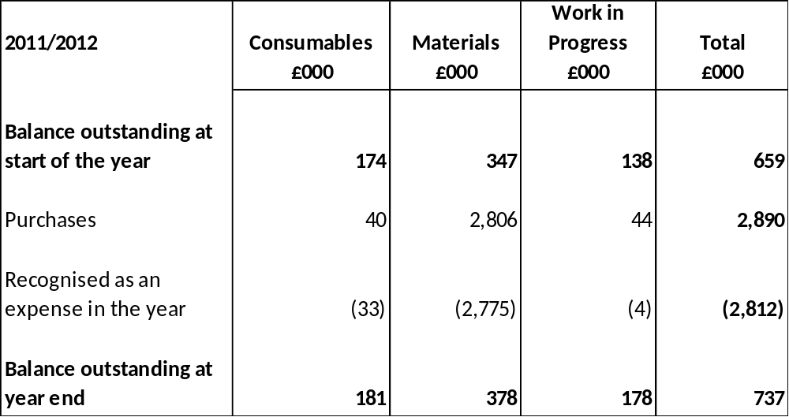

21. DEBTORS

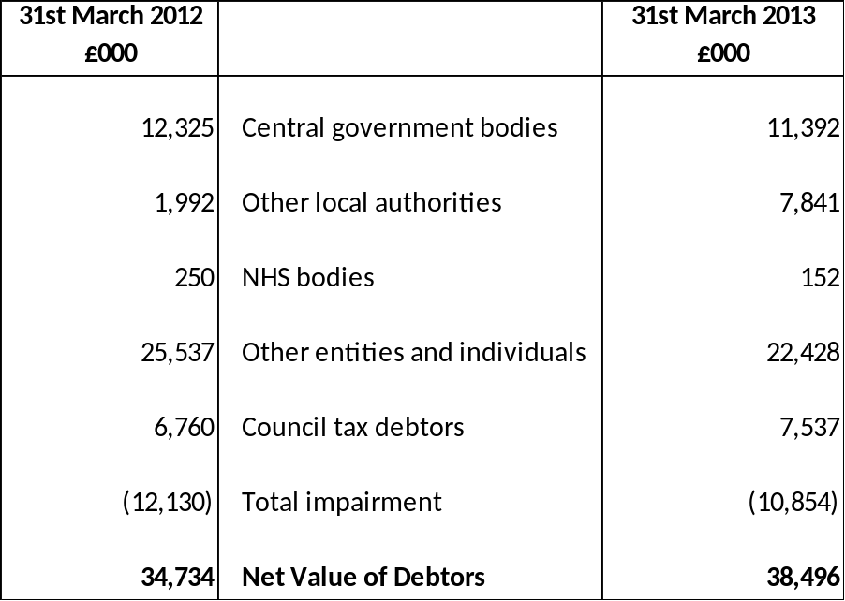

In 2012/2013 debtors relating to the Collection Fund included council tax arrears of £8.1m (£7.9m in 2011/2012) of which £1.1m was attributable to precepting authorities. Non-domestic rate arrears were £4.1m (£4.7m in 2011/12).
22. PAYMENTS IN ADVANCE

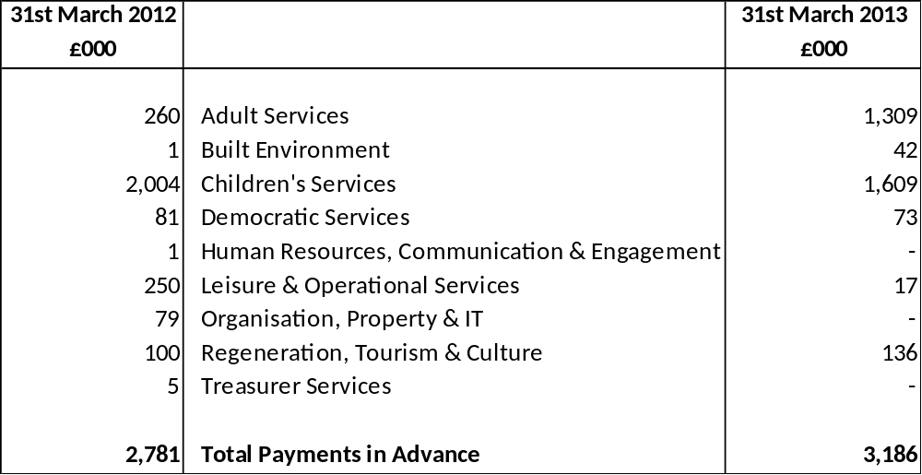

23. CASH AND CASH EQUIVALENTS

The balance of cash and cash equivalents is made up of the following elements:

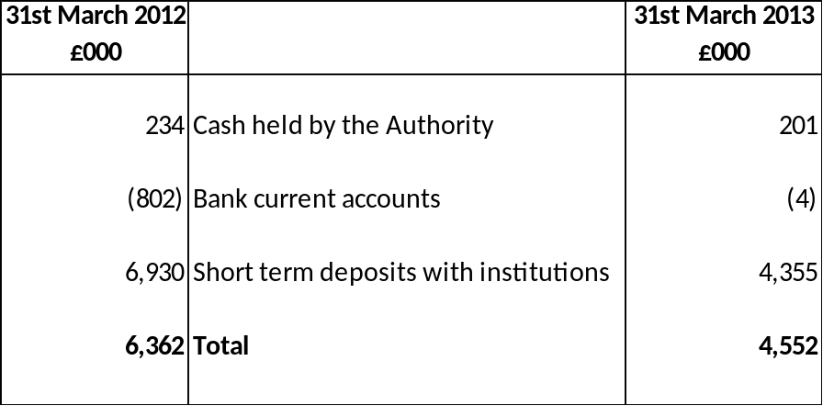

24. RECEIPTS IN ADVANCE

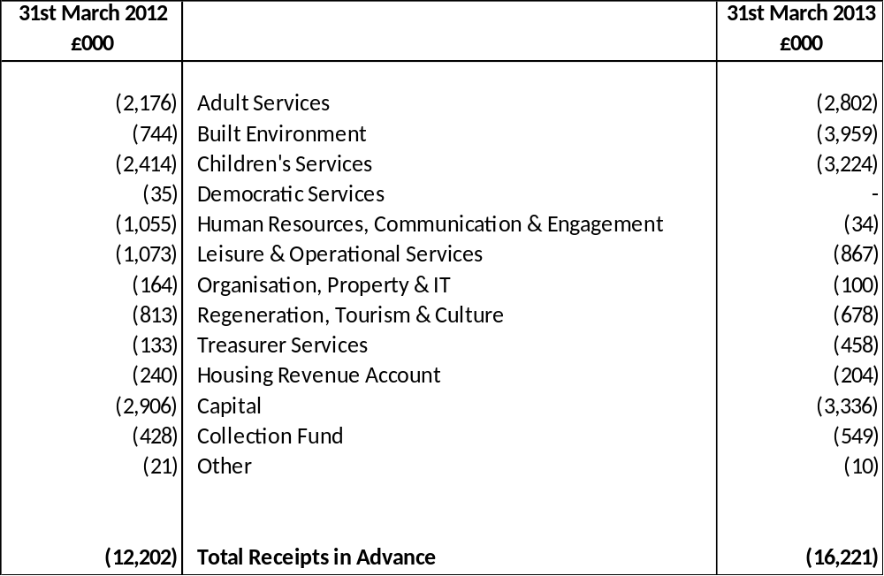

25. CREDITORS

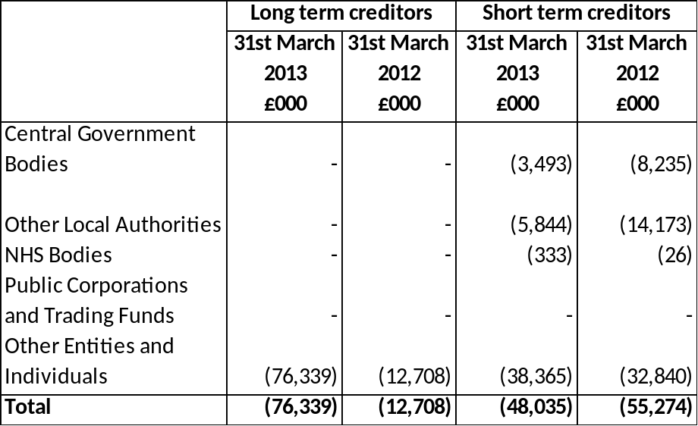

26. PROVISIONS

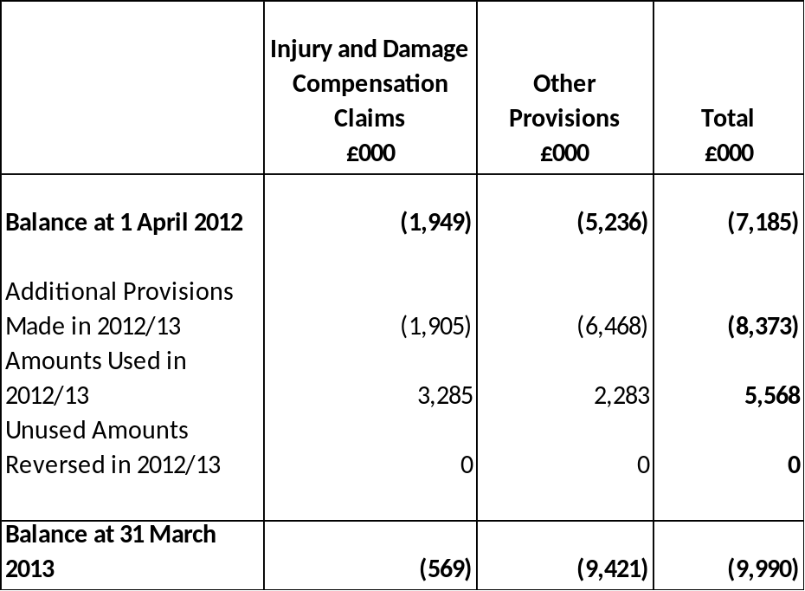

 | Injury and Damage Compensation Claims  £000 | Other Provisions  £000 | Total  £000
Balance at 1 April 2011 | (1,380) | (3,494) | (4,874)
Additional Provisions Made in 2011/12 | (569) | (4,685) | (5,254)
Amounts Used in 2011/12 | - | 2,848 | 2,848
Unused Amounts Reversed in 2011/12 | 0 | 95 | 95
Balance at 31 March 2012 | (1,949) | (5,236) | (7,185)

Outstanding legal cases

Injury Compensation Claims

Most of the injury compensation claims are individually insignificant. Significant claims are detailed in Note 3. They relate to personal injuries sustained where the Authority is alleged to be at fault (e.g. through failure to repair a road or pavement properly). Provision is made for those claims where it is deemed probable that the Authority will have to make settlement, based on past experience of court decisions about liability and the amount of damages payable. All outstanding claims are expected to be settled by 2013/2014. The Authority may be reimbursed by its insurers, but until claims are actually settled no income is recognised.

Other provisions

All other provisions are individually insignificant.

27. USABLE RESERVES

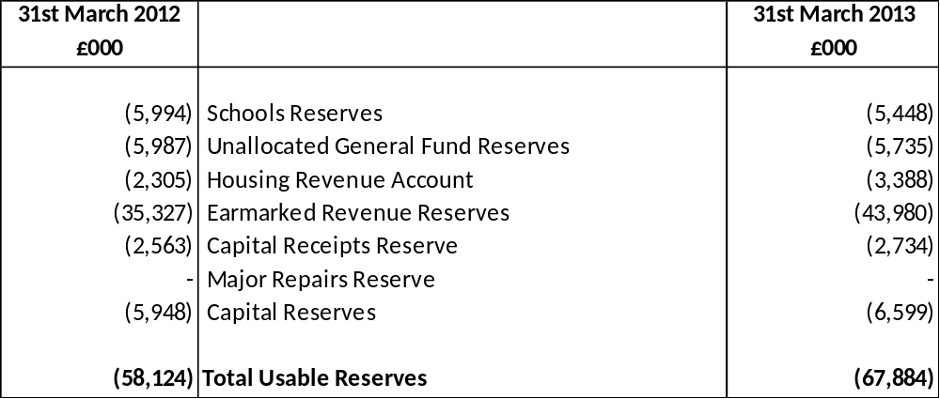

28. UNUSABLE RESERVES

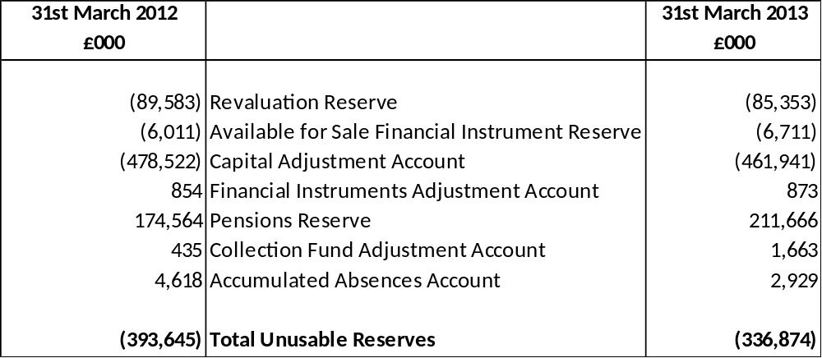

Revaluation Reserve

The Revaluation Reserve contains the gains made by the Authority arising from increases in the value of its Property, Plant and Equipment. The balance is reduced when assets with accumulated gains are:

- revalued downwards or impaired and the gains are lost
- used in the provision of services and the gains are consumed through depreciation, or
- disposed of and the gains are realised.

The Reserve contains only revaluation gains accumulated since 1 April 2007, the date that the Reserve was created. Accumulated gains arising before that date are consolidated into the balance on the Capital Adjustment Account.

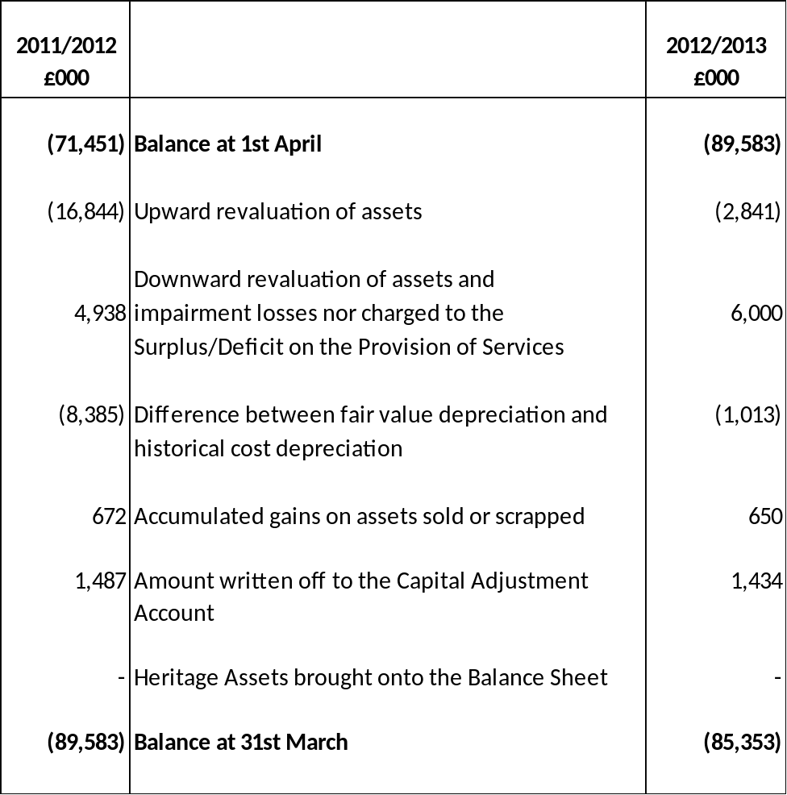

Available for Sale Financial Instruments Reserve

The Available for Sale Financial Instruments Reserve contains the gains made by the Authority arising from increases in the value of its investments that have quoted market prices or otherwise do not have fixed or determinable payments. The balance is reduced when investments with accumulated gains are:

- revalued downwards or impaired and the gains are lost
- disposed of and the gains are realised

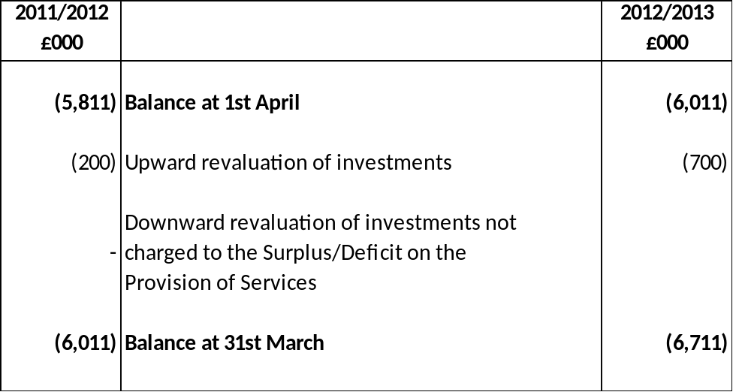

Capital Adjustment Account

The Capital Adjustment Account absorbs the timing differences arising from the different arrangements for accounting for the consumption of non-current assets and for financing the acquisition, construction or enhancement of those assets under statutory provisions. The Account is debited with the cost of acquisition, construction or enhancement as depreciation, impairment losses and amortisations are charged to the Comprehensive Income and Expenditure Statement (with reconciling postings from the Revaluation Reserve to convert fair value figures to a historical cost basis). The Account is credited with the amounts set aside by the Authority as finance for the costs of acquisition, construction and enhancement.

The Account contains accumulated gains and losses on Investment Properties and gains recognised on donated assets that have yet to be consumed by the Authority.

The Account also contains revaluation gains accumulated on Property, Plant and Equipment before 1 April 2007, the date that the Revaluation Reserve was created to hold such gains.

Note 7 provides details of the source of all the transactions posted to the Account, apart from those involving the Revaluation Reserve.

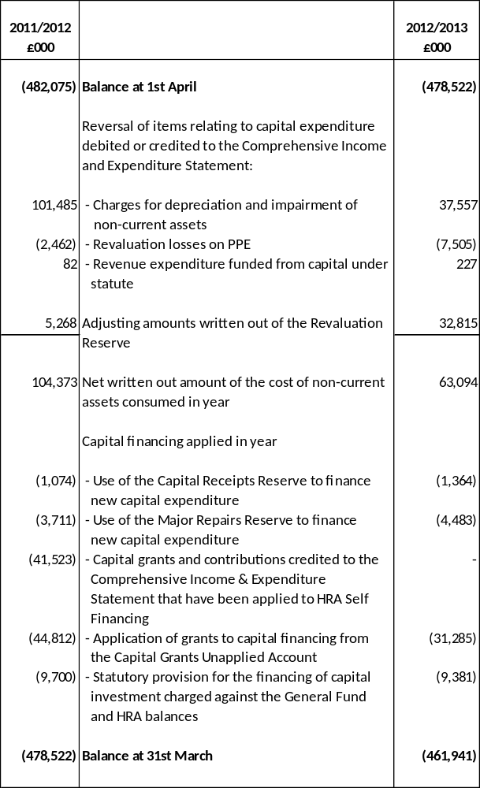

Financial Instruments Adjustment Account

The Financial Instruments Adjustment Account absorbs the timing differences arising from the different arrangements for accounting for income and expenses relating to certain financial instruments and for bearing losses or benefiting from gains per statutory provisions.

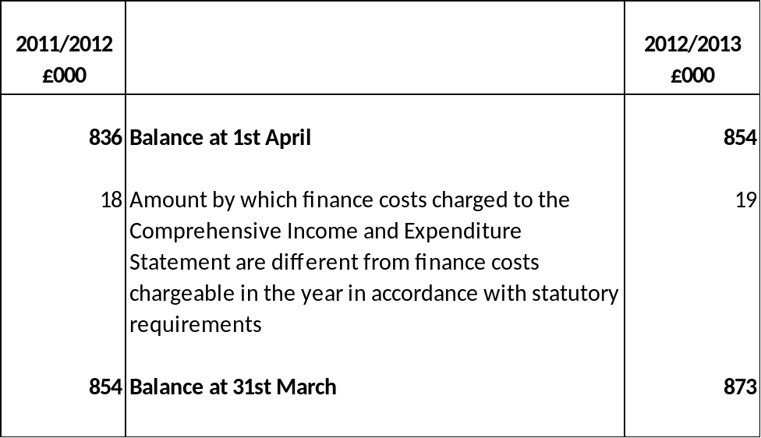

Pensions Reserve

The Pensions Reserve absorbs the timing differences arising from the different arrangements for accounting for post employment benefits and for funding benefits in accordance with statutory provisions. The Authority accounts for post employment benefits in the Comprehensive Income and Expenditure Statement as benefits are earned by employees accruing years of service, updating the liabilities recognised to reflect inflation, changing assumptions and investment returns on any resource set aside to meet costs. However, statutory arrangements require benefits earned to be financed as the Authority makes employer’s contributions to pension funds or eventually pays any pensions for which it is directly responsible. The debit balance on the Pensions Reserve therefore shows a substantial shortfall in the benefits earned by past and current employees and the resources the Authority has set aside to meet them. The statutory arrangements will ensure that funding will have been set aside by the time the benefits come to be paid.

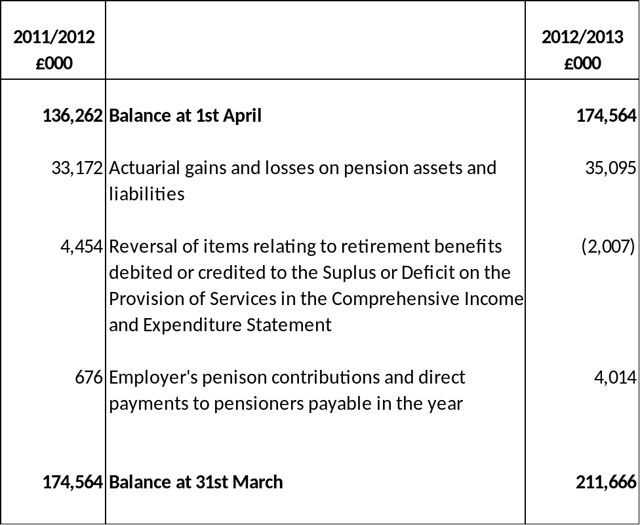

Collection Fund Adjustment Account

The Collection Fund Adjustment Account manages the differences arising from the recognition of council tax income in the Comprehensive Income and Expenditure Statement as it falls due from the council tax payers compared with statutory arrangements for paying across amounts to the General Fund from the Collection Fund.

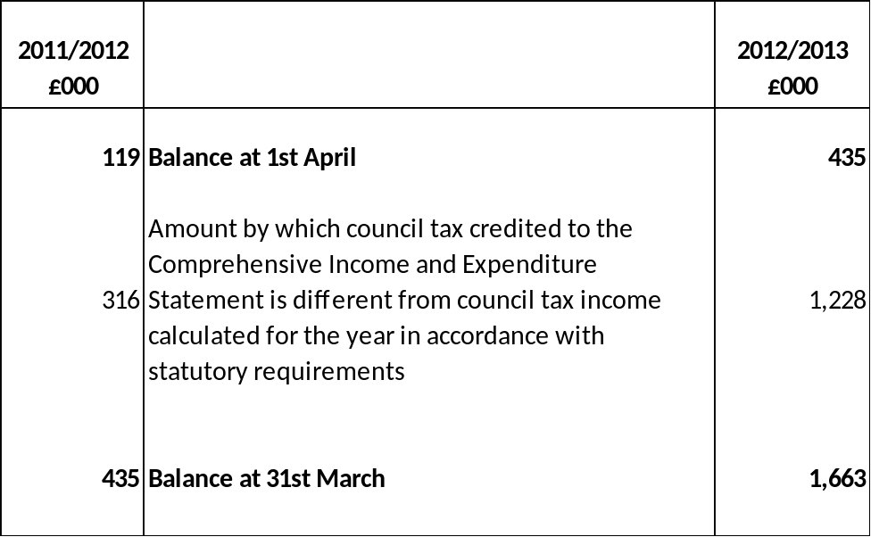

Accumulated Absences Account

The Accumulated Absences Account absorbs the differences that would otherwise arise on the General Fund Balance from accruing for compensated absences earned but not taken in the year eg annual leave entitlement carried forward at 31 March. Statutory arrangements require that the impact on the General Fund Balance is neutralised by transfers to or from the Account.

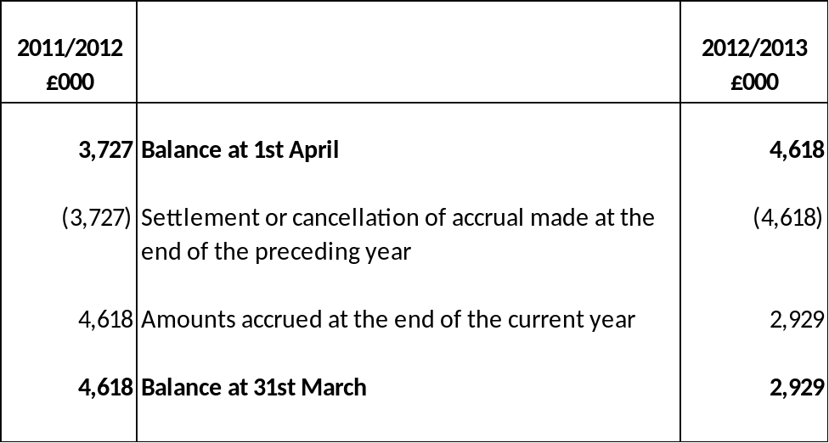

29. CASH FLOW STATEMENT – OPERATING ACTIVITIES

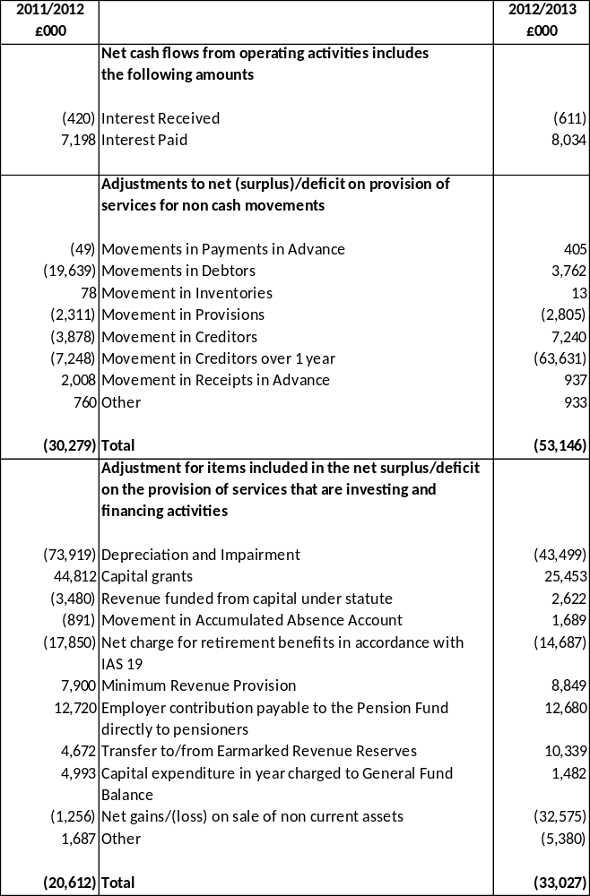

30 CASH FLOW STATEMENT - INVESTING ACTIVITIES

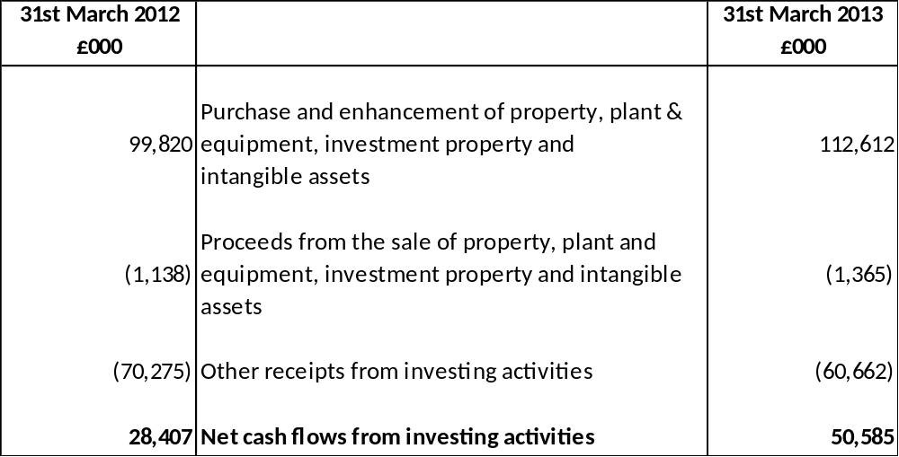

31. CASH FLOW STATEMENT – FINANCING ACTIVITIES

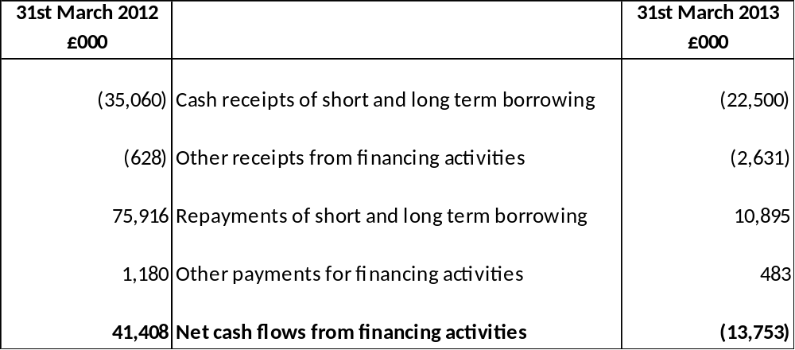

32. CASH FLOW STATEMENT – CASH & CASH EQUIVALENTS

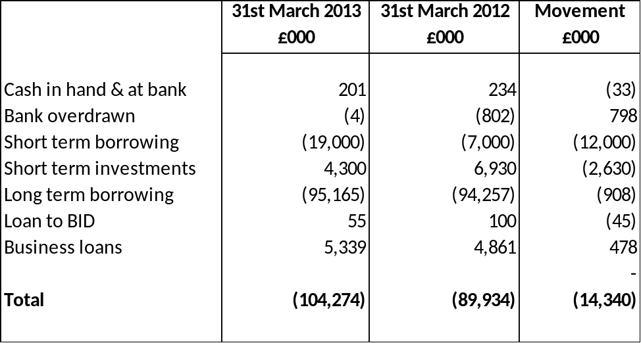

33. AMOUNTS REPORTED FOR RESOURCES ALLOCATION DECISIONS

The analysis of income and expenditure by service on the face of the Comprehensive Income and Expenditure Statement is that specified by the Service Reporting Code of Practice. However, decisions about resource allocation are taken by the Councils Executive Committee on the basis of budget reports analysed across the directorates. These reports are prepared on a different basis from the accounting policies used in the financial statements. In particular:

- no charges are made in relation to capital expenditure (whereas depreciation, revaluation and impairment losses in excess of the balance on the Revaluation Reserve and amortisations are charged to services in the Comprehensive Income and Expenditure Statement)
- the cost of retirement benefits is based on cash flows (payment of employer’s pensions contributions) rather than current service cost of benefits accrued in the year
- expenditure on some support services is budgeted for centrally and not charged to directorates.

The income and expenditure of the Authority’s departments recorded in the budget reports for the year is as follows:

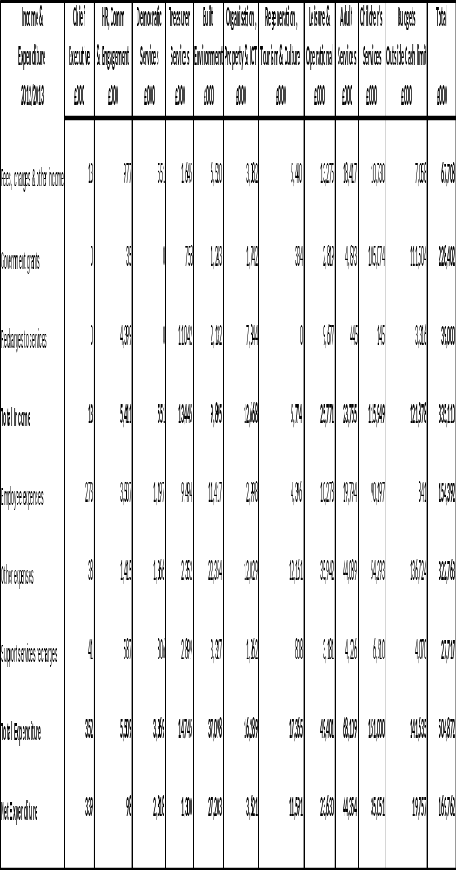

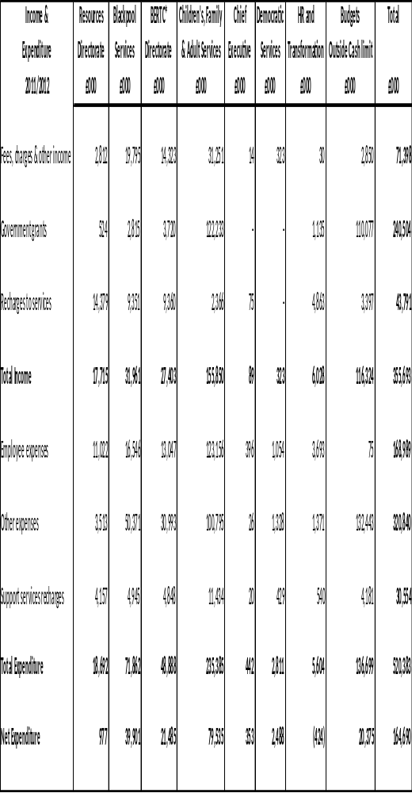

Reconciliation of the Departments Income and Expenditure to Cost of Services in the Comprehensive Income and Expenditure Statement

This reconciliation shoes how the figures in the analysis of department income and expenditure relate to the amounts included in the Comprehensive Income and Expenditure Statement.

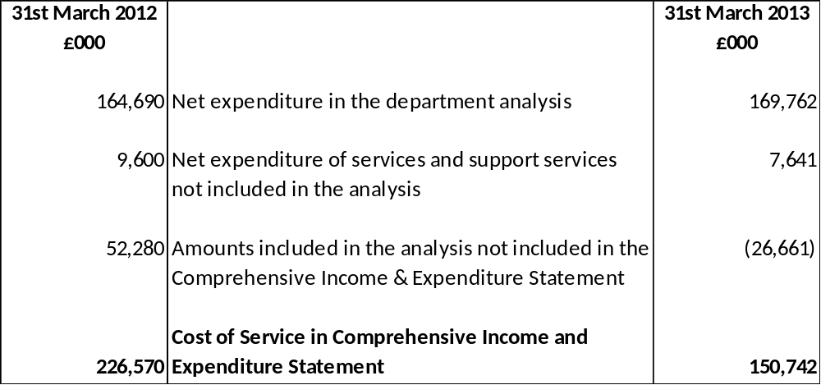

Reconciliation to the Subjective Analysis

This reconciliation shows how the figures in the analysis of department income and expenditure relate to a subjective analysis of Surplus or Deficit on the Provision of Services included in the Comprehensive Income and Expenditure Statement.

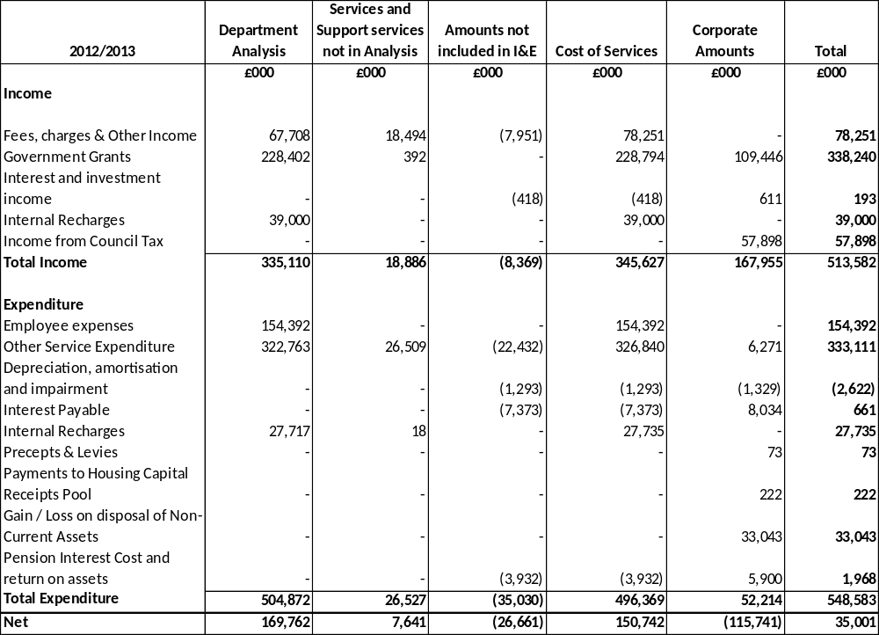

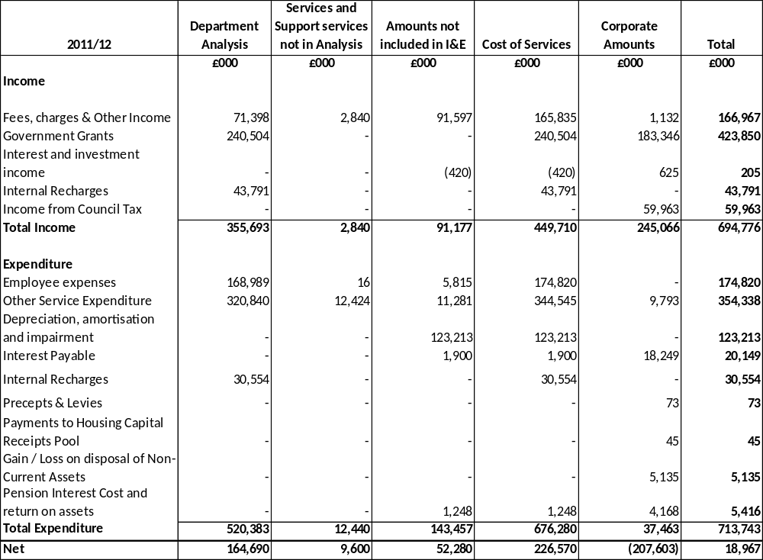

34. TRADING OPERATIONS

The Authority has 3 trading units where the service manager is required to operate in a commercial environment and balance their budget by generating income from other parts of the authority or other organisations. Trading operations are incorporated into the Comprehensive Income and Expenditure Statement. The expenditure of these operations is allocated or recharged to headings in the Net Operating Expenditure of Continuing Operations.

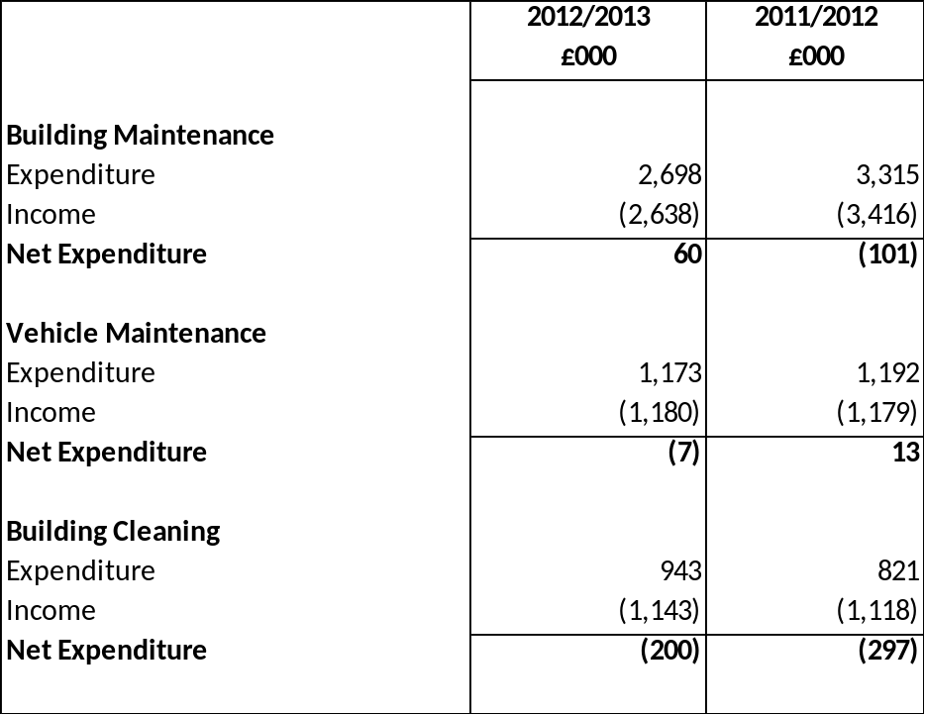

Building Maintenance

Building Maintenance are the contractor for the day to day maintenance of Council buildings including schools. The service maintains the Council’s building stock through planned maintenance work and reactive repairs.

The service also compete with the private sector for work outside of the Council and have a growing private sector client base.

Vehicle Maintenance

The Central Vehicle Maintenance Unit, as well as completing the routine servicing and maintaining of the Council’s fleet of 350 items of vehicles and plant, also provides routine and ad hoc testing of Blackpool’s taxi fleet.

Building Cleaning

Building Cleaning are the sole cleaning provider for the Council’s buildings and also compete for work in Blackpool schools.

The service is split into two areas: building cleaning and office porterage. The service has a number of private clients.

35. ROAD CHARGING SCHEMES UNDER THE TRANSPORT ACT 2000

Decriminalised Parking Enforcement (DPE) of on-street parking was introduced in November 2003 as part of the Local Transport Plan with the aim of reducing congestion and improving traffic management. The surplus arising from on street parking is used to defray qualifying expenditure. The use of DPE is governed by section 55 of the Road Traffic Regulation Act 1984, as amended from October 2004 by section 95 of the Traffic Management Act 2004. This specifies the use that DPE surpluses may be put to.

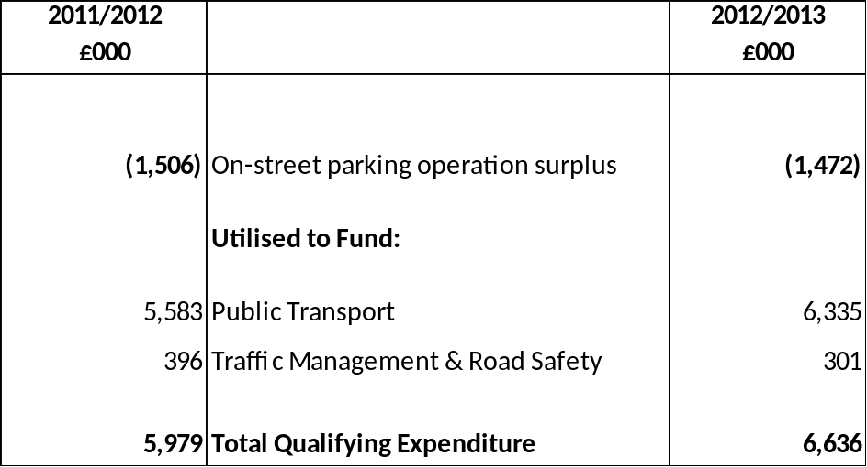

36. AGENCY SERVICES

The Authority provides payroll services for Chorley Borough Council, Fylde Borough Council, High Peak Community Housing, Blackpool Coastal Housing, Baines School, Claremont First Step Centre and Westcliff Academy Primary School. These organisations pay a management fee to the Council for the service. The total management fee received by the Council in 2012/2013 was £100,005 (2011/2012 £80,103). The management fee is based on the number of employees paid.

37. MEMBERS ALLOWANCES

The Authority paid the following amounts to Members of the Council during the year.

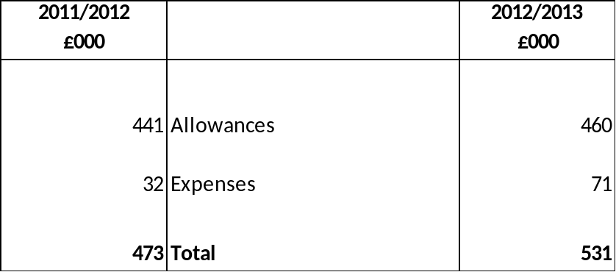

38. OFFICERS’ REMUNERATION

The number of employees whose remuneration, excluding pension contributions was £50,000 or more in bands of £5,000 is set out below.
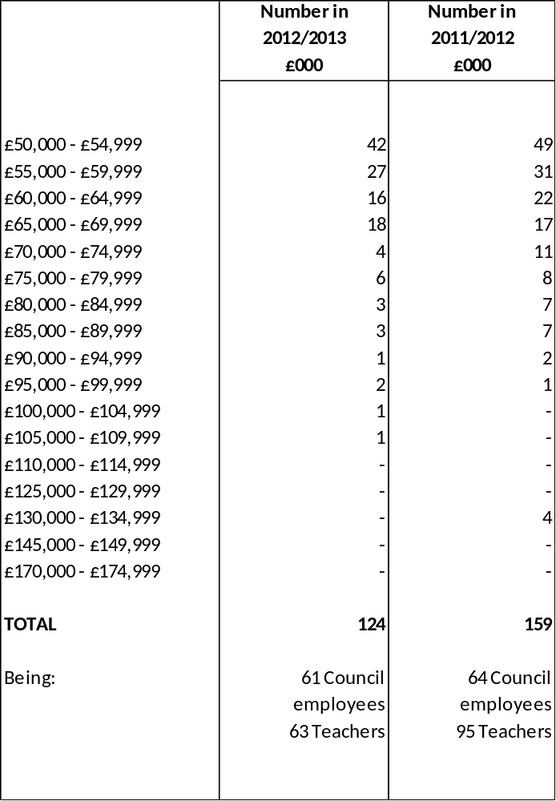

The remuneration paid to the Authority’s senior officers is as follows:

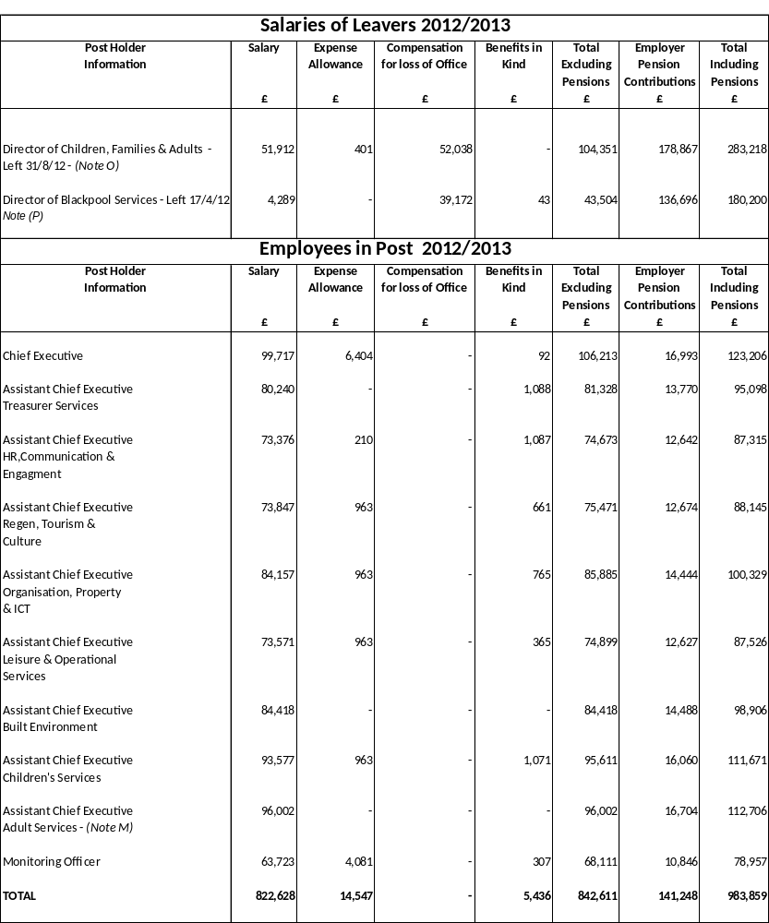

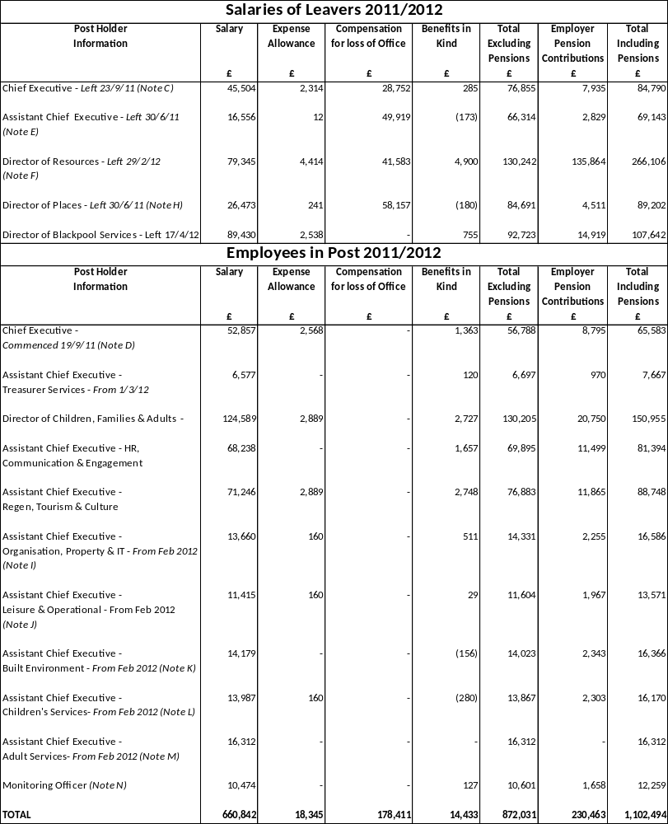

NOTES
A – Compensation for loss of office includes statutory redundancy pay. Statutory pension strain is included within employer pension contributions. Pension strain is the cost to the Council of the redundancy/retirement. It is not the amount received by the postholder.

B – Benefits in kind include travel & subsistence expenses, professional fees.

2011/12
C – Chief Executive – The post holder left on 23/9/11. Their contracted salary was £143,832.

D – Chief Executive – The post holder took office on 19/9/11. Their contracted salary was £100,550.

E – The post of Assistant Chief Executive Policy and Communications was disestablished on 30/6/11. Their contracted salary was £68,994.

F – The post of Director of Resources was disestablished on 29/2/11. Their contracted salary was £89,394.

G – The Chief Financial Officer became Assistant Chief Executive - Treasurer Services on 20/2/12. Their contracted salary was £80,000.

H – The post of Director of Places was disestablished on 30/6/11. Their contracted salary was £107,000.

J – The post of Assistant Chief Executive – Organisation, Property and Information Technology joined the Corporate Leadership Team in February 2012. Their contracted salary was £82,512.

I - The post of Assistant Chief Executive – Leisure and Operational Services joined the Corporate Leadership Team in February 2012. Their contracted salary was £68,994.

K - The post of Assistant Chief Executive – Built Environment joined the Corporate Leadership Team in February 2012. Their contracted salary was £85,728.

L - The post of Assistant Chief Executive – Children’s Services joined the Corporate Leadership Team in February 2012. Their contracted salary was £84,346.

M - The post of Assistant Chief Executive – Adult Services joined the Corporate Leadership Team in February 2012. The post holder is employed by NHS Blackpool and the Authority is recharged the cost of their salary each month.

N – The post of Monitoring Officer joined the Corporate Leadership Team in February 2012. Their contracted salary was £63,263.

2012/2013
O – The post of Director of Children’s, Families and Adults was disestablished on 31/8/12. Their contracted salary was £126,525.

P – The post of Director of Blackpool Services was disestablished on 17/4/12. Their contracted salary was £90,820.

Q - In addition to the Employer’s Pension Contributions shown above the employees contribute 7.2% - 7.5% of superannuable pay.

R – Expense Allowances include essential car user payments.

S – Salary includes a voluntary reduction for 4 days unpaid leave which commenced in April 2011.

The numbers of exit packages with total cost per band and total cost of the compulsory and other redundancies are set out in the table below:
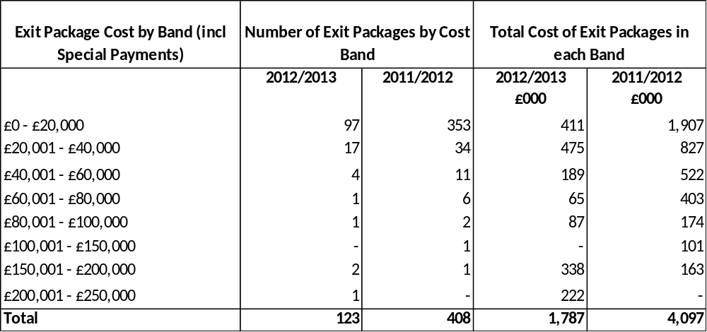

39. EXTERNAL AUDIT COSTS
The Authority has incurred the following costs in relation to the audit of the Statement of Accounts, certification of grant claims and statutory inspections and to non-audit services provided by the Authority’s external auditors:
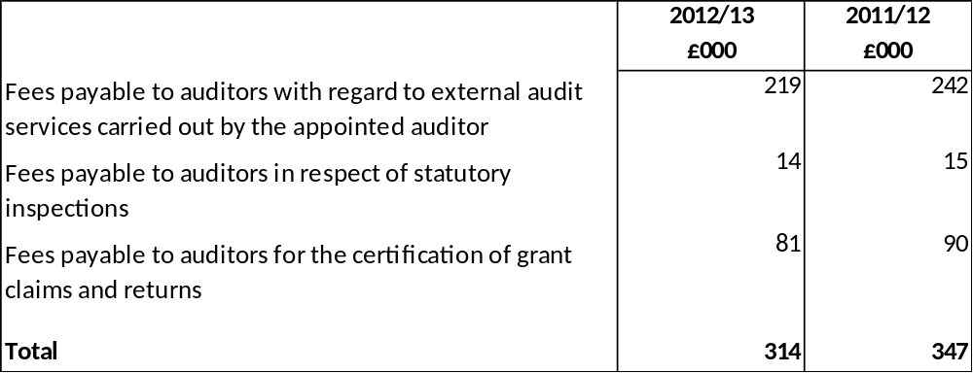

40. DISCLOSURE OF DEPLOYMENT OF DEDICATED SCHOOLS GRANT

The Council’s expenditure on schools is funded by grant monies provided by the Department for Education, the Dedicated Schools Grant (DSG). An element of DSG is recouped by the Department to fund academy schools in the Council’s area. DSG is ring-fenced and can only be applied to meet expenditure properly included in the schools budget as defined in the School Finance (England) Regulations 2011. The schools budget includes elements for a range of educational services provided on an authority wide basis and for the Individual Schools Budget, which is divided into a budget share for each maintained school.

Details of the deployment of DSG receivable for 2012/2013 are as follows:

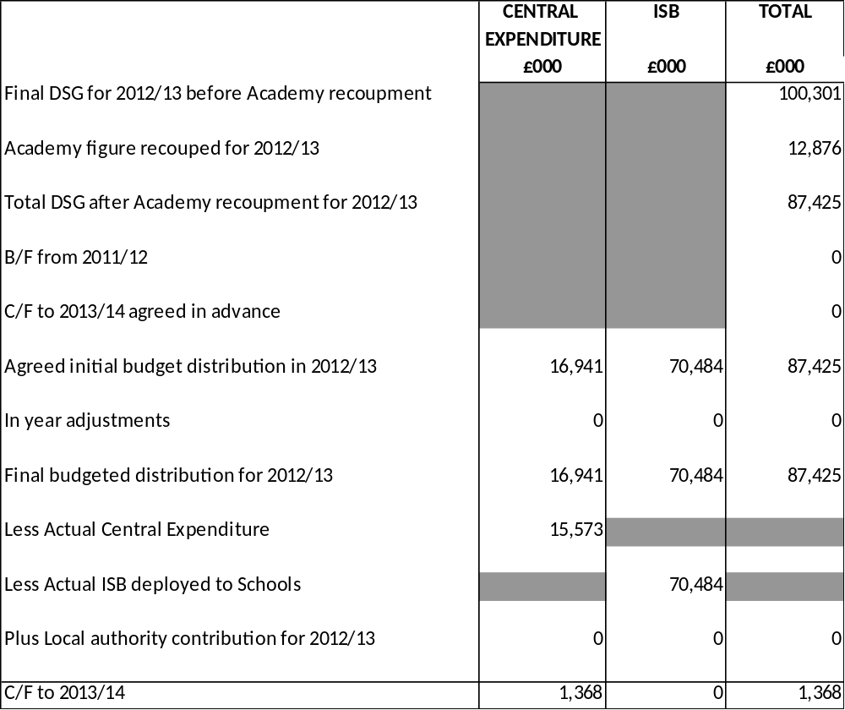

41. GRANT INCOME

The Authority credited the following grants, contributions and donations to the Comprehensive Income and Expenditure Statement in 2012/2013.

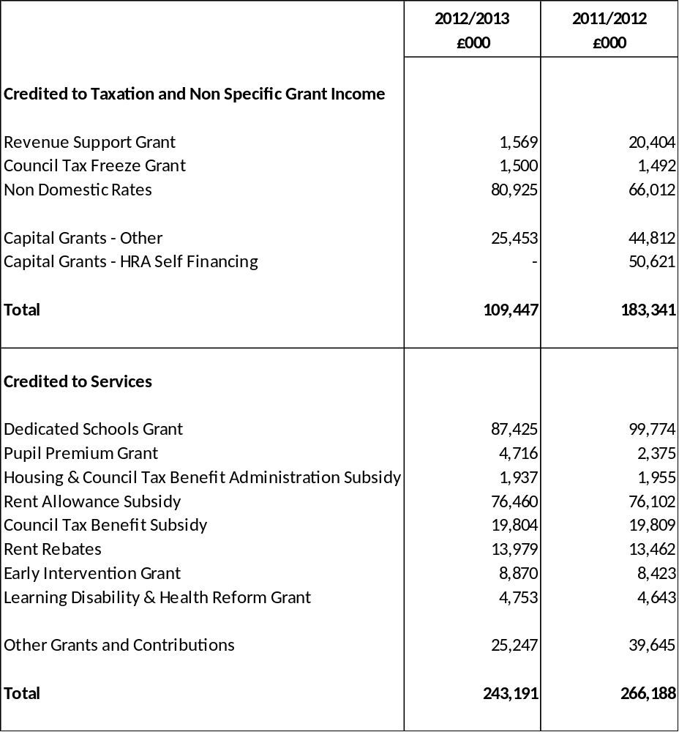

The Authority has received a number of grants, contributions and donations that have yet to be recognised as income as they have conditions attached to them that will require the monies or property to be returned to the provider. The balances at year end are as follows:

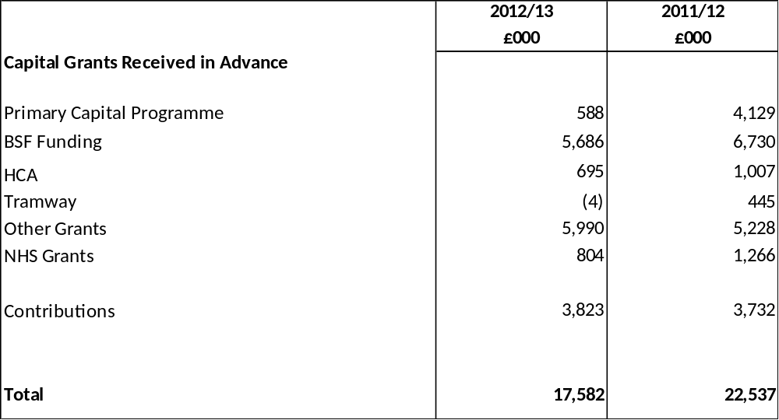

42. RELATED PARTIES

In accordance with IAS 24 the Council is required to disclose material transactions with related parties, bodies or individuals that have the potential to control or influence the Council or to be controlled or influenced by the Council. Disclosure of these transactions allows readers to assess the extent to which the Council might have been constrained in its ability to operate independently or might have secured the ability to limit another party’s ability to bargain freely with the Council.
Related party transactions include:-
Central Government has effective control over the general operations of the Council. It is responsible for providing the statutory framework within which the Council operates, provides the majority of its funding in the form of grants and prescribes the terms of many of the transactions that the Council has with other parties (e.g. housing benefits). Details of transactions with government departments are set out in Note 42.
Lancashire Police Authority and Lancashire Fire Authority
The level of council tax set by the Council each year includes a precept element, which the Council pays to Lancashire Police Authority and Lancashire Fire Authority. (See Collection Fund – Precepts).

Subsidiary and Associated Companies
The Council has an interest in three wholly owned companies: Blackpool Transport Services Ltd, Blackpool Operating Company (Sandcastle Waterpark) and Blackpool Coastal Housing. The Council also has a 20% share in Connexions, a 43% share in Lancashire and Blackpool Tourist Board and 50% in the Blackpool, Fylde and Wyre Economic Development Company. In addition the Council has a 5% share in Blackpool Airport. More detailed information on the group companies can be found in the Group Accounts section of the Statement of Accounts.
Shared Service
On 1st April 2008 the Council entered into a shared service arrangement with Fylde Borough Council for the provision of a Benefits and Revenues Service. The full cost of the service in 2012/2013 was £3,988,147 of which £2,961,860 related to Blackpool.

Members

A Member of the Council has a private interest in a local taxi firm. The Council made payments to this organisation amounting to £186,104 in 2012/2013 to meet the Council’s transport requirements.
A Member of the Council has a private interest in a homeless charity. The Council made payments to this charity amounting to £272,956 in 2012/2013 to meet the Council’s homelessness requirements
These transactions were conducted at arms length and in accordance with the Authority’s financial regulations.
Chief Officers
It is considered that transactions identified involving Chief Officers with related parties are not material.
Assisted Organisations
The Council has entered into a number of service level agreements with a number of local voluntary organisations and provides financial assistance to them totalling £376,950.

43. CAPITAL EXPENDITURE AND CAPITAL FINANCING

The total amount of capital expenditure incurred in the year is shown in the table below (including the value of assets acquired under finance leases and PFI contracts), together with the resources that have been used to finance it. Where capital expenditure is to be financed in future years by charges to revenue as assets are used by the Authority, the expenditure results in an increase in the Capital Financing Requirement (CFR), a measure of the capital expenditure incurred historically by the Authority that has yet to be financed. The CFR is analysed in the second part of this note.

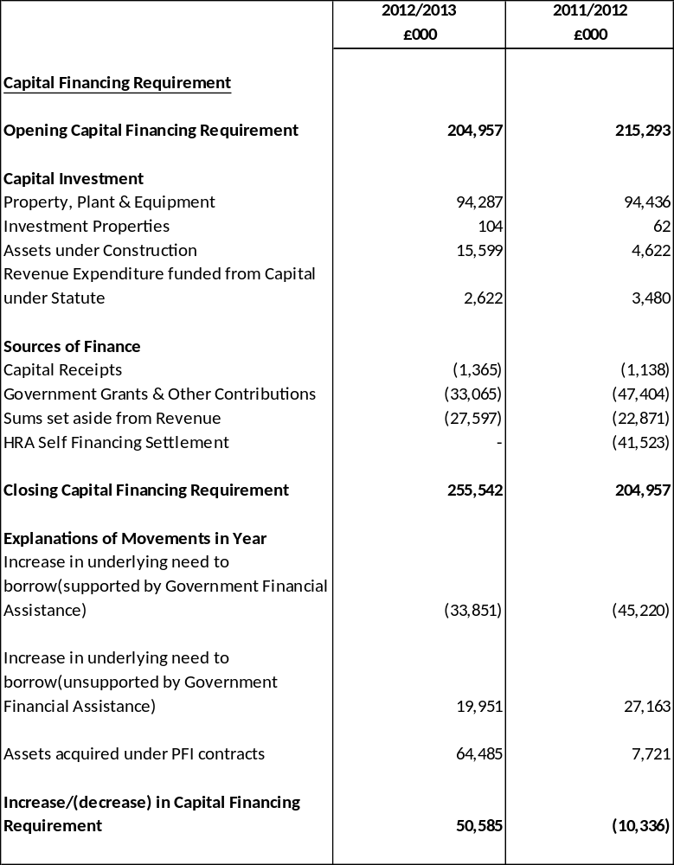

44. LEASES
Authority as Lessee
Finance Leases
The Council has acquired a number of vehicles, plant and equipment under finance leases. The assets acquired under these leases are carried as Property, Plant and Equipment in the Balance Sheet at the following net amounts:
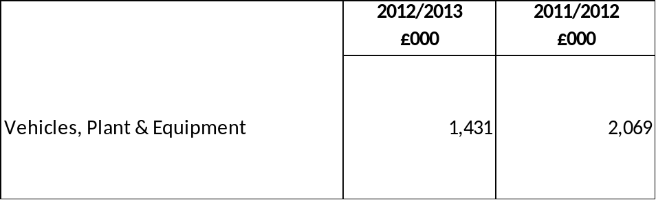

The Authority is committed to making payments under these leases comprising settlement of the long term liability for the interest in the property acquired by the Authority and finance lease costs that will be payable by the Authority in future years while the liability remains outstanding.
The minimum lease payments will be payable over the following periods:
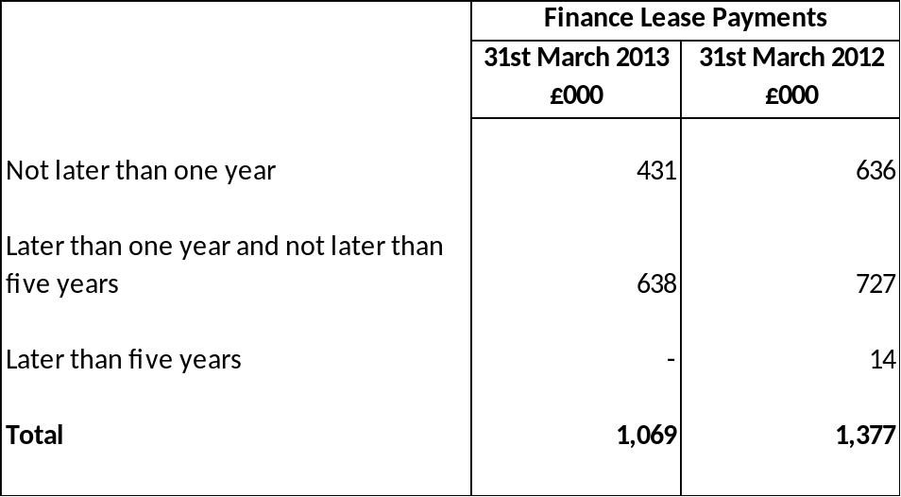

Operating Leases
The Authority has acquired assets by entering into operating leases. The future minimum lease payments due under non-cancellable leases in future years are:
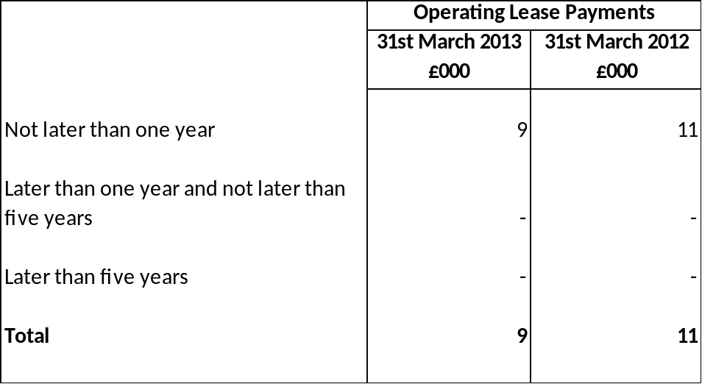
The expenditure charged to the Comprehensive Income and Expenditure Statement during the year in relation to these leases was:

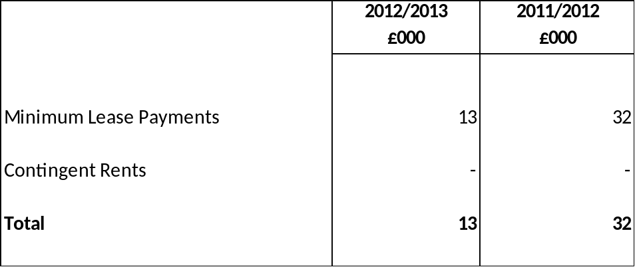

The Authority as Lessor

The Council has granted various property leases including the lease of the Sandcastle to Blackpool Operating Company. The rentals received in 2012/2013 amounted to £662,000 (2011/2012 £662,000). The gross value of the assets held for use in leases was £7.88m at 31st March 2013 (2011/2012 £8.275m). The assets have been subject to £400,000 depreciation at 31st March 2013.

All assets where the Council acts as lessor are considered operating leases in nature. The key determinations of the nature of a lease are :

- Restriction on use
- Risks and rewards are not transferred
- Value of lease payment does not amount to significant proportion of the fair value of the property
- The lease related to land only.

Operating Leases

The future minimum lease payments receivable under non-cancellable lease in future years are:

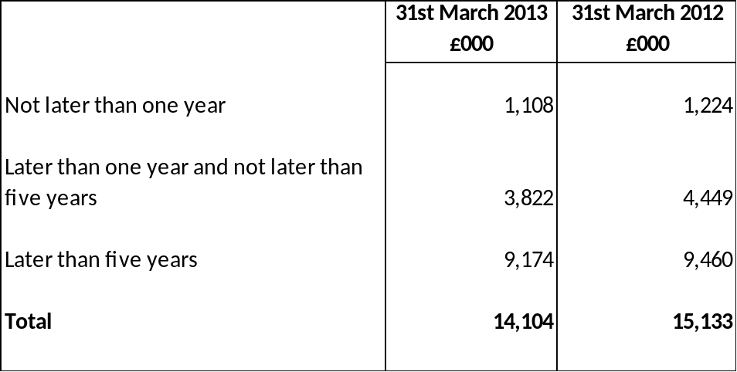

The minimum lease payments receivable do not include rents that are contingent on events taking place after the lease was entered into, such as adjustments following rent reviews.

45. PRIVATE FINANCE INITIATIVE (PFI)

Highfield Humanities College PFI

The Highfield Humanities College PFI scheme is the only PFI school resulting from the Government’s Building Schools for the Future Programme. This project consists of the new build of a secondary school for up to 1,216 pupils and the provision of a fully managed facility for a period 25 years by the selected operator.

The operator is Eric Wright Facilities Management via the Highfield PSI SPV Limited ( a company wholly owned by Blackpool Local Education Partnership, a joint venture between Eric Wright Group, Blackpool Council and Northgate Management Services ). The total projected cost over the life of the project is £98m which is funded by PFI credits of £40m from the Department of Education , the remainder funded by the School and Local Authority contributions.

The assets relating to the PFI are recognised on the Authority’s Balance Sheet. Movements in their value over the year are detailed in the analysis of the movement on Property, Plant and Equipment balance below.

The Authority makes an agreed payment each year which is increased by inflation and can be reduced if the contractor fails to meet availability and performance standards in any year but which is otherwise fixed. Payments remaining to be made under the PFI contract at 31st March 2013 (excluding any estimation of inflation and availability/performance deductions) are as follows:

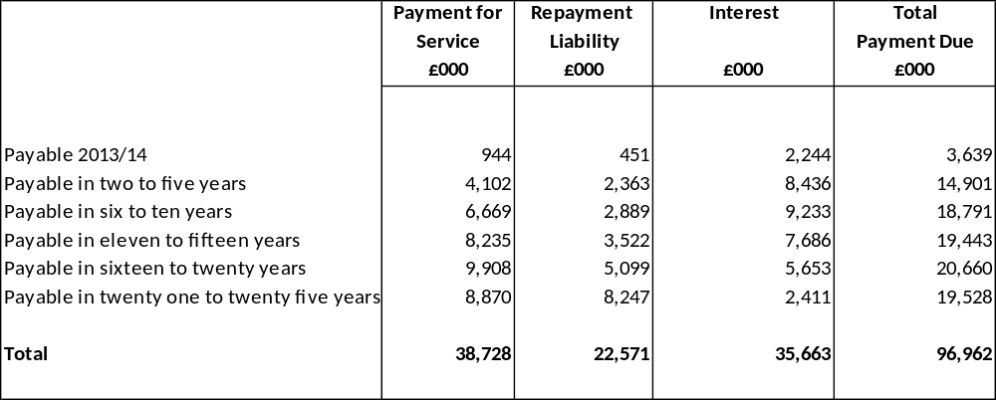

Although the payments made to the contractor are described as unitary payments, they have been calculated to compensate the contractor for the fair value of the services they provide, the capital expenditure incurred and interest payable whilst the capital expenditure remains to be reimbursed. The liability outstanding to pay the liability to the contractor for capital expenditure incurred is as follows:

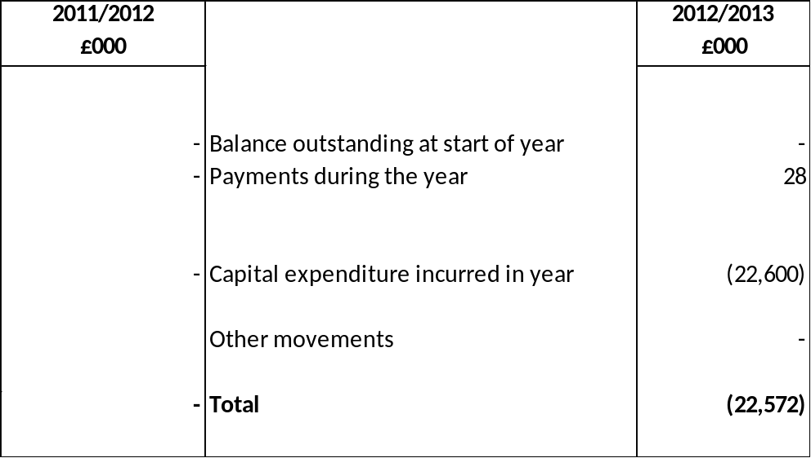

Waste Disposal PFI

The Council has entered into a Joint Working Agreement with Lancashire County Council (LCC) to co-operate in the provision of certain waste disposal functions. The Council has authorised Lancashire County Council to enter into a PFI contract with Global Renewables Lancashire Ltd and administer all matters under that contract on behalf of Blackpool Council.

The County Council signed a PFI (Private Finance Initiative) contract with Global Renewables Lancashire (GRL) Limited in March 2007. The contract covers the delivery of contract waste, treatment and diversion from landfill at the Farringdon and Thornton sites as well as subsequent disposal of waste from those sites. The waste handled and processed is household waste, commercial waste and green waste, but not industrial waste.

The contract runs until March 2037. A unitary payment is made to GRL which consists of a fixed and variable element, both of which are subject to inflation. This payment is reduced if the contractor fails to make targets. Under the terms of the Joint Working Arrangement, Blackpool Council contributes 12.5% towards all costs of the contract and has a 12.5% share of the total value of the asset.The Council’ share of capital costs is £35.126m and this has been reflected in the valuation of the asset in the 2012/2013 balance sheet.

Payments remaining to be made under the PFI contract at 31st March 2013 (excluding any estimation of inflation and availability/performance deductions) are as follows:

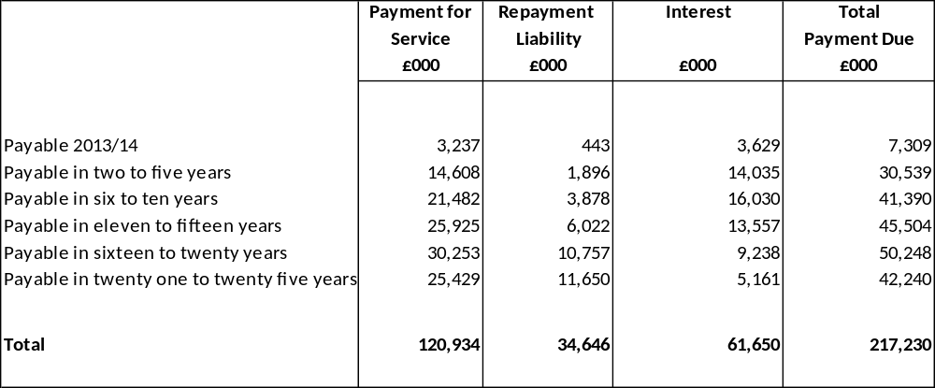

At the end of the concession period LCC may retender the provision of the services. At this point the Council would either continue to have a 12.5% share in any retendered contract, or continue under a new arrangement. If the Council decided that it no longer wished to continue with the contract then LCC would have to pay Blackpool the relevant rental value for its share of the assets. If LCC decides to dispose of the asset then the Council would receive a relevant percentage of the proceeds of the sale.

Street Lighting and Signals PFI

This project will be for 25 years with the service provider now responsible for the management and maintenance of street lights and signals within Blackpool. The project commenced on 4th January 2010. The contract was awarded to Community Lighting Partnership. The total sum payable to the contractor over the term of the contract is £129m, being met from Government Grant and Authority contributions. The scheme, supported by the Department for Transport, was signed in December 2009, and provides for the design, maintenance and replacement of Street Light and Signals across the town.

The Authority makes an agreed payment each year which is increased by inflation and can be reduced if the contractor fails to meet availability and performance standards in any year but which is otherwise fixed. Payments remaining to be made under the PFI contract at 31st March 2013 (excluding any estimation of inflation and availability/performance deductions) are as follows:

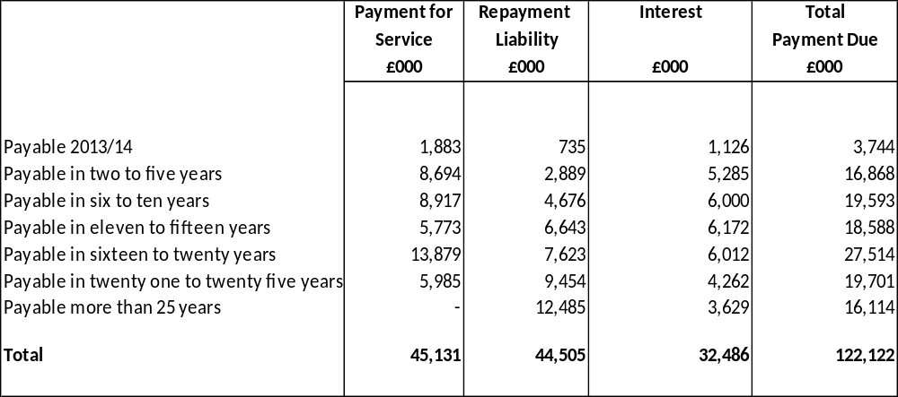

Although the payments made to the contractor are described as unitary payments, they have been calculated to compensate the contractor for the fair value of the services they provide, the capital expenditure incurred and interest payable whilst the capital expenditure remains to be reimbursed. The liability outstanding to pay the liability to the contractor for capital expenditure incurred is as follows:

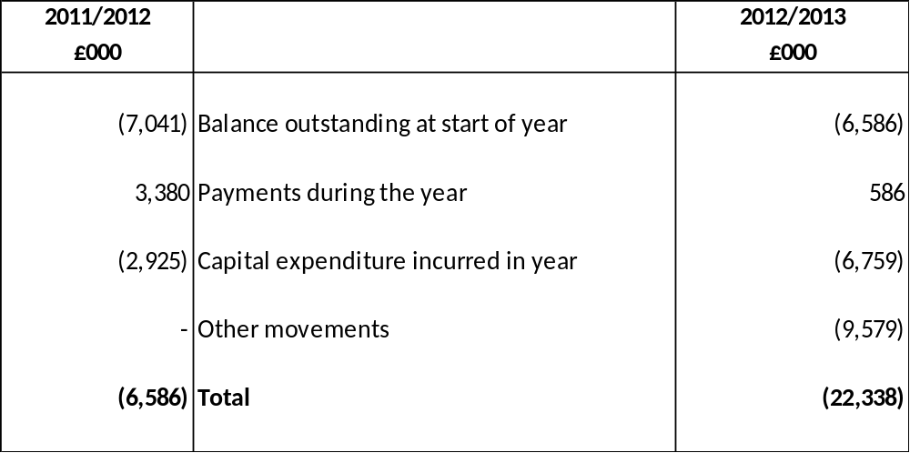

46. IMPAIRMENT LOSSES

During 2012/2013, the Authority has recognised a significant impairment in relation to its Council dwellings stock. Blackpool Council has decided that a number of tower blocks at the Queens Park site are to be demolished and replaced with new housing. Given that there has been Executive approval for the demolition, that the Council are actively decanting tenants, properties once vacant are not being re-let, and a contractor has been appointed, this part of the portfolio has been valued at nil. The impairment loss has been charged to the HRA line in the Comprehensive Income and Expenditure Statement.

During 2012/2013, the Authority has recognised an impairment loss of £6,417,644 in relation to land and buildings. The impairment loss has been charged to the Net Cost of Services in the Comprehensive Income and Expenditure Statement

47. PENSION SCHEMES ACCOUNTED FOR AS DEFINED CONTRIBUTION SCHEMES

Teachers employed by the Authority are members of the Teachers’ Pension Scheme, administered by the Department for Education. The Scheme provides teachers with specified benefits upon their retirement, and the authority contributes towards the costs by making contributions based on a percentage of the members’ pensionable salaries.
The scheme is technically a defined benefit scheme. However, the scheme is unfunded and the Department for Education uses a notional fund as the basis for calculating the employers’ contribution rate paid by local authorities. The Authority is not able to identify its share of underlying financial position and performance of the scheme with sufficient reliability for accounting purposes. For the purposes of this Statement of Accounts, it is therefore accounted for on the same basis as a defined contribution scheme.
In 2012/2013 the Council paid £5,002,219 (2011/12 £5,908,812) to the Department for Education in respect of teachers retirement benefits, representing 14.10% (2011/2012 14.10%) of teachers’ pensionable pay. In addition the Council is responsible for all pension payments relating to awards of added years and other related increases. In 2012/2013 these amounted to £133,058 (£124,811 in 2011/2012), which represents 0.38% of pensionable pay.

48. DEFINED BENEFIT PENSION SCHEMES
Participation in Pension Schemes
As part of the terms and conditions of employment of its officers, the Authority makes contributions towards the cost of post employment benefits. Although these benefits will not actually be payable until employees retire, the Authority has a commitment to make the payments that need to be disclosed at the time the employees earn their future entitlement.
The Council participates in the following post-employment scheme:
- The Local Government Pension Scheme, administered by Lancashire County Council this is a funded scheme, which means that the Council and employees pay contributions into the fund, calculated at a level intended to balance pension liabilities with the investment assets.

The Lancashire County Pension Fund (LCPF) scheme is a defined benefit scheme. This means that the retirement benefits are determined independently of the investments of the scheme and employers have obligations to make contributions where assets are insufficient to meet employee benefits.
Transactions Relating to Post-Employment Benefits
The Authority recognises the cost of retirement benefits in the reported cost of services when they are earned by employees, rather than when the benefits are eventually paid as pensions. However, the charge the Authority is required to make against council tax is based on the cash payable in the year, so the real cost of post- employment/retirement benefits is reversed out of the General Fund via the Movement in Reserves Statement. The following transactions have been made in the Comprehensive Income and Expenditure Statement and the General Fund Balance via the Movement in Reserves Statement during the year:

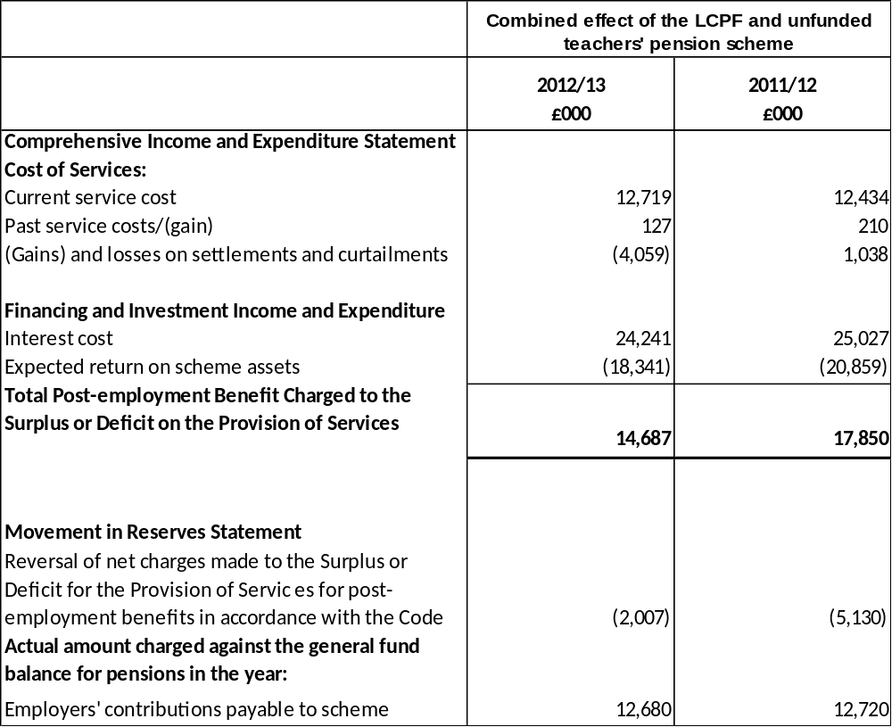

Assets and Liabilities in relation to Post-Employment Benefits
Reconciliation of present value of the scheme liabilities (defined benefit obligation).

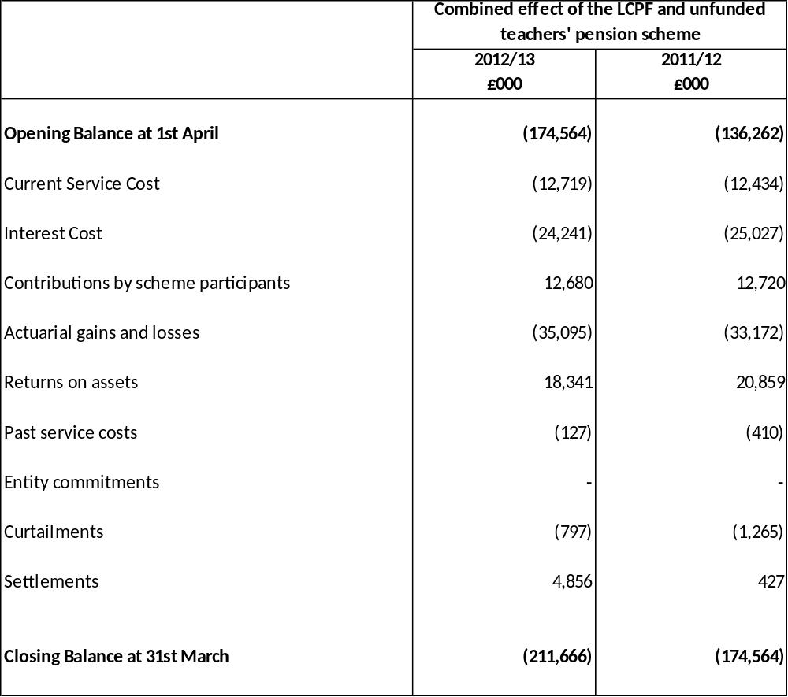
Reconciliation of fair value of the scheme (plan) assets:
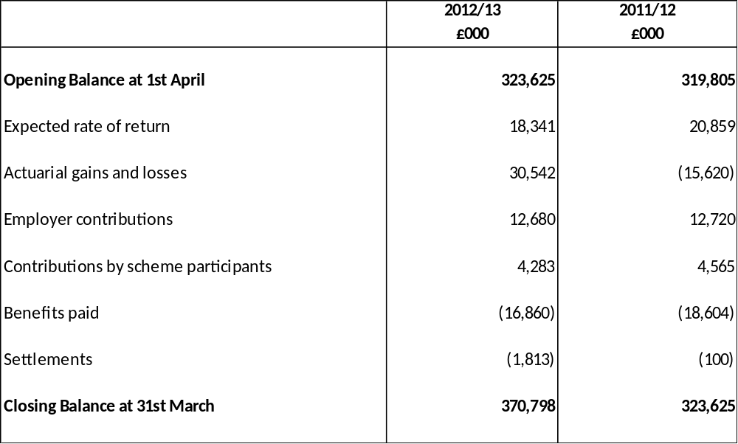

The expected return on scheme assets is determined by considering the expected returns available on the assets underlying the current investment policy. Expected yields on fixed interest investments are based on gross redemption yields as at the Balance Sheet date.
Expected returns on equity investment reflect long term real rates of return experienced in the respective markets.
The actual return on scheme assets in the year was £48,883,000 (2011/2012 - £5,239,000).

Scheme History
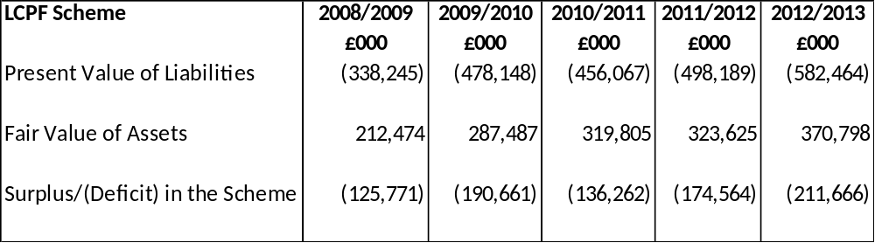

The liabilities show the underlying commitments that the authority has in the long term to pay post- employment (retirement) benefits. The total pension liability of £211,666,000 has a substantial impact on the net worth of the authority. However, statutory arrangements for funding the deficit mean that the financial position of the authority remains healthy:

- The deficit on the local government pension scheme will be made good by increased contributions over the remaining working life of employees (i.e. before payments fall due), as assessed by the scheme actuary.

The total contributions expected to be made to the Local Government Pension Scheme by the Council in the year to 31st March 2013 is £12,680,000.

Basis for Estimating Assets and Liabilities
Liabilities have been assessed on an actuarial basis using the projected unit credit method, an estimate of the pensions that will be payable both in future years dependent upon assumptions about mortality rates, salary levels etc. The Local Government Pension Scheme liabilities have been assessed by Mercer Limited an independent firm of actuaries. The last full actuarial valuation of the scheme was at 31 March 2010.
The principal assumptions used by the actuary have been:

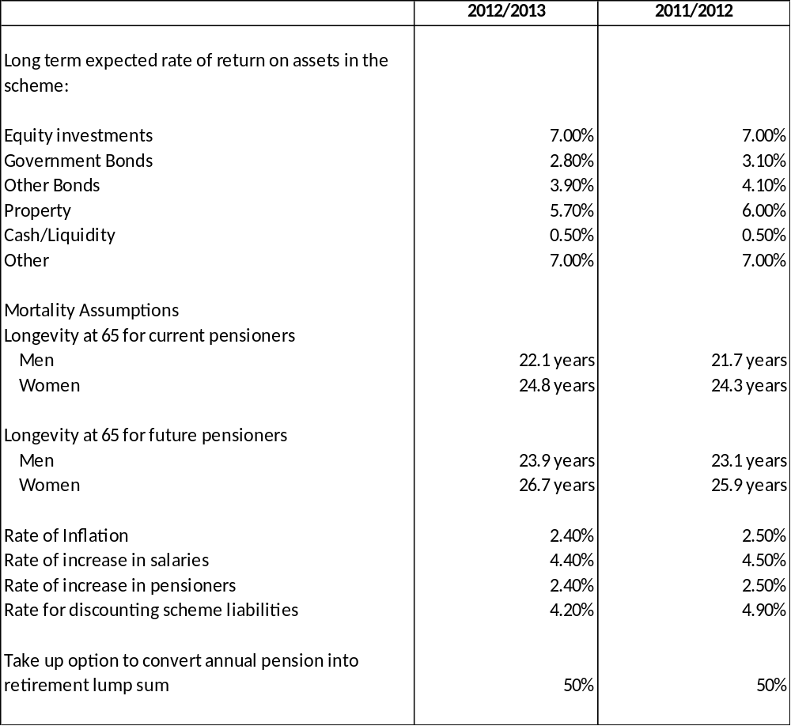

History of Experience Gains and Losses

The actuarial gains/(losses) identified as movements on the pension reserve in 2012/2013 can be analysed into the following categories measured as a percentage of assets on liabilities as at 31st March 2013.

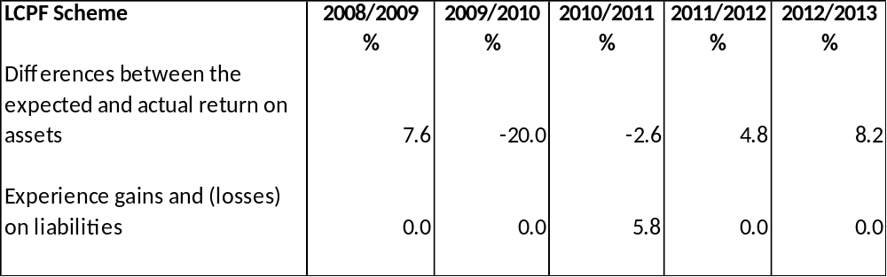

49. NATURE AND EXTENT OF RISKS ARISING FROM FINANCIAL INSTRUMENTS
The Council’s activities expose it to a variety of financial risks, the key risks are:
- Credit risk – the possibility that other parties might fail to pay amounts due to the Council;
- Liquidity risk – the possibility that the Council might not have funds available to meet its commitments to make payments;
- Market risk - the possibility that financial loss might arise for the Council as a result of changes in such measures as interest rates movements.
The Council’s overall risk management procedures focus on the unpredictability of financial markets, and seek to minimise potential adverse effects on resources available to fund services. Risk management is carried out by the Treasury Management Panel, under policies approved by the Executive in the Council’s Annual Treasury Management Strategy. The Council provides written principles for overall risk management, as well as written policies covering specific areas, such as interest rate risk, credit risk and the investment of surplus cash.
Credit risk
Credit risk arises from deposits with banks and financial institutions, as well as credit exposures to the Council’s customers.
This risk is minimised through the Annual Investment Strategy, which requires that deposits are not made with financial institutions unless they meet identified minimum credit criteria. The criteria are based on information from Fitch, Moody’s and Standard and Poors, the three principal credit ratings agencies.
Banks – the authority will use banks which have at least the following ratings:
- Short term – F1 or equivalent
- Long term – Single A or equivalent.
Building Societies – the authority will use any UK society with assets in excess of £1.5 billion.
Local authorities – the authority will use upper tier authorities only.
Investments in UK Government – permitted due to overall security
Investments in supranational institutions – not permitted along with investments in money market funds.
The Annual Investment Strategy also imposes a maximum sum to be invested with a financial institution located within each category.
Customers for goods and services are assessed, taking into account their financial position, past experience and other factors, with individual credit limits being set in accordance with internal ratings in accordance with parameters set by the Executive.
The Authority’s potential maximum exposure to credit risk in relation to its investments in banks and building societies of £6.8m cannot be assessed generally as the risk of any institution failing to make the interest payments or repay the principal sum will be specific to each individual institution. Recent experience has shown that it is rare for such entities to be unable to meet their commitments. A risk of irrecoverability applies to all of the Authority’s deposits but there was no evidence at 31st March 2013 that this was likely to crystallize.
The following analysis summarises the Authority’s potential maximum exposure to credit risk on other financial assets, based on experience of default and uncollectability over the last five financial years, adjusted to reflect current market conditions.

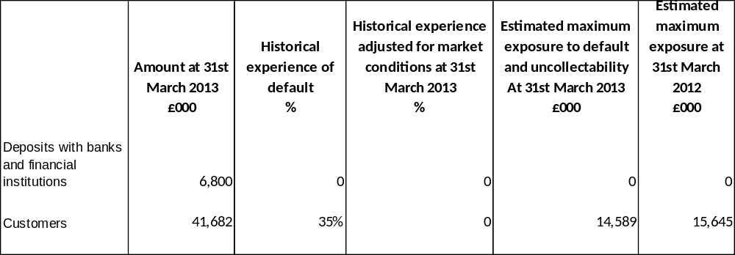

No credit limits were exceeded during the reporting period and the authority does not expect any losses from non-performance by any of its counterparties in relation to deposits.
The Authority does not generally allow credit for its customers, such that £2,440,000 of the £38.5m balance is past its due date for payment. The past due but not impaired amount can be analysed by age as follows:
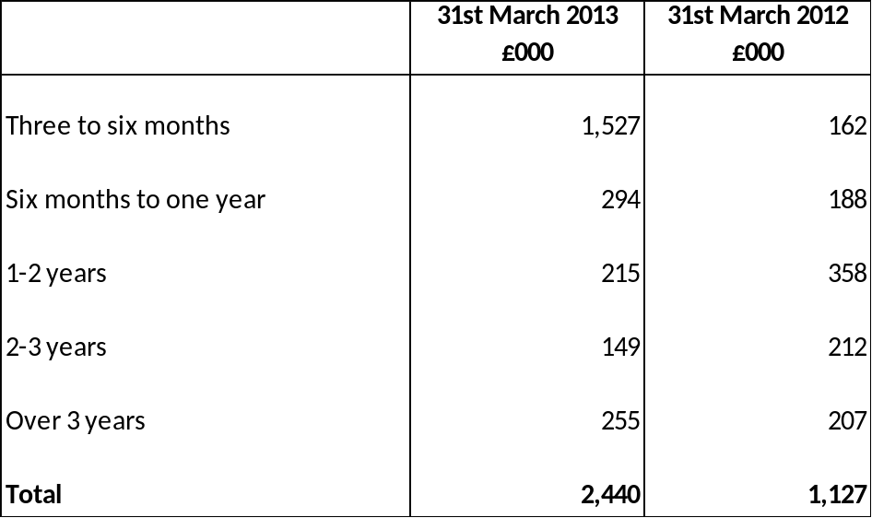

Liquidity risk
The Authority has a comprehensive cash flow management system that seeks to ensure that cash is available as needed. If unexpected movements happen, the authority has ready access to borrowings from the money markets. There is no significant risk that it will be unable to raise finance to meet its commitments under financial instruments. Instead, the risk is that the authority will be bound to replenish a significant proportion of borrowings at a time of unfavourable interest rates. The authority sets limits on the proportion of its fixed rate borrowing during specified periods. The strategy is to ensure that not more than 30% of loans are due to mature within any rolling five year period through a combination of careful planning of new loans taken out and (where it is economic to do so) making early repayments. The maturity analysis of financial liabilities is as follows:
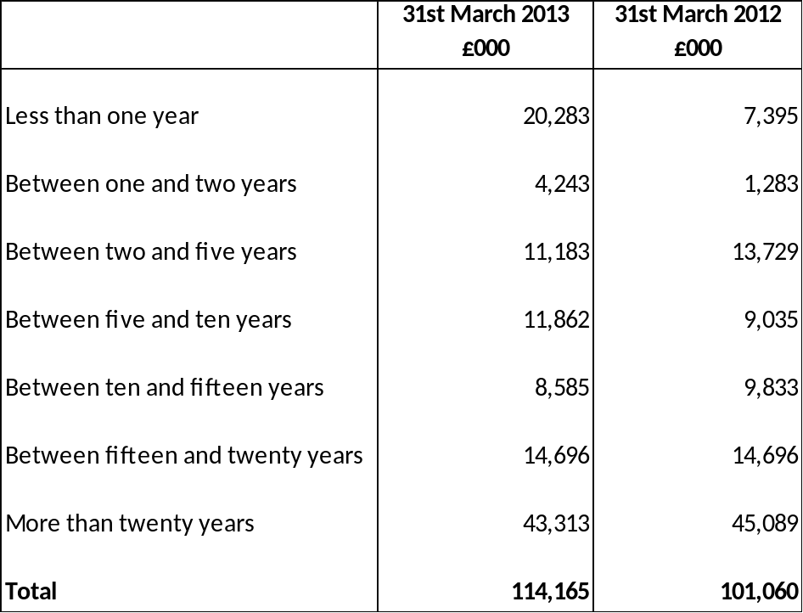

All trade and other payables are due to be paid in less than one year.
Market risk
Interest rate risk
The Authority is exposed to risk in terms of its exposure to interest rate movements on its borrowings and investments. Movements in interest rates have a complex impact on the authority. For instance, a rise in interest rates would have the following effects:
- borrowings at variable rates – the interest expense charged to the Surplus or Deficit on the Provision of Services will rise
- borrowings at fixed rates – the fair value of the liabilities borrowings will fall
- investments at variable rates – the interest income credited to the Surplus or Deficit on the Provision of Service will rise
- investments at fixed rates – the fair value of the assets will fall.
Borrowings are not carried at fair value, so nominal gains and losses on the fixed rate borrowings would not impact on the Surplus or Deficit on the Provision of Services or Other Comprehensive Income and Expenditure. However, changes in the interest payable and receivable on variable rate borrowings and investments will be posted to the Surplus or Deficit on the Provision of Services and affect the General Fund Balance. Movements in the fair value of fixed rate investments that have a quoted market price will be reflected in Other Comprehensive Income and Expenditure.
The Authority has a number of strategies for managing interest rate risk policy is to aim to keep a maximum of 35% of its borrowings in variable rate loans. During periods of falling interest rates, and where economic circumstances make it favourable, fixed rate loans will be repaid early to limit exposure to losses. The risk of loss is ameliorated by the fact that a proportion of government grant payable on financing costs will normally move with prevailing interest rates or the Authority’s cost of borrowing and provide compensation for a proportion of any higher costs.
The treasury management panel has an active strategy for assessing interest rate exposure that feeds into the annual budget setting. Any adverse changes are updated in the budget during the year. The analysis will also advise whether new borrowing taken out is fixed or variable.
If interest rates had been 1% higher with all other variables held constant, the financial effect would have a nil effect on the financial statements as would a 1% fall in interest rates. This assumption is based on the methodology used in the Note – Fair Value of Assets and Liabilities.
Price Risk
The Authority does not invest in equity shares but does have shareholdings to the value of £9,500,002 in a number of subsidiaries.
As the shareholdings have arisen in the acquisition of specific interests, the Authority is not in a position to limit its exposure to price movements by diversifying its portfolio. Instead it only acquires shareholdings in return for ‘open book’ arrangements with the company concerned so that the authority can monitor factors that might cause a fall in the value of specific shareholdings.
The £9.50m shares are classified as ‘available for sale’, meaning that all movements in price will impact on gains and losses recognised in Other Comprehensive Income and Expenditure. A general shift of 5% in the general price of shares (positive or negative) would thus have resulted in a £475,000 gain or loss being recognised in the Other Comprehensive Income and Expenditure for 2012/2013.
Foreign Exchange Risk
The Authority has no financial assets or liabilities denominated in foreign currencies and thus has no exposure to loss arising from movements in exchange rates.

50. CONTINGENT LIABILITIES / ASSETS

Blackpool Airport
Upon the sale of Blackpool Airport from City Hopper Airports to Balfour Beatty in May 2008 the agreement provides for a payment of £250,000 to the Council which will be received dependent upon passenger numbers.

Local Land Charges
A number of Property Research Companies are seeking to claim refunds of fees paid to local authorities to access land charges data. They have also intimated that they may bring a claim against all English and Welsh local authorities for alleged anti-competitive behaviour.

Proceedings have not yet been issued and it is therefore not clear what the value of any such claims would be against the Council.
These assets and liabilities are not included on the Balance Sheet.

- HERITAGE ASSETS: FIVE YEAR SUMMARY OF TRANSACTIONS
Information on Illuminations and Civic Regalia is not available before 1st April 2010. The Tower Company Collection only transferred to the Authority in March 2009 and there have been no movements in the valuation. There have been no movements in the valuation of the art collection, local and family history collection and Stanley Park statues.
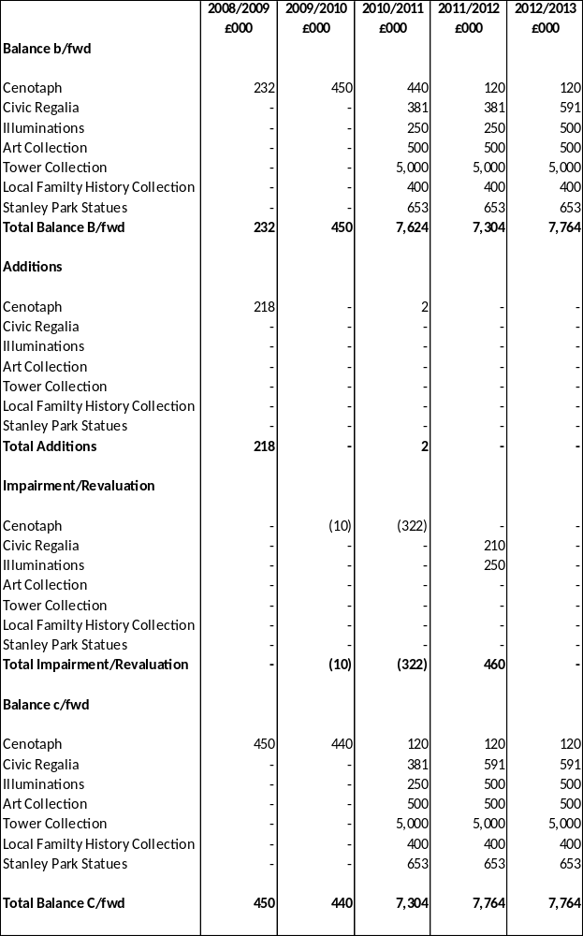

- HERITAGE ASSETS: FURTHER INFORMATION ON THE COLLECTION
Art Collection
The Art Collection is stored at the Grundy Art Gallery and consists of Victorian oils and watercolours, modern British paintings, contemporary prints, jewellery and video, oriental ivories, ceramics and photographs and souvenirs of Blackpool. The Council commissioned the building of the Grundy Art Gallery in 1908 following a bequest of 33 artworks from brothers John and Cuthbert Grundy, both of whom were artists. The Gallery displays artwork loaned from major UK institutions as well as its own permanent collection.
Family and Local History Collection
Mainly based at Blackpool Central Library this collection includes an extensive collection of maps, newspapers, and genealogical indices. It also includes the Cyril Critchlow Collection which is a collection of records, memorabilia and artefacts relating to Blackpool’s entertainment heritage.
Tower Company Collection
This collection transferred to the Authority when it purchased Blackpool Tower in March 2009. This collection is currently stored in Coastal House. The only item in this collection which is on display in Blackpool Tower is a silver model of Blackpool Tower. The collection has many items which represent Blackpool’s tourism heritage and includes many rare items.
Illuminations
This is a collection of illuminations previously used in the annual illuminations display. They are kept due to their historical and unique nature but will not form part of any future Illuminations displays. Many of the items have a “Disney studio” stamp on them which makes them unique and adds value.
Cenotaph
The Cenotaph was previously included in the balance sheet as a community asset but as it represents an historical event and is being held for the purposes of knowledge and culture the asset has been reclassified as a heritage asset.
The Cenotaph is situated on the promenade close to North Pier.
Civic Regalia
Civic Regalia includes the following items:
Mayor’s Chain –Made in 1875.
Mayoress’ Chain – Made in 1897.
Deputy Mayoress’ Chain – Made in 1897.
Deputy Mayor’s Chain – Made 1937.
Mayoral Mace – Made in 1897.
Stanley Park Statues
These are mainly statues of lions and other sculptures in Stanley Park.

SECTION 6

SUPPLEMENTARY SINGLE ENTITY FINANCIAL STATEMENTS

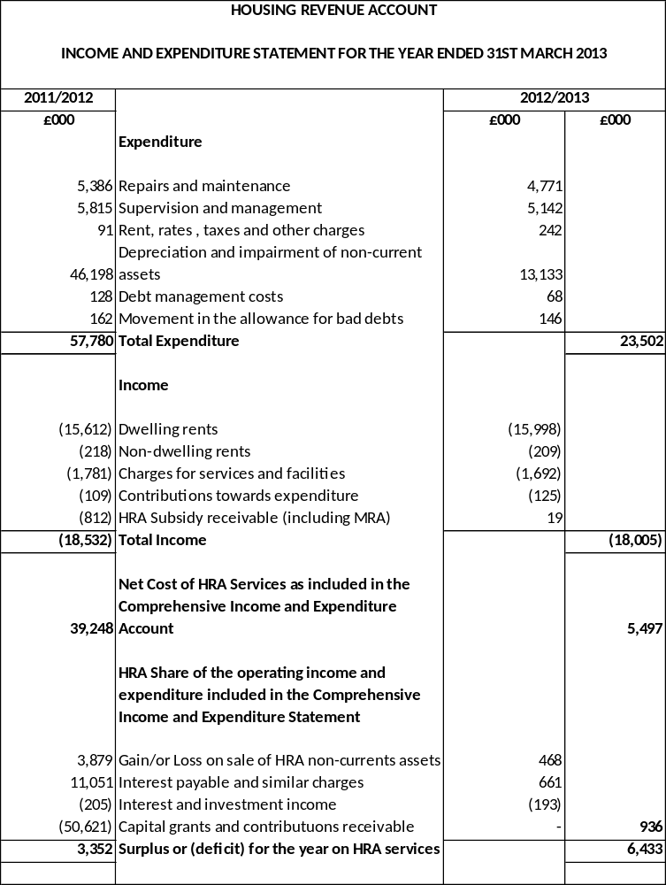

HOUSING REVENUE ACCOUNT
MOVEMENT IN RESERVES STATEMENT FOR THE YEAR ENDING 31ST MARCH 2013

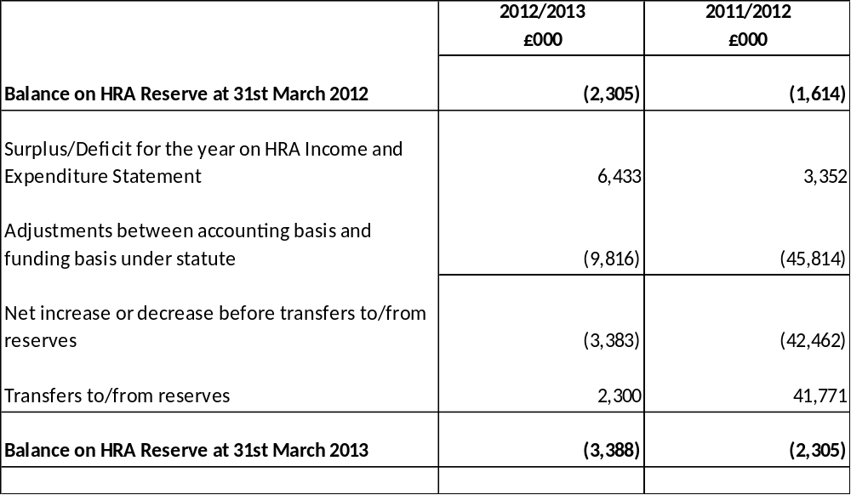

NOTES TO THE HRA STATEMENT

1. HOUSING REVENUE ACCOUNT STOCK

The Council owned 5,306 dwellings at 31st March 2013 which are analysed below:-

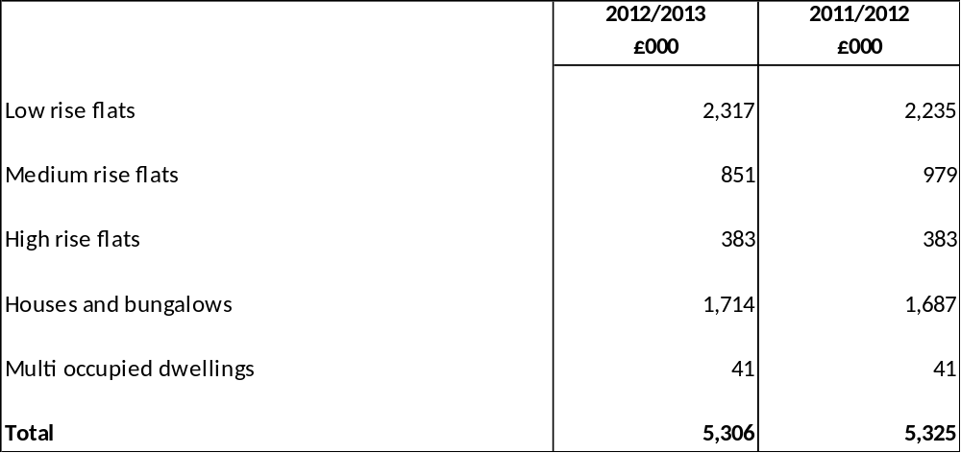

The change in the stock during the year is summarised below:-

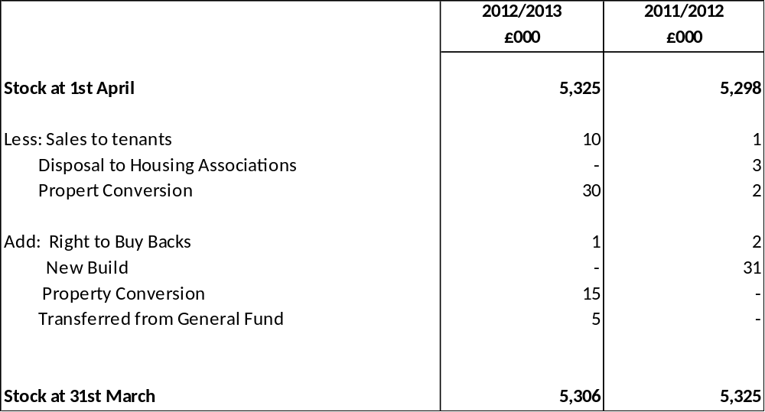

The Balance Sheet value of assets held in the Housing Revenue Account was as follows:-

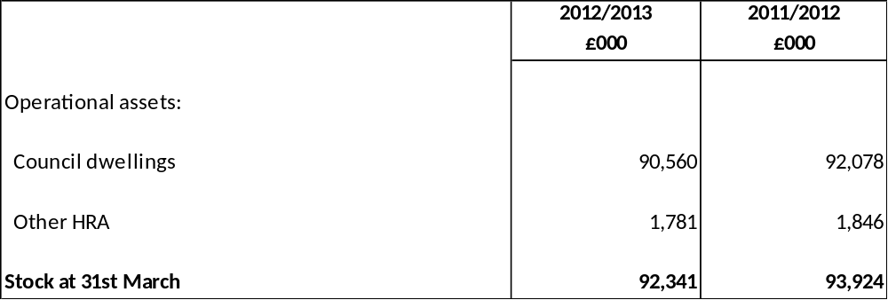

2. DWELLING RENTS

This is the total rent due for the year after allowance is made for voids etc. During the year 8.2% of lettable properties, including hostels, were vacant (2011/12: 4.9%). The predominant reason for the increased % is due to the proactive policy of holding properties vacant pending the future re-development of the Queens Park estate and other sites. The element for “development site” properties that were vacant was 4.76%, whereas the share for “non development site” properties was 3.53%.

The average rent was £62.79 a week in 2012/13, an increase of 6.64% over the previous year.

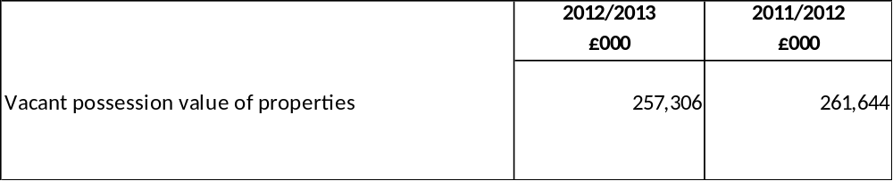

The vacant possession value of dwellings held on 31st March 2013 was £257,305,600. The difference between this and the Existing Use Value (Social Housing) valuation of £90,559,735 represents the economic cost to the Government of providing council housing at less than the open market rents.

3. MAJOR REPAIRS RESERVE

The movements in the Major Repairs Reserve (MRR) are summarised below:

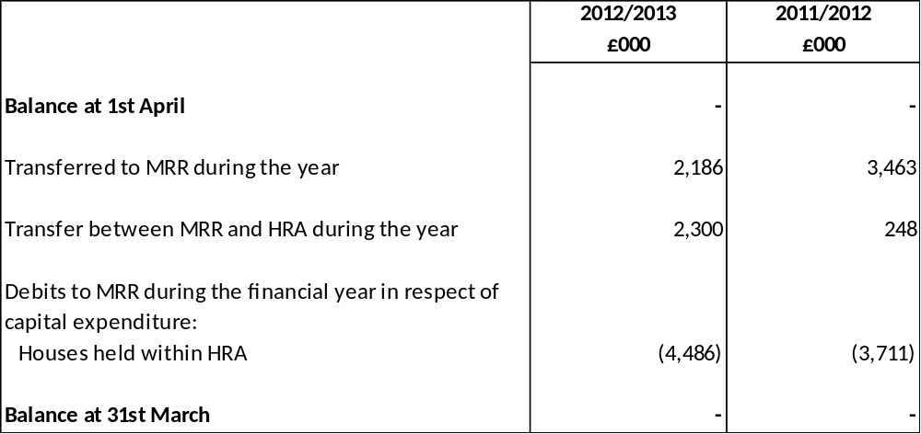

4. HOUSING REPAIRS ACCOUNT

The movement on the Housing Repairs Account during the year is summarised below:

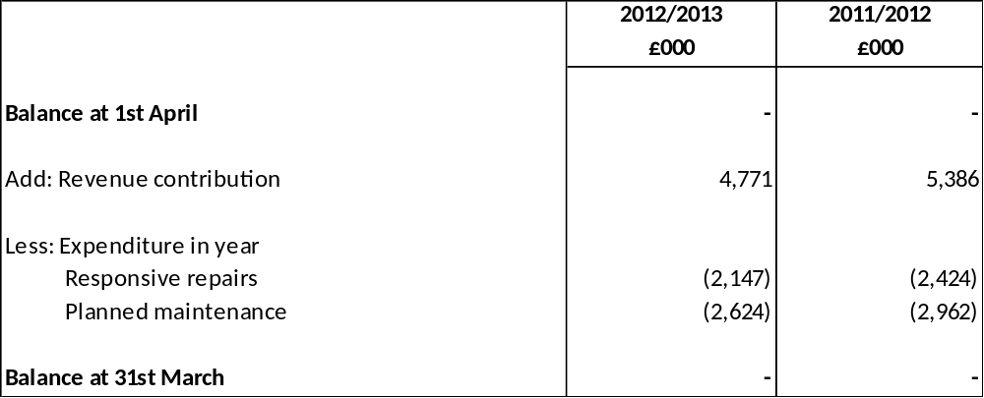

5. CAPITAL EXPENDITURE WITHIN HOUSING REVENUE ACCOUNT

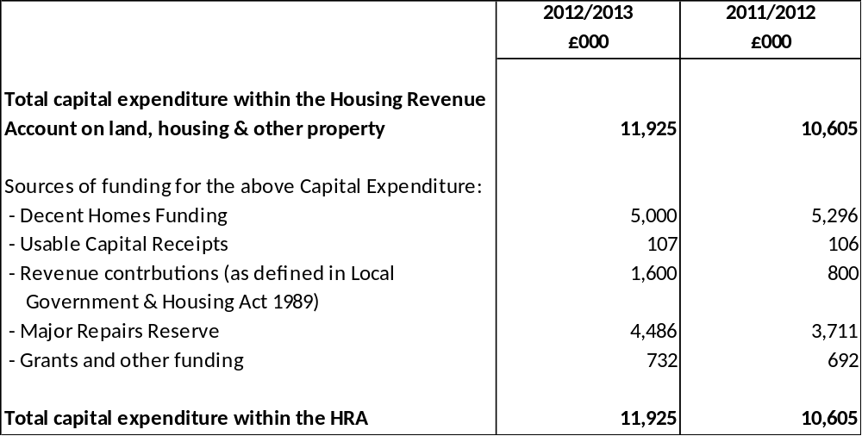

Usable capital receipts totalling £107,476 were received during the year.

6. DEPRECIATION CHARGE WITHIN THE HRA

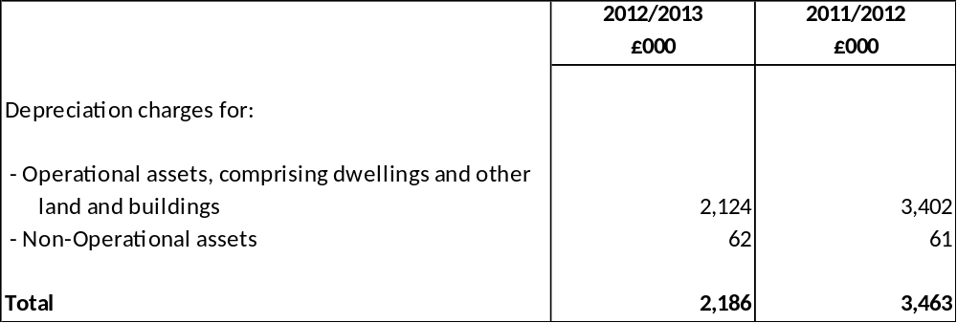

7. IMPAIRMENT

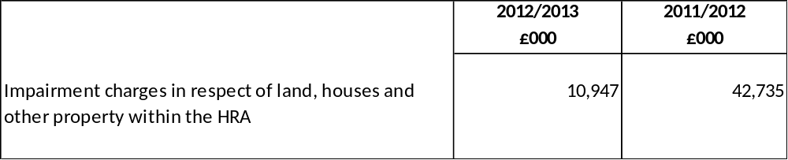

The basis of valuation of the housing stock within the HRA is Existing Use Value – Social Housing. This is calculated by applying a prescribed discount factor to the Existing Use Value – Vacant Possession. The impairment charge can be mainly accounted for as a result of the adjustment for properties earmarked for future demolition and redevelopment.

8. GOVERNMENT RULES

The Housing Revenue Account has been compiled in accordance with the Local Government and Housing Act 1989 as follows:

- Housing Subsidy and HRA Self-Financing

Up until 31 March 2012 the Housing Revenue Account Subsidy was central government’s contribution towards the cost of council housing in Blackpool. It was calculated as the amount required to balance a notional Housing Revenue Account, based on government estimates of the income and expenditure which should be earned and spent by the Authority on council housing.

The Housing Subsidy system ceased on 1 April 2012 when the HRA self-financing system was introduced as a result of the Localism Act 2011. The purpose of this Act is to put all local authorities in a position where they can manage their homes from their own income in future.

As a receiver of subsidy, Blackpool received a capital sum of £41,523,000 on 28th March 2012, in order to exit the subsidy system on 1st April 2012. The Secretary of State made a payment of £41,523,000 to the Public Works Loan Board (PWLB) to redeem PWLB debt on behalf of Blackpool. This early debt repayment lead to a premium payment of £9,098,000 which, in accordance with the Settlement Payment Determination, was also met by the Secretary of State. The total receipt of £50,621,000 was shown within the HRA under Capital grants and contributions and the immediate redemption of the debt and premium was also reflected within the HRA.

The balance of £19,000 in the 2012/13 accounts is a routine adjustment of the HRA Subsidy received in 2011/12 to adjust for actual figures compared with estimates when the subsidy returns were made. There are no further payments due to Blackpool from central government in relation to the subsidy system.

- The Ringfence

The present rules do not allow authorities to transfer funds from the Housing Revenue Account to the General Fund or vice versa except under specified conditions. The items to be included within the Housing Revenue Account are also specified.

- Control

A deficit balance on the Account is not allowed and the format of the Account must comply with Schedule 4 of the Act.

- Annual Report

An annual report to tenants must be published detailing activities and performance during the year.

Due to the cessation of the Housing Subsidy System on 1 April 2012 there was no receipt of Housing Subsidy in 2012/2013 as shown below:-

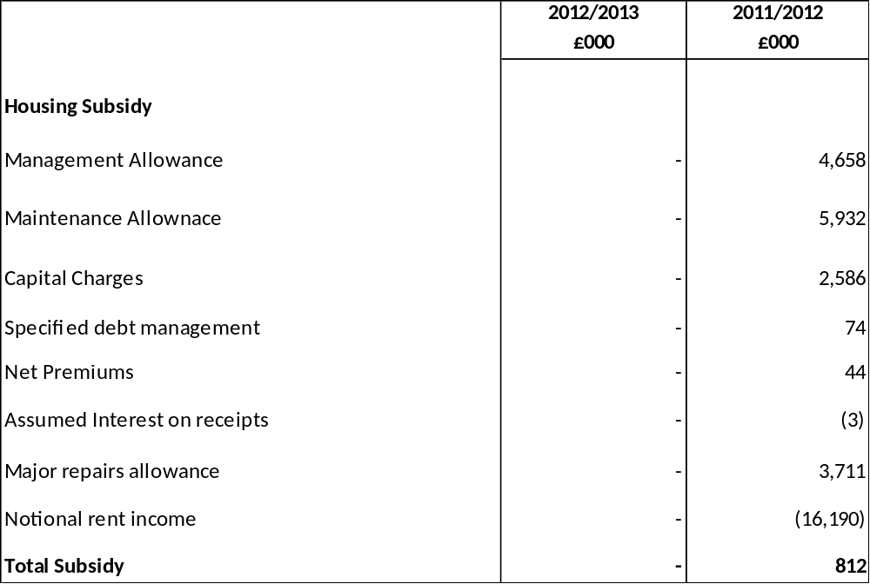

8. RENT ARREARS

Rent Arrears for 2012/2013 amounted to £577,000 compared to £641,000 in the previous year. During the year 2012/2013 rent arrears as a proportion of gross collectable rent (including service charges) were 3.6% (2011/2012 3.5%).

Amounts written off during the year amounted to £137,000 (2011/2012 £141,000). The total provision for bad and doubtful rental debts in the Housing Revenue Account at 31st March 2013 is £516,000 (£569,000 at 31st March 2012). This provision has been calculated in accordance with the Housing Revenue Account (Arrears of Rents and Charges) Directions 1990.

9. SUMS DIRECTED BY THE SECRETARY OF STATE

Rent Rebates are no longer accounted for in the HRA. This has implications for the method of controlling local authority rents used by the Department of Communities and Local Government. Local Authority rents are controlled by the Government through the use of Rent Rebate Subsidy Limitation. This reduces the level of grant the authority receives from the Department of Work and Pensions to fund the housing benefit payments if the average rent for the authority is above the limit set by the DCLG.
As Rent Rebates are no longer part of the Housing Subsidy, this amount is now reclaimed through the General Fund, but is still calculated on the same basis. As this loss of grant is suffered on the General Fund the HRA transfers funds to the General Fund to cover the loss of grant. This loss in 2012/2013 was nil (2011/2012 - £412,000) as the average rent was below the set limit.

COLLECTION FUND 2012/2013

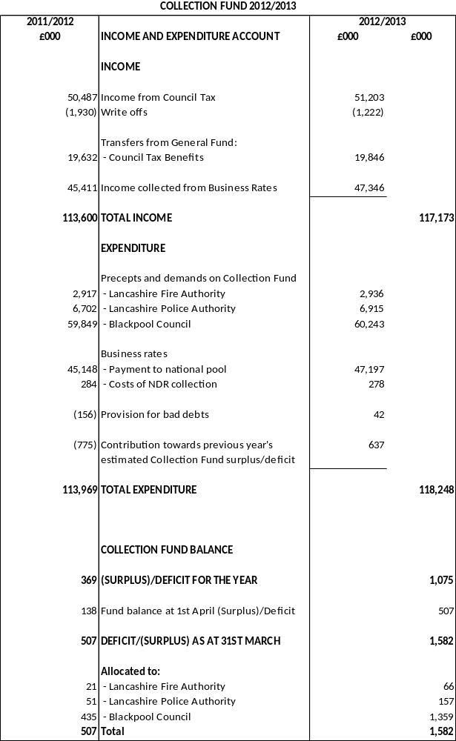

NOTES TO THE COLLECTION FUND

1. GENERAL

The Collection Fund was established under the Local Government Finance Act 1988 but the operation of the fund was changed substantially with the introduction of Council Tax in April 1993 under the Local Government Finance Act 1992.

The surplus or deficit on the Collection Fund is distributed between billing and precepting authorities on the basis of estimates made on 15th January of each year. The Collection Fund is operated on an accruals basis and the accounts are consolidated into the Council’s Balance Sheet.

2. INCOME FROM BUSINESS RATEPAYERS

The Council collects Non-Domestic Rates in respect of business premises by applying a rate poundage set by central Government to the rateable value of its premises. For 2012/2013 this was 45.8p (43.3p in 2011/2012). The rate for Small Business Rate Relief was 45.0p in 2012/2013 (42.6p for 2011/2012) Total non-domestic rateable value as at 31st March 2013 was £132m (6,835 properties).

The total amount, less certain reliefs and reductions, is paid to a central pool (the NNDR pool) managed by Central Government. The Government pay into the General Fund of the Council a share of the pool based on population.

3. COUNCIL TAX 2012/2013

The Council as billing authority is required to set a tax base for each billing year by 31st January of the previous year. The Council Tax base represents the number of chargeable dwellings in each valuation band (adjusted for discounts, etc) multiplied by a set proportion to give the number of band D equivalents.

The effect of the variation between the actual tax base during the year and the estimated tax base has resulted in a deficit on the Collection Fund relating to Council Tax as follows:-

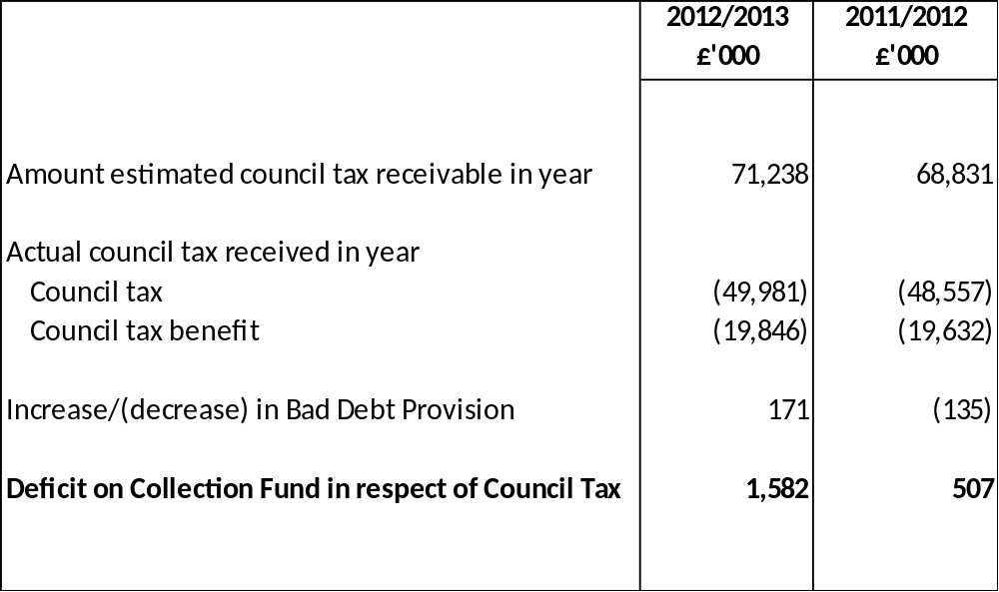

4.COUNCIL TAX BASE CALCULATION

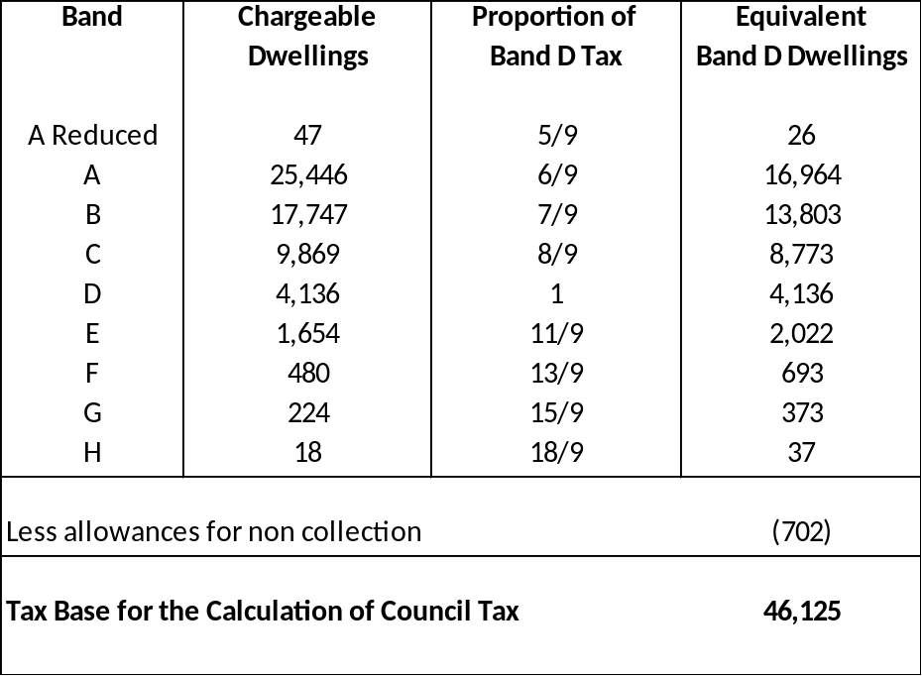

The tax base is not constant. The number of properties eligible for discounts varies during the year. The number of properties on the valuation list also varies during the year owing to new properties being occupied and others being demolished. As a result the amount receivable from council tax payers in the year varies from the estimated amount. This will result in a surplus or deficit on the Collection Fund in respect of Council Tax. Surplus and deficits on the Collection Fund are shared between the Council and the other precepting authorities (Lancashire Police Authority and Lancashire Fire Authority) in proportion to their budgets. The Council’s share of any surplus or deficit is used to reduce or increase the level of council tax bills in later years.

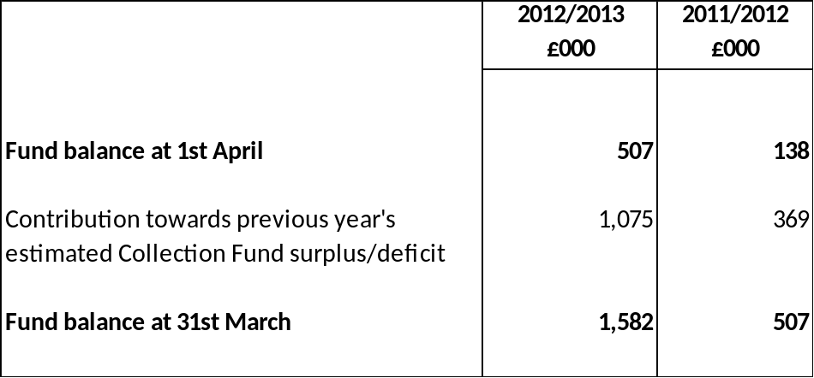

SECTION 7

GROUP ACCOUNTS 2012/2013

7.0 INTRODUCTION

The Group Accounts show the combined overall financial position of the Council, it’s subsidiary companies and it’s associates.

Subsidiaries are where the Council exercises control. Blackpool Transport Services, Blackpool Operating Company and Blackpool Coastal Housing are 100% owned by the Council and are therefore classified as subsidiaries. They are incorporated into the accounts on a line-by-line basis.

Associates are where the Council exercises significant influence. Marketing Lancashire and The Via Partnership are classified as such and are incorporated into the accounts on an equity basis.

Subsidiaries

Blackpool Transport Services

Blackpool Transport Services Limited was set up in accordance with the provisions of the Transport Act 1985 to operate the Council’s municipal bus operation. The company provides a comprehensive passenger transport service in the Fylde coast area through its bus and tram operations.
Blackpool Operating Company

The Council purchased the operation of the Sandcastle Waterpark from a private company on 20th June 2003 and now wholly owns both the building and the commercial operator - Blackpool Operating Company Limited (BOC). The Council’s shares in Blackpool Operating Company are valued at £2.

Blackpool Coastal Housing

Blackpool Coastal Housing is an ALMO (arms-length management organisation) of the Council and was formed on 15th January 2007. The company’s principal activities are to manage and maintain the housing stock of the Council.

Associates

Marketing Lancashire

Marketing Lancashire (previously known as Lancashire and Blackpool Tourist Board) is limited by guarantee and therefore has no share capital. The Council has 43% of the voting rights. It supports businesses in the Lancashire and Blackpool area by representing their interests regionally and nationally, by co-ordinating marketing activity, managing and developing the tourism product and working in partnership with industry. Activities in commercial membership, business support, “Welcome to Excellence” training, visitors services and marketing activity are all designed to improve quality and achieve common goals.

The Via Partnership

The Via Partnership (previously known as CX Limited) is limited by guarantee and therefore has no share capital. The Council has 30% of the voting rights. CXL supplies outsourced careers and personal development services to young people and adults and provides workforce training and development.

7.1 CORE FINANCIAL STATEMENTS – GROUP

GROUP MOVEMENT IN RESERVES STATEMENT
2012/2013

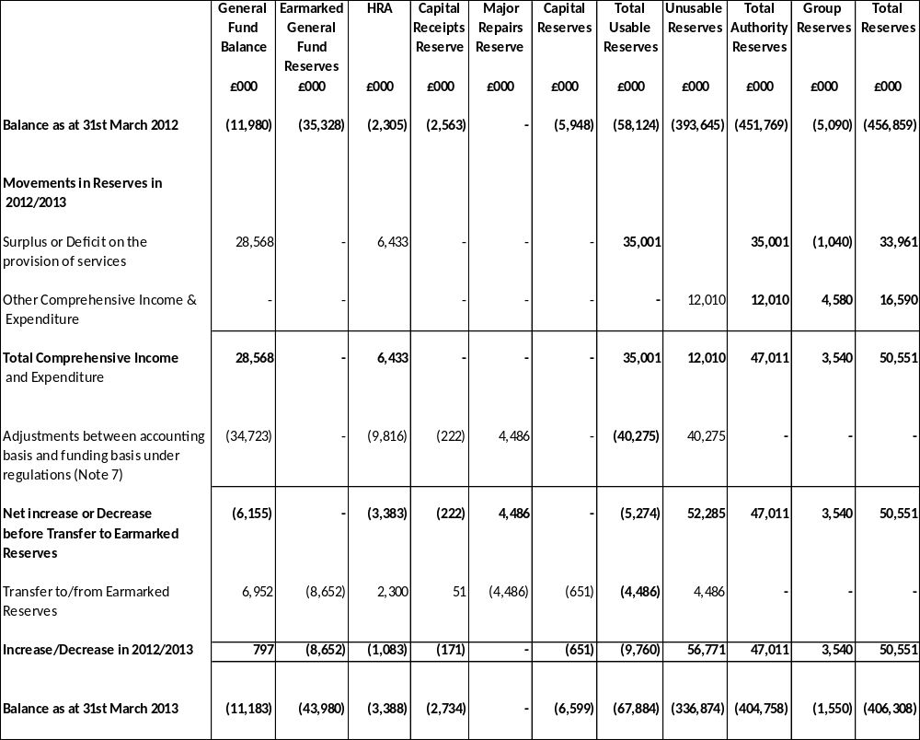

2011/2012

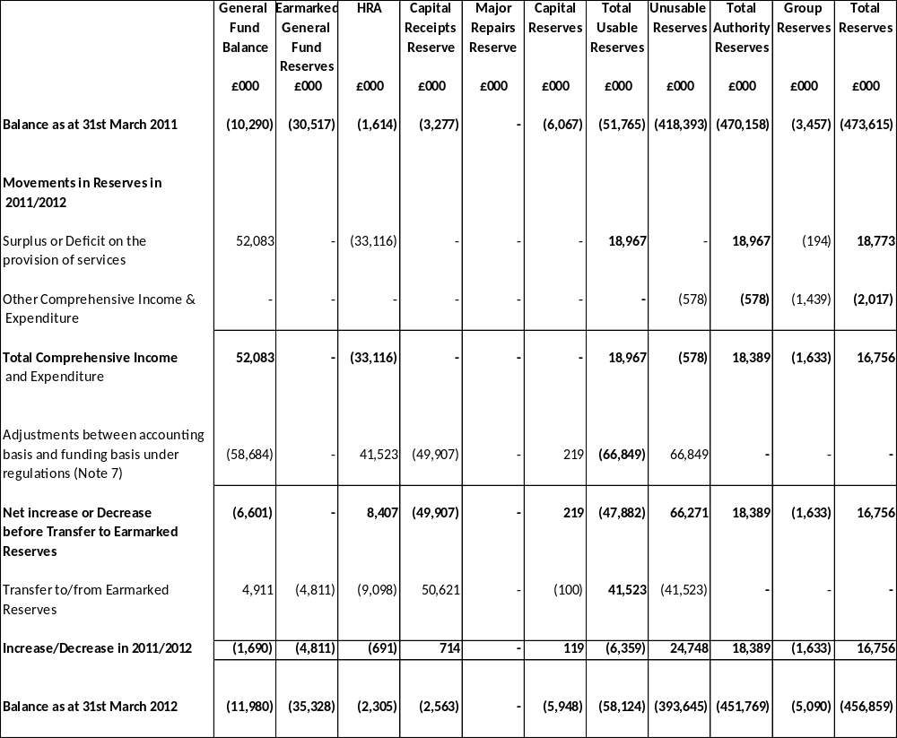

GROUP COMPREHENSIVE INCOME AND EXPENDITURE STATEMENT
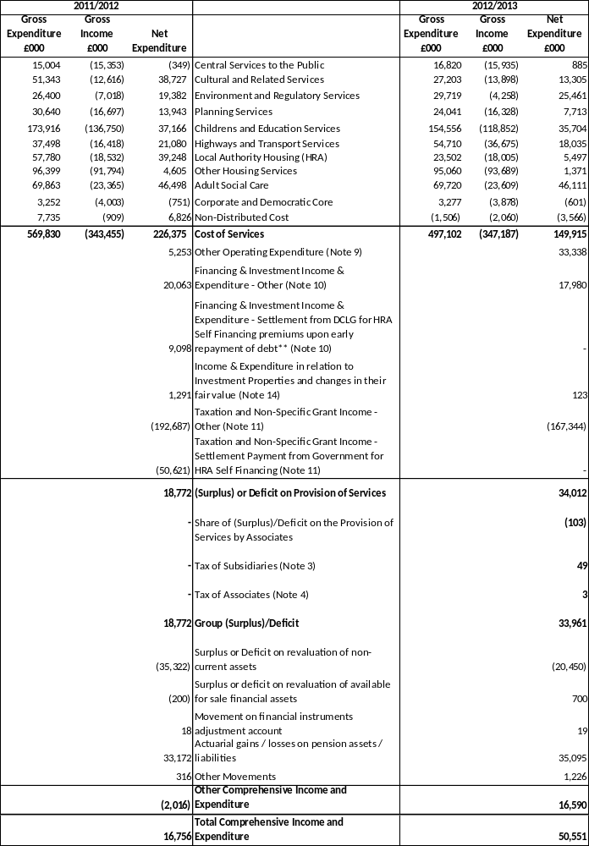

GROUP BALANCE SHEET
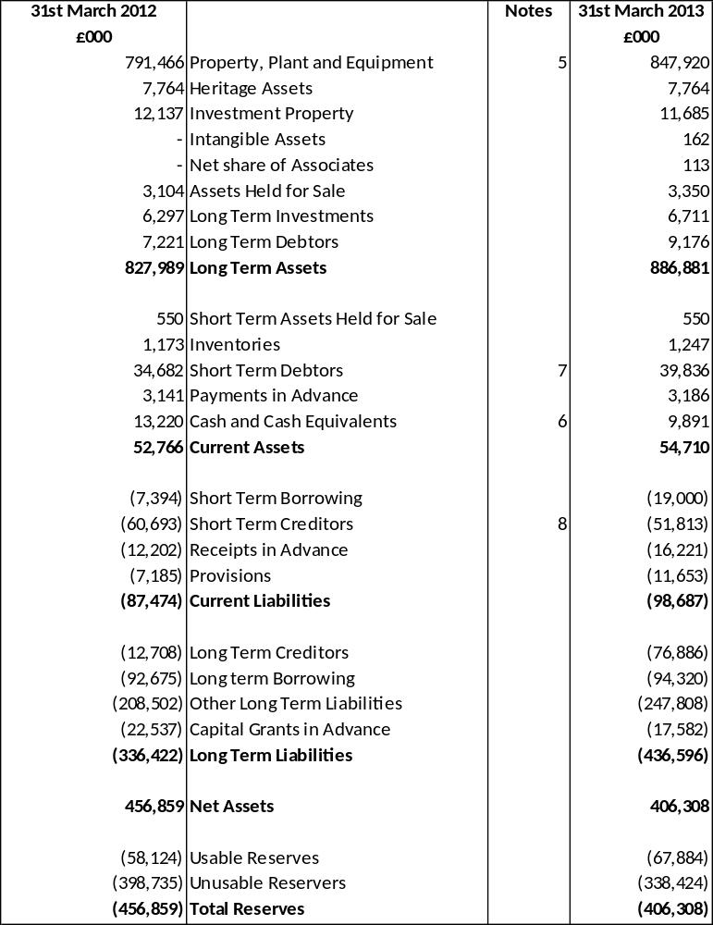

GROUP CASH FLOW STATEMENT

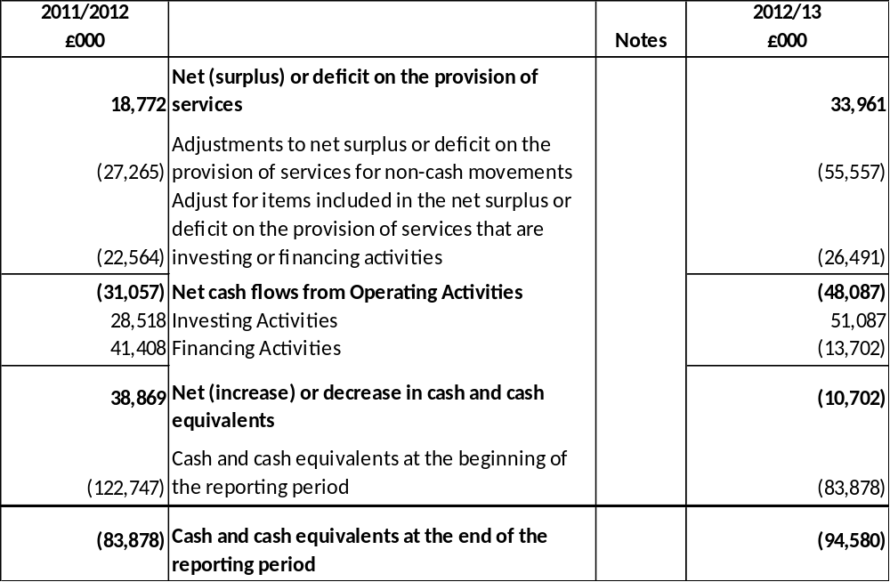

7.2 NOTES TO THE GROUP ACCOUNTS

- ACCOUNTING POLICIES

The group accounts include the Council’s share of the operating results, assets and liabilities of each group entity’s accounts. Subsidiaries are accounted for on an acquisition basis and incorporated line-by-line, writing out inter-group transactions. Associates are incorporated by accounting for the Council’s share of their operating results in the group income and expenditure accounts and of their assets in the balance sheet.

- INTER GROUP TRANSACTIONS

Certain figures from the balance sheets of Group members have been taken out of the consolidated position as they represent amounts outstanding within the Group and therefore cancel each other out in the balance sheet. The adjustments are as follows:

- The Council owns shares to the value of £2,789,000 in Blackpool Transport. This has been taken out of long term investments and capital and reserves
- An amount of £216,761 representing amounts outstanding between the Council and Blackpool Transport has been taken out of debtors and creditors.
- An amount of £776,603 representing amounts outstanding between the Council and Blackpool Operating Company has been taken out of debtors and creditors

- TAX OF SUBSIDIARIES

This figure represents the Council’s share of the Corporation Tax due by its subsidiary Blackpool Operating Company, £49,000.

- TAX OF ASSOCIATES

This figure represents the Council’s share of the Corporation Tax due by its associate Marketing Lancashire, £3,000.

- PROPERTY, PLANT AND EQUIPMENT

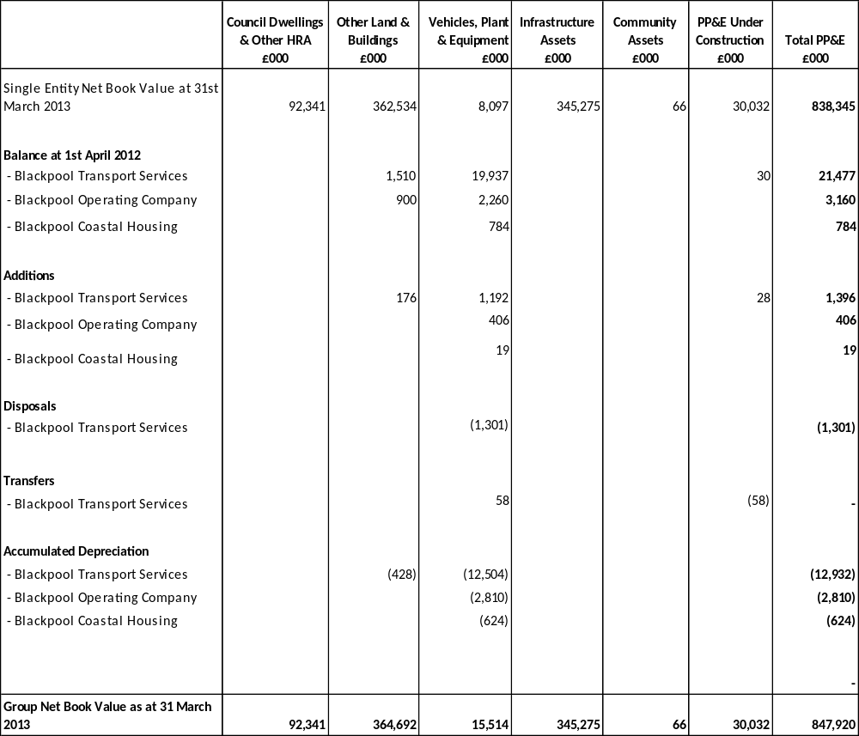

- CASH AND CASH EQUIVALENTS

The balance of cash and cash equivalents is made up of the following elements:

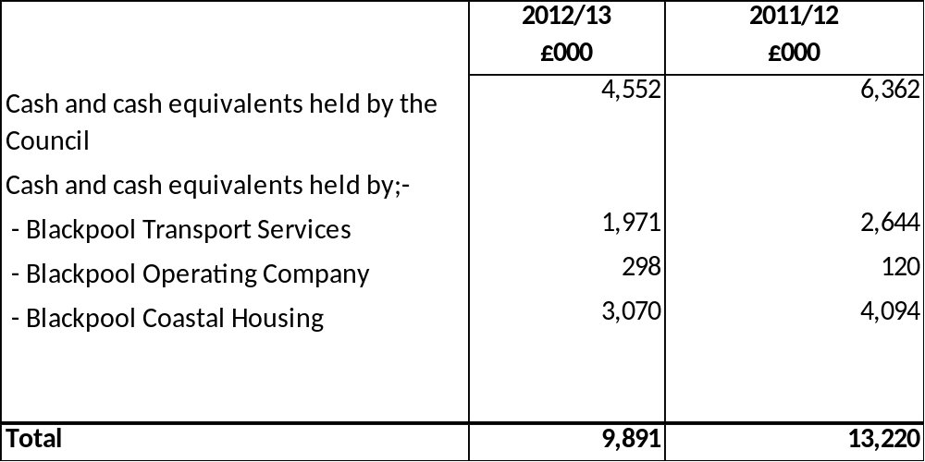

- SHORT-TERM DEBTORS

The group short-term debtors are made up of the following amounts:

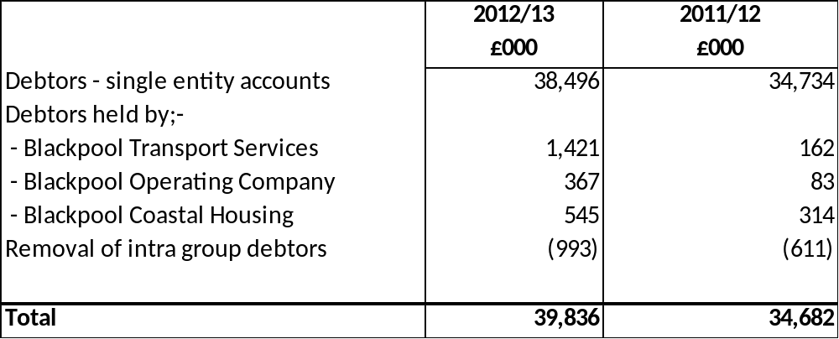

- SHORT-TERM CREDITORS

The group short-term creditors are made up of the following amounts:

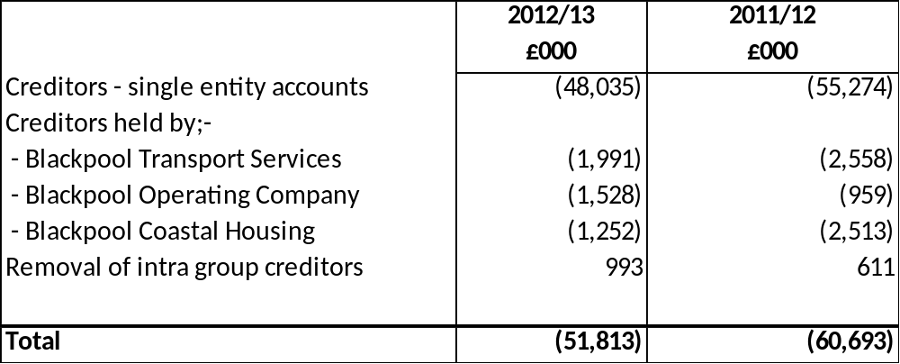

- SEGMENTAL REPORTING

The income and expenditure of the Authority’s Group recorded in the budget reports for the year is as follows:

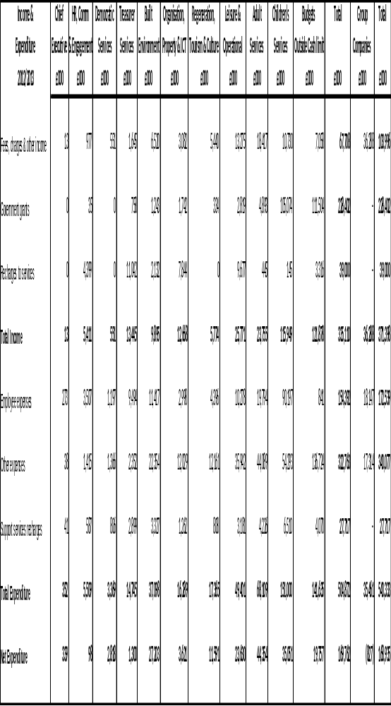

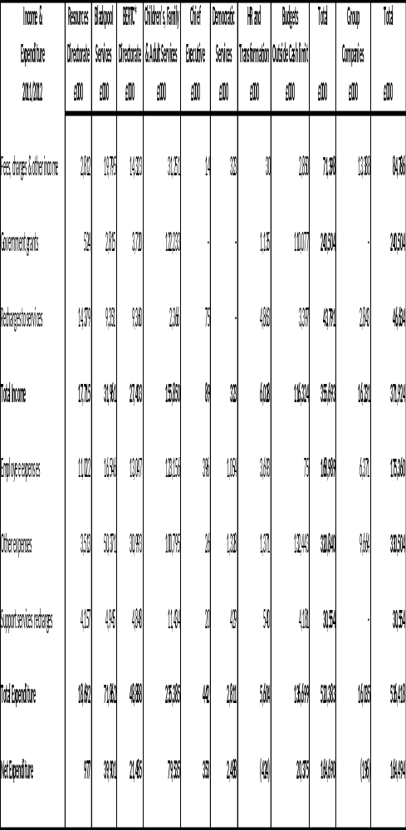

Reconciliation of the Departments Income and Expenditure to Cost of Services in the Comprehensive Income and Expenditure Statement

This reconciliation shoes how the figures in the analysis of department’s income and expenditure relate to the amounts included in the Comprehensive Income and Expenditure Statement.

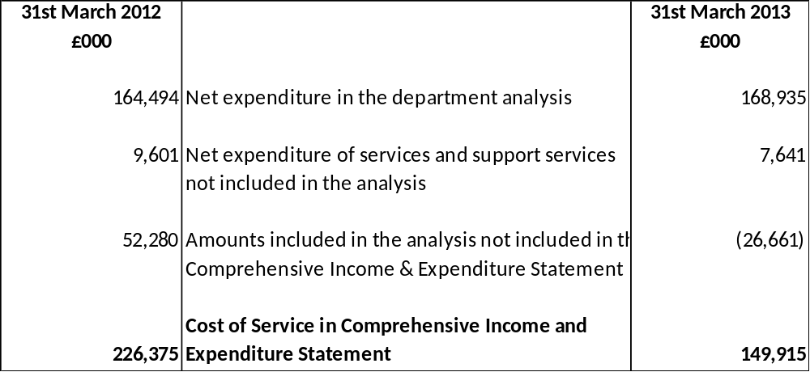

Reconciliation to the Subjective Analysis

This reconciliation shows how the figures in the analysis of department’s income and expenditure relate to a subjective analysis of Surplus or Deficit on the Provision of Services included in the Group Comprehensive Income and Expenditure Statement.

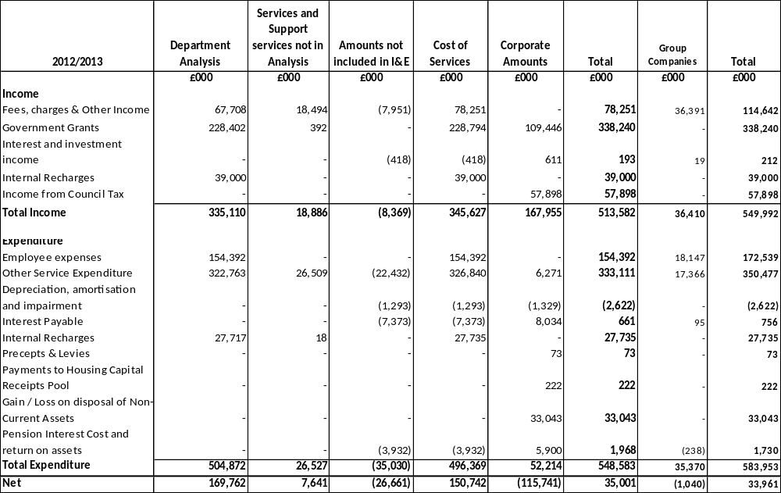

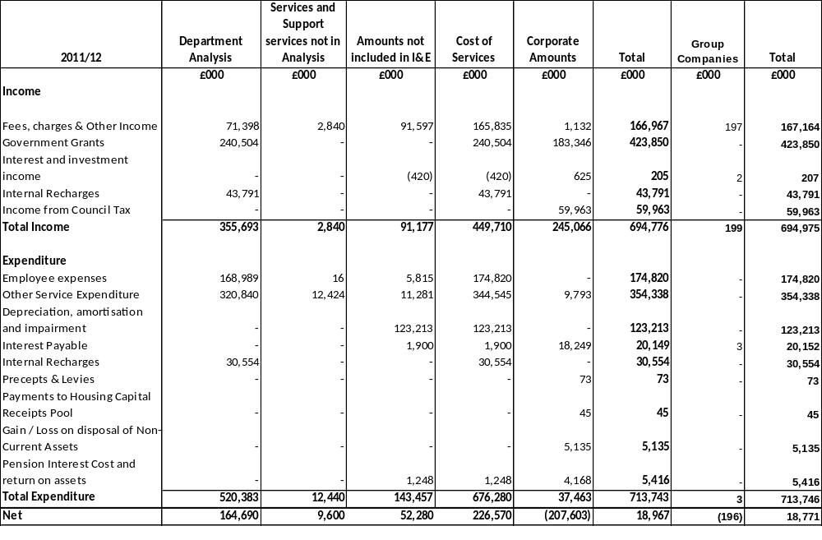

SECTION 8

ANNUAL GOVERNANCE STATEMENT

Blackpool Council
Annual Governance Statement – 2012/2013

Scope of responsibility

Blackpool Council is responsible for ensuring that its business is conducted in accordance with the law and proper standards, and that public money is safeguarded and properly accounted for, and used economically, efficiently and effectively. Blackpool Council also has a duty under the Local Government Act 1999 to make arrangements to secure continuous improvement in the way in which its functions are exercised, having regard to a combination of economy, efficiency and effectiveness.

In discharging this overall responsibility, Blackpool Council is responsible for putting in place proper arrangements for the governance of its affairs, facilitating the effective exercise of its functions, and which includes arrangements for the management of risk.

Blackpool Council strives to operate is a manner consistent with the principles of the CIPFA / SOLACE Framework Delivering Good Governance in Local Government. This statement explains how Blackpool Council has complied with the code and also meets the requirements of Accounts and Audit (England) Regulations 2011, regulation 4 (3), which requires all relevant bodies to prepare an Annual Governance Statement.

The purpose of the governance framework

The governance framework comprises the system and processes, culture and values by which the authority is directed and controlled and its activities through which it accounts to, engages with and leads its communities. It enables the authority to monitor the achievement of its strategic objectives and to consider whether those objectives have led to the delivery of appropriate services and value for money.

The system of internal control is a significant part of that framework and is designed to manage risk to a reasonable level. It cannot eliminate all risk of failure to achieve policies, aims and objectives and can therefore only provide reasonable and not absolute assurance of effectiveness. The system of internal control is based on an ongoing process designed to identify and prioritise the risks to the achievement of Blackpool Council’s policies, aims and objectives, to evaluate the likelihood and potential impact of those risks being realised, and to manage them efficiently, effectively and economically.

The governance framework has been in place at Blackpool Council for the year ended 31st March 2013 and up to the date of the approval of the statement of accounts for that year.

The governance framework

The key elements of the systems and processes that comprise Blackpool Council’s governance arrangements are summarised below.

Vision, Values and Priorities

Blackpool Council’s Vision is:

“We will build a Blackpool where aspiration and ambition are encouraged and supported. We will seek to narrow the gap between the richest members of our society and the poorest and deliver a sustainable and fairer community, of which our communities will be proud.”

Blackpool Council’s slogan is:

“'Blackpool: A fair place where aspiration and ambition are encouraged’.

Blackpool Councils Value’s are:

- We are accountable for delivering on the promises we make and take responsibility for our actions and the outcomes achieved
- We are committed to being fair to people and treat everyone we meet with dignity and respect
- We take pride in delivering quality services that are community focused and are based on listening carefully to what people need
- We act with integrity and we are trustworthy in all our dealings with people and we are open about the decisions we make and the services we offer
- We are compassionate, caring, hard-working and committed to delivering the best services that we can with a positive and collaborative attitude

The vision and values set out a high level vision of how the Council will address the ten priorities of the Council. These will be developed in the Council’s Plan which is a key element of Blackpool’s business planning process.

The Council’s priorities are:
- Tackle child poverty, raise aspirations and improve educational achievement
- Safeguard and protect the most vulnerable
- Expand and promote our tourism, arts, heritage and cultural offer
- Improve health and well-being especially for the most disadvantaged
- Attract sustainable investment and create quality jobs
- Encourage responsible entrepreneurship for the benefit of our communities
- Improve housing standards and the environment we live in by using housing investment to create stable communities
- Create safer communities and reduce crime and anti-social behaviour
- Deliver quality services through a professional, well-rewarded and motivated workforce

The priorities seek to address the big issues and policy drivers facing local government. The Council priorities feed into departmental business plans and are a key tool for managers to use when developing business plans for the coming year. The strong golden thread from community aspirations continues through to individual performance appraisals as they are developed based on Council’s vision, values and priorities.

The Leadership Team are currently refining the Council Priorities which will be published in the Council Plan in July 2013. Performance will be reported against the Council’s priorities on a quarterly basis. These reports will include progress made against actions, performance indicators, contextual information and progress against issues raised at Scrutiny Committee in the previous quarter.

Performance Management

There has been a reduced inspection regime on Council services due to changes in Central Government. To help mitigate the risk of the impact of the reduced inspection regime the Council is starting to participate in more peer reviews drawing on experience from other Local Authorities and the private sector.

The Council has a performance management system in place with high level performance issues being reported to the Scrutiny Committee and local performance indicators being managed through the business planning framework.

In March 2013 the Scrutiny Committee were presented with a number of options for future performance management arrangements. It was agreed that these would consist of:

- Presentation of performance data by officers and cabinet members
- Performance challenge through scrutiny reviews
- Overarching performance reports

Performance challenge sessions will take place at the Scrutiny Committee on a quarterly basis, and performance management will be integrated into future scrutiny reviews.

Roles and Responsibilities

Responsibilities and functions are in place for each of the Council’s Committees, including Licensing, Planning, Standards, Scrutiny and the Finance and Audit Committees. These are reviewed annually with any changes made at the Council’s Annual Meeting, to ensure they are fit for purpose. The Executive has also recently agreed a revised set of criteria relating to levels of decision making, which will add clarity and consistency for decision makers.

All Council Officers, including the Corporate Leadership Team, have a job description which sets out their roles and responsibilities. Individual objectives for each officer are then part of the Individual Performance Appraisal process.

The Council’s Constitution, including the Scheme of Delegation set out the arrangements and protocols which are in place to enable effective communication within the authority and they also identify arrangements for working with partnership.

Behaviour and Conduct

An elected member/ officer protocol is incorporated in the Council’s Constitution and there is also a Planning Committee protocol. Training is provided to officers and members to enable them to better understand the roles of each other.

There are registers of interests and hospitality for both elected members and officers. Members must register and declare interests on appropriate occasions, supported by appropriate professional advice at any time where this is required.

The Council’s Standards Framework has specific regard to probity and high standards of ethical conduct. This process has been subject to significant changes following the introduction of the Localism Act, including the Council adopting a revised Code of Conduct for Elected Members and a new procedure for handling the initial assessment on elected member misconduct complaints.

Any development needs in terms of conduct are identified through officer Individual Performance Appraisal or member self-assessment as appropriate, a regular programme of training is also provided.

Employees abide by the terms of the Council’s officers Code of Conduct. Where appropriate staff are expected to comply with the Constitution and Financial Regulations, these are both updated regularly and appropriate training offered on changes.

Decision Making Framework

The Constitution sets out the functions and responsibilities of the Council, the Executive and committees. Included in this are the delegation arrangements adopted by the Council and the Executive.

All Executive decisions contain all relevant policy implications including financial, risk management, human resource issues including equality analysis and legal considerations. Records of decisions and supporting materials are maintained, with public disclosure of decisions on the Council’s internet site. The Monitoring Officer or a designated representative, receive all decisions before they are processed and therefore are able to check the robustness of data quality prior to a decision being submitted for formal approval.

The Constitution is reviewed and updated on an ongoing basis with several updates occurring during the last 12 months.

Risk Management

An officer Corporate Risk Management Group meets quarterly to co-ordinate and promote risk management activity, and the Council Leader is invited to all meetings and is provided with all papers relating to the agenda and minutes. It is supported by departmental and thematic risk management groups. All departments have nominated risk champions to promote best practice in their areas and risk registers are maintained for major projects and partnerships.

The Strategic Risk Register is reviewed by the Corporate Leadership Team every six months and considered by the Finance and Audit Committee annually. Responsible officers identified in the Strategic Risk Register are required to attend Finance and Audit Committee to explain how the risks are being managed and what further mitigating controls may be required.

Counter Fraud and Anti-Corruption Arrangements

The Council has an Anti-Fraud and Corruption Statement in place and this is approved by the Finance and Audit Committee on an annual basis. Any suspected instances of fraud and corruption are reported to the Chief Internal Auditor so that an appropriate investigation into the matter can be undertaken.

An Investigations Team is in place which investigates instances of welfare benefit fraud in line with the relevant legislation and guidance.

The Council has appropriate procedures in place to deal with the risk of money laundering and also to raise awareness of the Bribery Act and ensure that appropriate controls are in place to reduce the risk.

The Council participates in the National Fraud Initiative and a plan for investigating the data matches released was agreed in February 2013 and progress against this is monitored on a regular basis.

Management of Change and Transformation

The Council is committed to ensuring that it delivers value for money. Significant changes have been made to the Council structure and working practices to ensure the delivery of significant budget cuts as a result of the Comprehensive Spending Review. The Council continually considers ways in which further efficiency can be made to reduce costs whilst maintaining the delivery of a quality service and also considers how to effectively manage change.

Financial Management Arrangements

The Council has designated a Section 151 Officer with appropriate qualifications and experience and a deputy has also been appointed. The section 151 Officer, known in Blackpool as the ‘Statutory Finance Officer’, has arrangements in place for financial management, financial reporting and value for money which are assessed as satisfactory by the Council’s external auditors.

Monthly financial reporting summaries are made available to the Corporate Leadership Team, the Executive and the Finance and Audit Committee.

The Council’s financial management arrangements conform to the governance requirements of the CIPFA Statement on the Role of the Chief Financial Officer in Local Government (2010).

The 2011/2012 ISA260 report provided by external audit has not identified any significant issues in the Council’s financial management arrangements.

Assurance Arrangements

The Council prepares an annual Audit Plan which is approved by the Corporate Leadership Team and the Finance and Audit Committee each year. This includes a balance of risk and compliance work. The assurance statement for each audit is reported quarterly to the Finance and Audit Committee and contributes to the Chief Internal Auditor’s annual opinion. The opinion of the Chief Internal Auditor was presented to Finance and Audit Committee on the 6th June 2013.

An element of contingency is built into the Audit Plan to enable the Internal Audit Team to proactively respond to any issues which may arise throughout the year.

The Council’s assurance arrangements broadly conform to the governance requirements of the CIPFA Statement on the Role of the Head of Internal Audit (2010) and this is reviewed annually.

Monitoring Officer

The Council has designated a Monitoring Officer with appropriate qualifications and experience and a deputy has also been appointed. The Monitoring Officer is responsible to Blackpool Council for ensuring that agreed procedures are followed and all applicable statutes and regulations are complied with.

Head of Paid Service

The Council has in place effective arrangements to discharge the Head of Paid Service function and this role is undertaken by the Chief Executive.

Finance and Audit Committee

The Council has a Finance and Audit Committee which meets on a regular basis. This is independent of the scrutiny framework, and as a full committee of the Council is able to discharge all the core functions of a Finance and Audit Committee identified in CIPFA’s Audit Committee: Practical Guidance for Local Authorities including approval of the annual Statement of Accounts.

An ongoing programme of training on finance, audit and corporate governance topics is in place to ensure members have all the skills required to undertake their role.

Compliance with Laws, Regulations, Internal Policies and Procedures

The Council has an internal control framework in place which helps ensure compliance with relevant laws and regulations, internal policies and procedures and that expenditure is lawful.

All managers are expected to adhere to the Council’s Constitution and Financial Regulations. Non-compliance with such procedures may result in disciplinary action.

An internal audit function is in place to provide assurance that controls are being adhered to. The Finance and Audit Committee receives copies of all audit assurance statements and has the ability to challenge officers where issues of non-compliance have been identified.

The Council’s Monitoring Officer has a role in ensuring that the Council acts within the remit of relevant law and regulations and that a robust democratic process is maintained.

Whistleblowing and Complaints

A whistleblowing procedure is in place. All complaints received under this procedure are investigated by appropriate officers. A corporate complaints procedure also operated during the period to ensure that any issues raised by members of the public were fully investigated. A pilot process has been implemented to deal with complaints which reach Stage Three of the complaints process where an independent panel of officers review and investigate the complaint before a response is provided to the complainant. This is chaired by the Deputy Chief Executive and attended by the Monitoring Officer, Chief Internal Auditor and Chief Accountant.

Training and Development

A Member Development Programme is in place which helps deliver training to elected members to help them fulfil their role.

Elected members have personal development plans in place which are used to help identify training needs and the decision has been taken to split the members training budget in 2013/2014 between the political groups, to ensure that appropriate training can be delivered to all members.

A range of training and development opportunities are available for officers and this is informed through the Individual Performance Appraisal process which is mandatory for all officers across the Council.

A training programme is in place for senior officers to help enhance leadership skills.

Consultation

The Council consults and engages with a diverse cross-section of the community to help ensure that their views are considered, such as Area Forums.

Public speaking is available at many meetings such as Executive, Scrutiny and the full Council meeting.

The Council also regularly publishes the Your Blackpool newsletter and is currently in the process of updating its website to help improve access to information via this forum.

Partnerships and Joint Working

The Council has recently reviewed the governance arrangements with its wholly owned companies and has now a Companies Governance Code of Practice in place. This has led to the Memorandum and Articles of Association for each company being reviewed and the development of a Memorandum of Understanding between the Council and each company, to help define working arrangements.

Review of effectiveness

Blackpool Council has responsibility for conducting, at least annually, a review of the effectiveness of its governance framework including the system of internal control. The review of effectiveness is informed by the work of executive managers within Blackpool Council, who have responsibility for the development and maintenance of the governance environment, the Chief Internal Auditor’s annual report, and also by comments made by the external auditors and other review agencies and inspectorates.

A number of steps have been taken to review the effectiveness of governance arrangements in 2012/2013 and these include:

- Risk Champions have completed a control self-assessment on the internal control framework within their departments.
- A governance workshop was held with the Leader of the Council, Chair of Finance and Audit Committee and Chair of Standards Committee to assess the Council’s performance against the key principles of the CIPFA / SOLACE governance framework.
- The members of the Finance and Audit Committee undertook a self-evaluation of their effectiveness against the CIPFA Audit Committee: Practical Guidance for Local Authorities.
- The development of a set of principles to further define Executive decision making, giving increased clarity on who takes decisions at what level.
- Key officers, charged with governance responsibilities, including the Monitoring Officer, Section 151 Officer, Chief Internal Auditor and Head of Corporate Development, Engagement and Communication were involved in the review.
- The Corporate Leadership Team has had the opportunity to comment on the governance framework and statement.

The implications of the results of the effectiveness of the governance framework have been identified by the Finance and Audit Committee, and these state that arrangements continue to be regarded as fit for purpose in accordance with the governance framework. The areas already addressed and those to be specifically addressed with new actions planned are outlined below.

Significant Governance Issues

As part of the review of significant governance issues highlighted in 2011/2012 it has been deemed appropriate to remove some of the actions as these have now been effectively addressed included in this are:

Governance Issues Addressed in 2012/2013
Issues | Action to be taken | Responsible Officer
Welfare Reform | Implement an effective system to address the localisation of council tax support.  Implement processes for the transition of social funds to the Council. | Treasurer
Facilities management | Ensure that the recommendations in relation to property services review are implemented to avoid unnecessary duplication. | Assistant Chief Executive Organisation, Property and Information Technology / Assistant Chief Executive Leisure and Operational Services
Governance arrangements for subsidiary companies, leisure assets and key partnerships | Ensure adequate governance arrangements are in place for subsidiary companies.  Ensure adequate financial governance arrangements for leisure assets and new marketing company. | Head of Democratic Services and Monitoring Officer
Member involvement | Ensure that members are fully supported in their constituency work by the continued roll out of the EBF member enquiry system.  Ensure that there is a Member Development Strategy and Member Training Programme and the continuation of briefing sessions between Council meetings.  Implement the new Standards Framework and train elected members and co-opted members accordingly. | Head of Democratic Services and Monitoring Officer
Public Health Transition | Ensure that effective governance arrangements are in place for public health.  Ensure that the public health transition project is effectively managed. | Assistant Chief Executive Adults and Families

There are a number of governance issues which it would be prudent to carry forward as further work is required to fully address the issues. Additional actions have been identified as part of the 2012/2013 review of the effectiveness of the governance framework and these are captured in the following table. It should be noted that some of the issues identified are not deemed as significant but have been included to aid openness and transparency.

Governance Issues to be Addressed in 2013/2014
Issues | Action to be taken | Responsible Officer
Welfare Reform | Manage the transition to Universal Credit.  Ensure that the Council has the resource available to investigate corporate fraud after the introduction of the Single Fraud Investigation Service. | Treasurer
Collection Fund | Monitoring and management of the Collection Fund to assess the impact of the introduction of the Localisation of Business Rates and the Council Tax Reduction Scheme. | Treasurer
Delivery of corporate savings programme | Departments to adhere to agreed savings targets, identifying alternative savings or income generation where pressures develop.  Progress on achieving savings monitored from month 0.  Delivery of core services including appraisal of internal controls within available resource. | Treasurer
Project management | Undertake an advisory role to ensure effective project management leads to successful project outcomes across all Council projects.  Ensure effective project management leads to successful project outcomes within sphere of influence  Ensure project management training is available. | Assistant Chief Executive Organisation, Property and Information Technology  Deputy Chief Executive Human Resources, Communication and Engagement
Facilities management | Deliver Council’s accommodation strategy and reduce desk footprint by delivery of the Central Business District project.  Ensure that the Council’s property estate is operated to maximise rental income or disposal values as appropriate. | Assistant Chief Executive Organisation, Property and Information Technology
Procurement | Ensure all services comply with Contract Procedure Rules.  Completion of e-procurement and e-invoicing rollout.  Development of integrated commissioning frameworks with economies of scale.  Delivery of Personalisation agenda. | Treasurer  Assistant Chief Executive Children and Younger Adults  Assistant Chief Executive Adults and Families
Member involvement | Ensure that officers are aware of the decision making process and that this is adhered to.  The Member’s Code of Conduct to be reviewed.  A skills audit to be undertaken with elected members.  The scrutiny function should be strengthened to ensure that elected members have the skills to effectively challenge.  The work planning process for the Scrutiny Committee should be improved to ensure that it is prioritised effectively. | Head of Democratic Services
Complaints and requests for information. | Deliver the new corporate complaints process across the Council.  Ensure that Freedom of Information, Subject Access and Environmental Information requests are dealt with in a timely manner. | Deputy Chief Executive Human Resources, Communications and Engagement  Assistant Chief Executive Organisation, Property and IT
Staff development | Ensure that all staff complete mandatory training requirements.  Ensure that senior managers complete the Working with Members training programme.  Ensure that staff appraisals are carried out across the Council and that these are uploaded to the Vision HR system. | Deputy Chief Executive Human Resources, Communications and Engagement
Protect vulnerable adults and children. | Ensure that adequate controls are put in place to safeguard vulnerable adults and children.  Ensure that steps are taken to address the control failings identified in the recent inspection reports. | Assistant Chief Executive Adults and Families  Assistant Chief Executive Children and Younger Adults
Risk management | Ensure that all services have in place up-to-date and fit-for-purpose business continuity plans.  Ensure that all departments have in place an effective Departmental Risk Management Group.  The Property Risk Management Group’s terms of reference and representation should be reviewed to ensure that it is working effectively. | Treasurer
Performance management | A review of the revised performance monitoring arrangements should be undertaken to ensure that it is effective.  A piece of work should be undertaken to identify the Council’s core business going forward. | Deputy Chief Executive Human Resources, Communications and Engagement  Corporate Leadership Team / Executive

We propose over the coming year to take steps to address the above matters to further enhance our governance arrangements. We are satisfied that these steps will address the need for improvements that were identified in our review of effectiveness and will monitor their implementation and operation as part of our next annual review.

Signed: 
Cllr Blackburn
(Leader of the Council)

Signed: 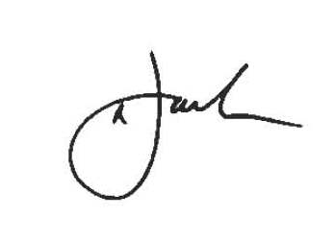
Neil Jack
(Chief Executive)

SECTION 9

GLOSSARY OF TERMS

ACCOUNTING POLICIES
Those principles, bases, conventions, rules and practices applied by an entity that specify how the effects of transactions and other events are to be reflected in its financial statements through:
- recognising,
- selecting measurement bases for; and
- presenting assets, liabilities, gains, losses and changes to reserves.
Accounting policies do not include estimation techniques.

Accounting policies define the process whereby transactions and other events are
reflected in financial statements. For example, an accounting policy for a particular type of
expenditure may specify whether an asset or a loss is to be recognised; the basis on
which it is to be measured; and where in the revenue account or balance sheet it is to be
presented.

ACCRUALS
The concept that income and expenditure are recognised as they are earned or incurred, not as money is received or paid.
ACQUIRED OPERATIONS
Operations comprise services and divisions of service as defined in Service Reporting Code of Practice. Acquired operations are those operations of the local authority that are acquired in the period.
ACTUARIAL GAINS AND LOSSES
For a defined benefit scheme the changes in actuarial deficits or surpluses that arise because:
- events have not coincided with the actuarial assumptions made for the last valuation (experienced gains and losses); or
- the actuarial assumptions have changed.

ASSOCIATE COMPANY
This is an entity other than a subsidiary or joint venture in which the Council has a participating interest and over whose operating and financial policies the Council is able to exercise significant influence.
CAPITAL CHARGE
A charge to service revenue accounts to reflect the cost of non current assets used in the provision of services.

CAPITAL EXPENDITURE
Expenditure above £15,000 on the acquisition of a non current asset or expenditure which adds to and not merely maintains the value of an existing fixed asset.

CAPITAL RECEIPTS
Proceeds above £10,000 from the sale of capital assets. Such income may only be used for capital purposes, ie to repay existing loan debt or to finance new capital expenditure. Any receipts which have not yet been utilised as described are referred to as “capital receipts unapplied”.

CIPFA
The Chartered Institute of Public Finance and Accountancy - the Institute provides financial and statistical information for local government and other public sector bodies and advises central government and other bodies on local government and public finance matters.
CLASS OF NON CURRENT ASSETS
The classes of non current assets required to be included in the accounting statements are:
Operational assets
- council dwellings
- other land and buildings
- vehicles, plant, furniture and equipment
- infrastructure assets
- community assets
Non-operational assets
- Investment properties
- Assets under construction
- Surplus assets, held for disposal

COLLECTION FUND
A statutory account which billing authorities have to maintain for the collection and distribution of amounts due in respect of Council Tax and Non-Domestic Rates.
COMMUNITY ASSETS
Assets that the local authority intends to hold in perpetuity, that have no determinable useful life and that may have restrictions on their disposal. Examples of community assets are parks and historic buildings.
CONSISTENCY
The principle that the accounting treatment of like items within an accounting period and from one period to the next is the same.
CONTINGENT ASSET
A contingent asset is a possible asset arising from past events whose existence will be confirmed only by the occurrence of one or more uncertain future events not wholly within the local authority’s control.
CONTINGENT LIABILITY
A contingent liability is either:
- a possible obligation arising from past events whose existence will be confirmed only by the occurrence of one or more uncertain future events not wholly within the authority’s control; or
- a present obligation arising from past events where it is not probable that a transfer of economic benefits will be required or the amount of the obligation cannot be measured with sufficient reliability.

CORPORATE AND DEMOCRATIC CORE
The corporate and democratic core comprises all activities which local authorities engage in specifically because they are elected, multi-purpose authorities. The cost of these activities are thus over and above those which would be incurred by a series of independent, single purpose, nominated bodies managing the same services. There is therefore no logical basis for apportioning these costs to services.
COUNCIL TAX
A banded property tax which is levied on domestic properties throughout the country. The banding is based on estimated property values as at 1st April 1991. The level of tax is set annually by each local authority for the properties in its area.
CREDITORS
Amounts owed by the Council for work done, goods received or services rendered to it during the accounting period, but for which payment has not been made by the balance sheet date.
CURRENT ASSETS
Assets which will be consumed or cease to have value within the next accounting period, e.g. inventories and debtors.
CURRENT LIABILITIES
Amounts which will become payable or could be called in within the next accounting period, e.g. creditors and cash overdrawn.
CURRENT SERVICE COST (PENSIONS)
The increase in the present value of a defined benefit scheme’s liabilities expected to arise from employee service in the current period.
CURTAILMENT
For a defined benefit scheme, an event that reduces the expected years of future services of present employees or reduces for a number of employees the accrual of defined benefits for some or all of their future service. Curtailments include:
- termination of employees’ services earlier than expected, for example as a result of closing a factory or discontinuing a segment of a business, and
- termination of, or amendment to the terms of, a defined benefit scheme so that some or all future service by current employees will no longer qualify for benefits or will qualify only for reduced benefits.
DEBTORS
Amounts due to the Council which relate to the accounting period and have not been received by the balance sheet date.
DEFINED BENEFIT SCHEME
A pension or other retirement benefit scheme other than a defined contribution scheme. Usually, the scheme rules define the benefits independently of the contributions payable, and the benefits are not directly related to the investments of the scheme. The scheme may be funded or unfunded (including notionally funded).
DEFINED CONTRIBUTION SCHEME
A pension or other retirement benefit scheme into which an employer pays regular contributions fixed as an amount or as a percentage of pay and will have no legal or constructive obligation to pay further contributions if the scheme does not have sufficient assets to pay all employee benefits relating to employee service in the current and prior periods.
DEPRECIATION
The measure of the cost or revalued amount of the benefits of the non current asset that have been consumed during the period.
Consumption includes the wearing out, using up or other reduction in the useful life of a fixed asset, whether arising from use, effluxion of time or obsolescence through either changes in technology or demand for the goods and services produced by the asset.
DISCONTINUED OPERATIONS
Operations comprise services and divisions of service as defined in CIPFA’s Standard Classification of Income and Expenditure. An operation should be classified as discontinued if all the following conditions are met:
- the termination of the operation is completed either in the period or before the earlier of three months after the commencement of the subsequent period and the date on which the financial statements are approved.
- The activities relating to the operations have ceased permanently.
- The termination of the operation has a material effect on the nature and focus of the local authority’s operations and represents a material reduction in its provision of services resulting either from its withdrawal from a particular activity (whether a service or division of service or its provision in a specific geographical area) or from a material reduction in net expenditure in the local authority’s continuing operations.
- The assets, liabilities, income and expenditure of operations and activities are clearly distinguishable physically, operationally and for financial reporting purposes..
Operations not satisfying all these conditions are classified as continuing.
DISCRETIONARY BENEFITS
Retirement benefits which the employer has no legal, contractual or constructive obligation to award and are awarded under the authority’s discretionary powers, such as the Local Government (Discretionary Payments) Regulations 1996.
EMOLUMENTS
All sums paid to or receivable by an employee and sums due by way of expenses allowances (as far as those sums are chargeable to UK income tax) and the money value of any other benefits received other than in cash. Pension contributions payable by either employer or employee are excluded.
ESTIMATION TECHNIQUES
The methods adopted by an entity to arrive at estimated monetary amounts, corresponding to the measurement bases selected, for assets, liabilities, gains, losses and changes to reserves.

Estimation techniques implement the measurement aspects of accounting policies. An accounting policy will specify the basis on which an item is to be measured; where there is uncertainty over the monetary amount corresponding to that basis, the amount will be arrived at by using an estimation technique. Estimation techniques include, for example:
- Methods of depreciation, such as straight line and reducing balance, applied in the context of a particular measurement basis, used to estimate the proportion of the economic benefits of a non current asset consumed in period.
- Different methods used to estimate the proportion of debts that will not be recovered, particularly where such methods consider a population as a whole rather than individual balances.

EXCEPTIONAL ITEMS
Material items which derive from events or transactions that fall within the ordinary activities of the authority and which need to be disclosed separately by virtue of their size or incidence to give fair presentation of the accounts.
EXPECTED RATE OF RETURN ON PENSIONS ASSETS
For a funded defined benefit scheme, the average rate of return, including both income and changes in fair value but net of scheme expenses, expected over the remaining life of the related obligation on the actual assets held by the scheme.
EXTRAORDINARY ITEMS
Material items possessing a high degree of abnormality, which derive from events or transactions that fall outside the ordinary activities of the authority and which are not expected to recur.
FINANCE LEASE
A lease that transfers substantially all of the risks and rewards of ownership of a non current asset to the lessee. Such a transfer of risks and rewards may be presumed to occur if at the inception of the lease the present value of the minimum lease payments, including any initial payment, amounts to substantially all of the fair value of the leased asset.
FINANCIAL YEAR
The Council’s financial year runs from the 1st April through to the following 31st March.

FORMULA GRANT
Grant distributed by formula through the local government finance settlement. It comprises Revenue Support Grant and redistributed business rates (NNDR). It is a general subsidy towards council spending and is not ringfenced for specific services.

GENERAL FUND
The main revenue account of the Council which brings together all income and expenditure other than that recorded in the Housing Revenue Account and the Collection Fund.
HOUSING REVENUE ACCOUNT
A statutory account which local authorities have to maintain if they provide public housing and which includes all income and expenditure relating to the administration and maintenance of council dwellings and related properties.
IMPAIRMENT
A reduction in the value of a fixed asset below its value brought forward in the Balance Sheet. Examples of factors which may cause such a reduction in value include general price decreases, a significant decline in a fixed asset’s market value and evidence of obsolescence or physical damage to the asset.
INFRASTRUCTURE ASSETS
Fixed assets that are inalienable, expenditure on which is recoverable only by continued use of the asset created. Examples are highways and footpaths.
INTEREST COST (PENSIONS)
For a defined benefit scheme, the expected increase during the period in the present value of the scheme liabilities because the benefits are one period closer to settlement.
INTERNATIONAL ACCOUNTING STANDARDS (IAS)
Accounting standards developed by the International Accounting Standards Board that are primarily applicable to general purpose company accounts. These standards are adopted by the CIPFA Code of Practice except where the standards conflict with specific statutory requirements.
INTERNATIONAL FINANCIAL REPORTING STANDARDS (IFRS)
Financial reporting standards developed by the International Accounting Standards Board.
INVENTORIES
The amount of unused or unconsumed stocks held in expectation of future use. When use will not arise until a later period, it is appropriate to carry forward the amount to be matched to the use or consumption when it arises. Stocks comprise the following categories: goods or other assets purchased for resale, consumable stores, raw materials and components purchased for incorporation into products for sale, products and services in intermediate stages of completion, long-term contract balances and finished goods.
INVESTMENTS (NON-PENSIONS FUND)
A long-term investment is an investment that is intended to be held for use on a continuing basis in the activities of the authority. Investments should be so classified only where an intention to hold the investment for the long term can clearly be demonstrated or where there are restrictions as to the investor’s ability to dispose of the investment.
Investments, other than those in relation to the pensions fund, that do not meet the above criteria should be classified as current assets.
LEA
Local Education Authority – a local authority with the statutory responsibility for securing the provision of education in its area.

MINIMUM REVENUE PROVISION
Minimum revenue provision is the minimum amount which must be charged to an Authority’s revenue account each year and set aside as provision for credit liabilities, as required by the Local Government and Housing Act 1989.

NATIONAL NON-DOMESTIC RATES (NNDR)
A tax levied on business properties and sometimes known as Business Rates. An NNDR poundage is set annually by the Government. Sums based on rateable values are collected by billing authorities and paid into a national pool. The proceeds are then redistributed by central government as a grant to local authorities in proportion to adult population.
NET BOOK VALUE
The amount at which non current assets are included in the balance sheet, i.e historic cost or current value less the cumulative amounts provided for depreciation.
NET CURRENT REPLACEMENT COST
The cost of replacing or recreating the particular asset in its existing condition and in its existing use, i.e. the cost of its replacement or of the nearest equivalent asset, adjusted to reflect the current condition of the existing asset.
NET REALISABLE VALUE
The open market value of an asset in its existing use less the expenses to be incurred in realising the asset.
NON CURRENT ASSETS (previously fixed assets)
Assets that yield benefits to the local authority and the services it provides for a period of more than one year.

OPERATING LEASES

Leases which do not meet the definition of a finance lease, ie where the terms of the lease transfer substantially all the risks and rewards incidental to the ownership of the property, plant and equipment from the lessor to the lessee, are accounted for as operating leases.

PAST SERVICE COST
For a defined benefit scheme, the increase in the present value of the scheme liabilities related to employee service in prior periods arising in the current period as a result of the introduction of, or improvement to, retirement benefits.

PRIVATE FINANCE INITIATIVE (PFI)
A central Government initiative which aims to increase the level of funding available for public services by attracting private sources of finance. The PFI is supported by a number of incentives to encourage Authority’s participation.

PROVISION
An amount set aside by the Council for any liability of uncertain timing or amount that has been incurred.
PRUDENTIAL CODE FOR CAPITAL FINANCE
The Code was introduced from 1st April 2004. The basic principle of the Code is that local authorities will be free to invest so long as their capital spending plans are affordable, prudent and sustainable. The Code sets out indicators that the authority must use and factors that they must take account to demonstrate that they have fulfilled this objective.

RESERVES
Amounts set aside in the accounts to meet expenditure which the Council may be committed to in future periods, but not allocated to specific liabilities which are certain or very likely to occur.
Earmarked reserves are allocated to a specific purpose or area of spending. Unallocated reserves are often described as balances.

REVENUE ACCOUNT
An account which records all annual running costs and the associated income.
REVENUE EXPENDITURE
Expenditure incurred on the day-to-day running of the Council.
REVENUE SUPPORT GRANT
A central government grant paid to each local authority to help to finance its general expenditure. The distribution of the grant between authorities is intended to allow the provision of similar standards of service throughout the country for a similar council tax levy.
SERVICE REPORTING CODE OF PRACTICE
A code of practice prepared to provide accounting guidance on financial reporting to stakeholders which is designed to enhance the comparability of local authority financial information. The code represents proper accounting practice for the purpose of best value reporting.
SUPPORTED CAPITAL EXPENDITURE (REVENUE) (SCE(R))
Replaces Basic Credit Approvals from 2004/2005 under the Local Government Act 2003. A specific amount of capital expenditure for which the Government will support the borrowing via RSG grant.
WORK IN PROGRESS
The cost of work undertaken up to a specified date on an uncompleted revenue project.

